Team ID: 26FSDPYCPMID1030
Case-Study Report
On
“Privacy-Aware Cloud–Edge Intelligence for Distributed Data Science”
submitted as part of
BCSE318L Data Privacy
by
23BCE0644
Lakshay Chauhan

23BCE0110
Suraj Goyal

23BCE0031
Shrish Shrinivas K

To
Dr. M. Rajasekhara Babu
School of Computer Science and Engineering
Vellore Institute of Technology
(Deemed to be University under section 3 of UGC Act, 1956)
October 2026

Index
Sl. No. | Section Topic | Page No.
 | Executive Summary and Abstract | 6
1. | Introduction | 6
2. | Problem Statement | 8
3. | Background and Literature Review | 8
4. | Requirements Analysis for Privacy-Aware Cloud–Edge Systems | 10
5. | Privacy-Aware Cloud–Edge Intelligence Architecture | 12
6. | Data Acquisition and Edge Intelligence Layer | 13
7. | Distributed Data Engineering Layer | 15
8. | Privacy Preservation and Security Layer | 16
9. | Federated Analytics and Learning Layer | 17
10. | Cloud Intelligence and Advanced Analytics Layer | 19
11. | Explainability, Trust, and Decision Intelligence Layer | 20
12. | Governance, Compliance, and Policy Enforcement Layer | 21
13. | Experimental Setup | 22
14. | Evaluation Metrics | 23
15. | Results and Findings | 24
16. | Comparative Analysis | 27
17. | Reliability, Security, and Trustworthiness Assessment | 28
18. | Industry Use Cases and Case Study Evaluation | 29
19. | Business Impact Assessment | 30
20. | Challenges and Limitations | 31
21. | Future Research Directions | 32
22. | Conclusion | 33
 | Data and Code Availability / Acknowledgment | 35
 | References | 36
 | Appendix | 38

List of Figures
Fig. No. | Figure Title | Page No.
1. | Evolution of Cloud–Edge Analytics Architectures | 7
2. | Distributed Data Science Ecosystem Overview | 7
3. | Privacy Challenges in Cloud–Edge Data Science Systems | 8
4. | Literature Taxonomy Framework | 8
5. | Requirements Engineering Framework | 11
6. | Privacy-Aware Cloud–Edge Intelligence Architecture for Distributed Data Science | 12
7. | Multi-Layer Architectural View | 13
8. | Edge Data Acquisition Framework | 14
9. | Edge Intelligence Processing Pipeline | 14
10. | Distributed Data Engineering Workflow | 15
11. | Edge-to-Cloud Data Flow Architecture | 15
12. | Privacy Preservation Framework | 16
13. | Secure Communication and Storage Architecture | 17
14. | Federated Analytics Architecture | 18
15. | Federated Learning Workflow | 18
16. | Cloud Analytics Framework | 19
17. | AI-Powered Intelligence Pipeline | 19
18. | Explainability and Trust Framework | 20
19. | Decision Intelligence Architecture | 21
20. | Governance and Compliance Architecture | 21
21. | Experimental Testbed Architecture | 22
22. | Evaluation Framework | 23
23. | Privacy Preservation Performance Analysis | 25
24. | Latency and Throughput Evaluation | 26
25. | Trustworthiness Assessment Results | 27
26. | Comparative Radar Chart | 27
27. | Security and Reliability Framework | 28
28. | Smart City Cloud–Edge Ecosystem | 29
29. | Healthcare Edge Intelligence Framework | 30
30. | Business Impact Dashboard | 31
31. | Challenges and Limitations Roadmap | 31
32. | Future Research Roadmap | 32
33. | Next-Generation Cloud–Edge Intelligence Ecosystem | 33
34. | Research Contribution Framework | 33
35. | Pixel Importance Maps under Privacy | 38

List of Tables
Table No. | Table Title | Page No.
1. | Executive Summary of Contributions and Outcomes | 6
2. | Research Challenges and Gap Analysis | 8
3. | Comparative Analysis of Existing Approaches | 10
4. | Functional and Non-Functional Requirements Matrix | 12
5. | Edge Analytics Components | 14
6. | Privacy Protection Techniques | 17
7. | Governance Controls and Compliance Requirements | 22
8. | Experimental Configuration Details | 23
9. | Metrics Definition Matrix | 23
10. | Experimental Results Summary (mean over 3 seeds; ± standard deviation) | 24
11. | Comparative Benchmark Analysis (pillar scores in [0, 1]; T under three weightings) | 27
12. | Trustworthiness Assessment Matrix | 28
13. | Industry Use Cases Matrix | 30
14. | Cost–Benefit Analysis (assumed inputs; US$ per year) | 31
15. | Reproducibility and Environment Details | 38

Contributions
Sl. No. | Section Topic | Reg. No. of Team Member contributed | No. of Words
 | Executive Summary and Abstract | 23BCE0644 | 514
1 | Introduction | 23BCE0644 | 658
2 | Problem Statement | 23BCE0644 | 403
3 | Background and Literature Review | 23BCE0110 | 1274
4 | Requirements Analysis for Privacy-Aware Cloud–Edge Systems | 23BCE0110 | 554
5 | Privacy-Aware Cloud–Edge Intelligence Architecture | 23BCE0110 | 728
6 | Data Acquisition and Edge Intelligence Layer | 23BCE0031 | 668
7 | Distributed Data Engineering Layer | 23BCE0031 | 660
8 | Privacy Preservation and Security Layer | 23BCE0031 | 723
9 | Federated Analytics and Learning Layer | 23BCE0031 | 733
10 | Cloud Intelligence and Advanced Analytics Layer | 23BCE0644 | 562
11 | Explainability, Trust, and Decision Intelligence Layer | 23BCE0110 | 588
12 | Governance, Compliance, and Policy Enforcement Layer | 23BCE0644 | 578
13 | Experimental Setup | 23BCE0644 | 637
14 | Evaluation Metrics | 23BCE0110 | 447
15 | Results and Findings | 23BCE0110 | 1143
16 | Comparative Analysis | 23BCE0031 | 568
17 | Reliability, Security, and Trustworthiness Assessment | 23BCE0031 | 562
18 | Industry Use Cases and Case Study Evaluation | 23BCE0644 | 513
19 | Business Impact Assessment | 23BCE0031 | 534
20 | Challenges and Limitations | 23BCE0644 | 462
21 | Future Research Directions | 23BCE0644 | 442
22 | Conclusion | 23BCE0110 | 287
 | References | 23BCE0110 | n/a (83 references)
 | Data availability and acknowledgment | 23BCE0644 | 98
 | Appendix | 23BCE0644 | 75
Consolidated Report on contributions
Sl. No. | Reg. No. of Student | Total number of Words contributed across the sections
1 | 23BCE0644 | 4942
2 | 23BCE0110 | 5021
3 | 23BCE0031 | 4448
 | Total number of words | 14411

Privacy-Aware Cloud–Edge Intelligence for Distributed Data Science
Dr. M. Rajasekhara Babu¹, Lakshay Chauhan², Suraj Goyal³, Shrish Shrinivas K⁴
School of Computer Science and Engineering, Vellore Institute of Technology (VIT), Vellore-632014, T.N., India
¹mrajasekharababu@vit.ac.in, ²lakshay.chauhan2023@vitstudent.ac.in, ³suraj.goyal2023@vitstudent.ac.in, ⁴shrish.shrinivaask2023@vitstudent.ac.in
Corresponding author: M Rajasekhara Babu (e-mail: mrajasekharababu@vit.ac.in).
ABSTRACT Distributed analytics increasingly depends on data created at the network edge, yet moving those data to a central cloud raises privacy, latency, and governance risks. This article presents a privacy-aware cloud–edge intelligence framework for distributed data science and evaluates its core privacy mechanisms in a reproducible testbed. The framework has seven layers: edge data acquisition, distributed data engineering, privacy preservation, federated analytics, cloud intelligence, explainability and trust, and governance. Raw data stay on the device, whereas clipped, noised, and masked model updates travel to the cloud. We combine client-side differentially private training, secure aggregation, robust aggregation, and a Rényi privacy accountant, and we define a six-pillar trust score. On two public datasets, federated averaging reached 92.3% accuracy on image data and 91.8% on clinical data, against 97.0% and 92.2% for centralized training. Differentially private training with a worst-case privacy budget of 23.6 at a failure probability of 10⁻⁵ retained 86.2% accuracy on image data. Secure aggregation reproduced the plain sum to within 10⁻¹³, but its cost grew quadratically with the number of clients. A coordinate-wise median preserved 89.3% accuracy with 30% label-flipping clients, whereas plain averaging fell to 76.1%. A loss-threshold membership attack stayed near chance for all models, so we do not claim an empirical privacy gain. A hybrid edge–cloud policy offloaded 24% of requests and recovered most of the accuracy gap. We also map requirements to technical controls for the European General Data Protection Regulation, the Indian Digital Personal Data Protection Act, and the European Artificial Intelligence Act.
INDEX TERMS Cloud–edge intelligence, data governance, differential privacy, distributed data science, edge AI, federated analytics, privacy-aware analytics, secure aggregation, secure computing, trust score, trustworthy AI

EXECUTIVE SUMMARY
Organizations now collect data on phones, sensors, vehicles, and hospital devices, and they want analytics that combine these sources without centralizing raw records. Centralized pipelines are simple, but they expose every record to leakage, add network delay, and concentrate regulatory risk. Recent surveys of edge intelligence and federated learning describe the opportunity but also the open privacy, trust, and deployment problems [1][2][3]. This report designs and evaluates a privacy-aware cloud–edge framework that answers those problems in a single, auditable architecture.
The framework has seven layers that run from device-level acquisition to governance. Edge nodes filter and minimize data and train local models. Updates are clipped and perturbed for differential privacy, masked for secure aggregation, and combined in the cloud with federated averaging or a robust median. An explainability and trust layer turns utility, data minimization, formal privacy, fairness, robustness, and communication-efficiency measurements into a transparent score. A governance layer maps legal duties to technical controls.
We tested the privacy mechanisms with real, reproducible experiments on two public datasets, using emulated edge clients. Federated training came within 4.7 points of centralized accuracy on image data and within 0.4 points on clinical data. Differential privacy reduced accuracy in a predictable way, and a median aggregator protected against poisoning. Two results were not favorable and are reported plainly: a standard membership attack could not distinguish members from non-members even without differential privacy, and, on these small datasets, federated training exchanged more bytes than a one-off raw-data upload. The business model in Section 19 is an assumption-based illustration, not a measurement.
Table 1 summarizes the contributions and outcomes.
TABLE 1. Executive Summary of Contributions and Outcomes
Contribution | Outcome and evidence | Section
Seven-layer architecture | Acquisition to governance, with a governance plane across all layers (Figs. 6–7) | 5–12
Privacy toolkit | Client DP + secure aggregation + Rényi accounting; σ = 1.0 gave ε = 23.6 and 86.2% accuracy on Digits | 8, 15
Robust aggregation | Median kept 89.3% accuracy at 30% label-flipping clients; mean fell to 76.1% | 9, 15
Hybrid edge–cloud policy | Offloading 24% of requests recovered 97% of the accuracy gap | 15
Trust score and governance map | Six-pillar score and a requirement-to-control table | 11, 12
Candid negative results | Membership attack near chance (AUC 0.50–0.54); federated learning moved 12.8× the bytes of a raw upload | 15
Business model (assumed inputs) | 22.7% lower annual cost; break-even breach probability 0.74% | 19

1. INTRODUCTION

1.1 Evolution of cloud–edge analytics
Early analytics pipelines sent all data to a central data center. As sensors and mobile devices multiplied, that design met limits in bandwidth, delay, and trust, and computing moved closer to the data through fog and edge computing. A comprehensive survey describes edge intelligence as the combination of edge caching, training, inference, and offloading, intended to improve processing while protecting privacy and security [1]. A later review tracks how artificial intelligence is used to organize edge networks and to run smart applications on them [4]. Today the cloud and the edge are treated as a continuum, with orchestration across both [5]. Fig. 1 shows this progression.
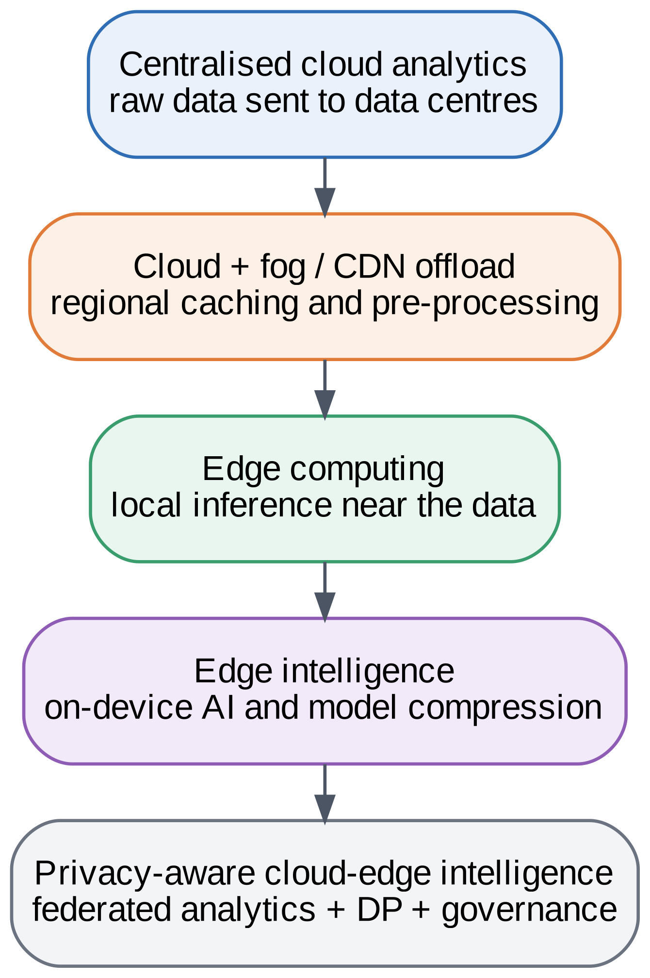
FIGURE 1. Evolution of Cloud–Edge Analytics Architectures.

1.2 Distributed data science ecosystems
A distributed data science ecosystem links data sources, edge nodes, cloud services, and consumers, with privacy and governance controls running through every tier (Fig. 2). Federated learning is the leading way to train models across such an ecosystem without pooling raw data, and surveys cover it for Internet of Things (IoT) settings [2], for mobile edge networks [6], and for edge computing in general [7]. Edge intelligence is also reaching large language models, which brings new privacy and resource questions [8].
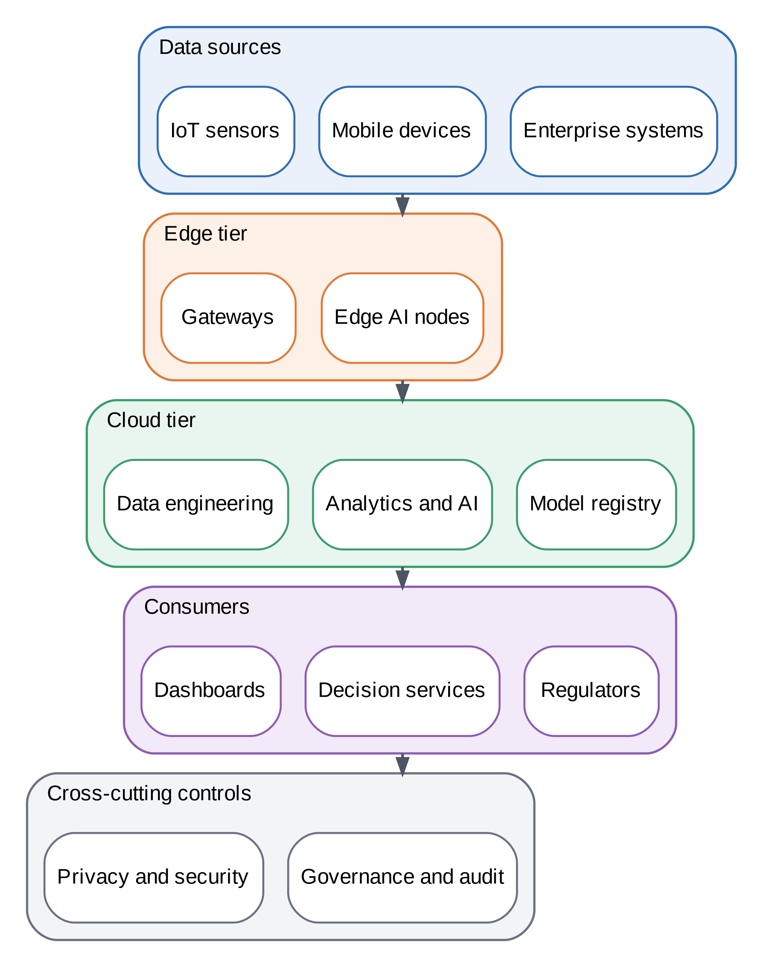
FIGURE 2. Distributed Data Science Ecosystem Overview.

1.3 Privacy concerns and the need for a framework
Keeping data local does not by itself guarantee privacy. Shared model updates can leak information, and surveys of trustworthy federated learning and of privacy in distributed cloud computing stress that security, privacy, and governance must be designed together [3][9]. Laws raise the stakes: the GDPR, India’s Digital Personal Data Protection Act, and the EU AI Act impose duties on how personal data are processed and how AI systems are governed [10][11][12]. Existing work tends to address one concern at a time, such as an algorithm, a protocol, or a policy, while practitioners need an end-to-end design. Recent studies also point to the opportunity and risk of running language-model agents and data analysis at the edge [13][14].

1.4 Motivating scenarios and scope
Three scenarios motivate the framework. A hospital network wants a shared diagnostic model, but patient records cannot leave each hospital. A city wants traffic and air-quality forecasts from thousands of roadside sensors and cameras, but video of people is sensitive. A manufacturer wants predictive maintenance across plants, but process data are trade secrets. In all three, the data owners are willing to share what a model has learned but not the records themselves, and regulators expect them to show how that line is enforced [15][16][17].
The scope of this report is deliberately bounded. It covers the design of a layered framework, an emulated testbed that exercises the privacy, aggregation, and routing mechanisms, and an analysis of trust, governance, and cost. It does not claim to measure behavior on physical edge hardware, to certify legal compliance, or to establish production-scale performance. Where a result depends on an assumption, the text says so, and Section 20 lists the limits in one place.
The contribution is integration and honest measurement rather than a new algorithm. We combine established components, namely federated averaging [18], differentially private training [19], and secure aggregation [20], and we report how they interact, including the cases where a component does not help. Reporting such cases is useful because published surveys tend to describe what mechanisms promise, and practitioners need to know what they cost on a concrete workload [3][21].

1.5 Objectives and contributions
The objectives of this report are as follows.
- Design a seven-layer, privacy-aware cloud–edge architecture for distributed data science.
- Integrate client-side differential privacy, secure aggregation, and robust aggregation with a formal privacy accountant.
- Define a six-pillar trust score and a requirement-to-control mapping for major regulations.
- Evaluate the mechanisms in an open, reproducible testbed and report favorable and unfavorable findings alike.
- Provide a transparent business-impact model and a roadmap for future work.
The rest of this report follows the section plan of the course template. Sections 2 to 4 define the problem and requirements, Sections 5 to 12 present the architecture layer by layer, Sections 13 to 17 describe the experiments and findings, and Sections 18 to 22 cover use cases, impact, limits, future work, and conclusions.

2. PROBLEM STATEMENT

2.1 Challenges in distributed analytics
Five problems motivate this work, and Fig. 3 summarizes them.
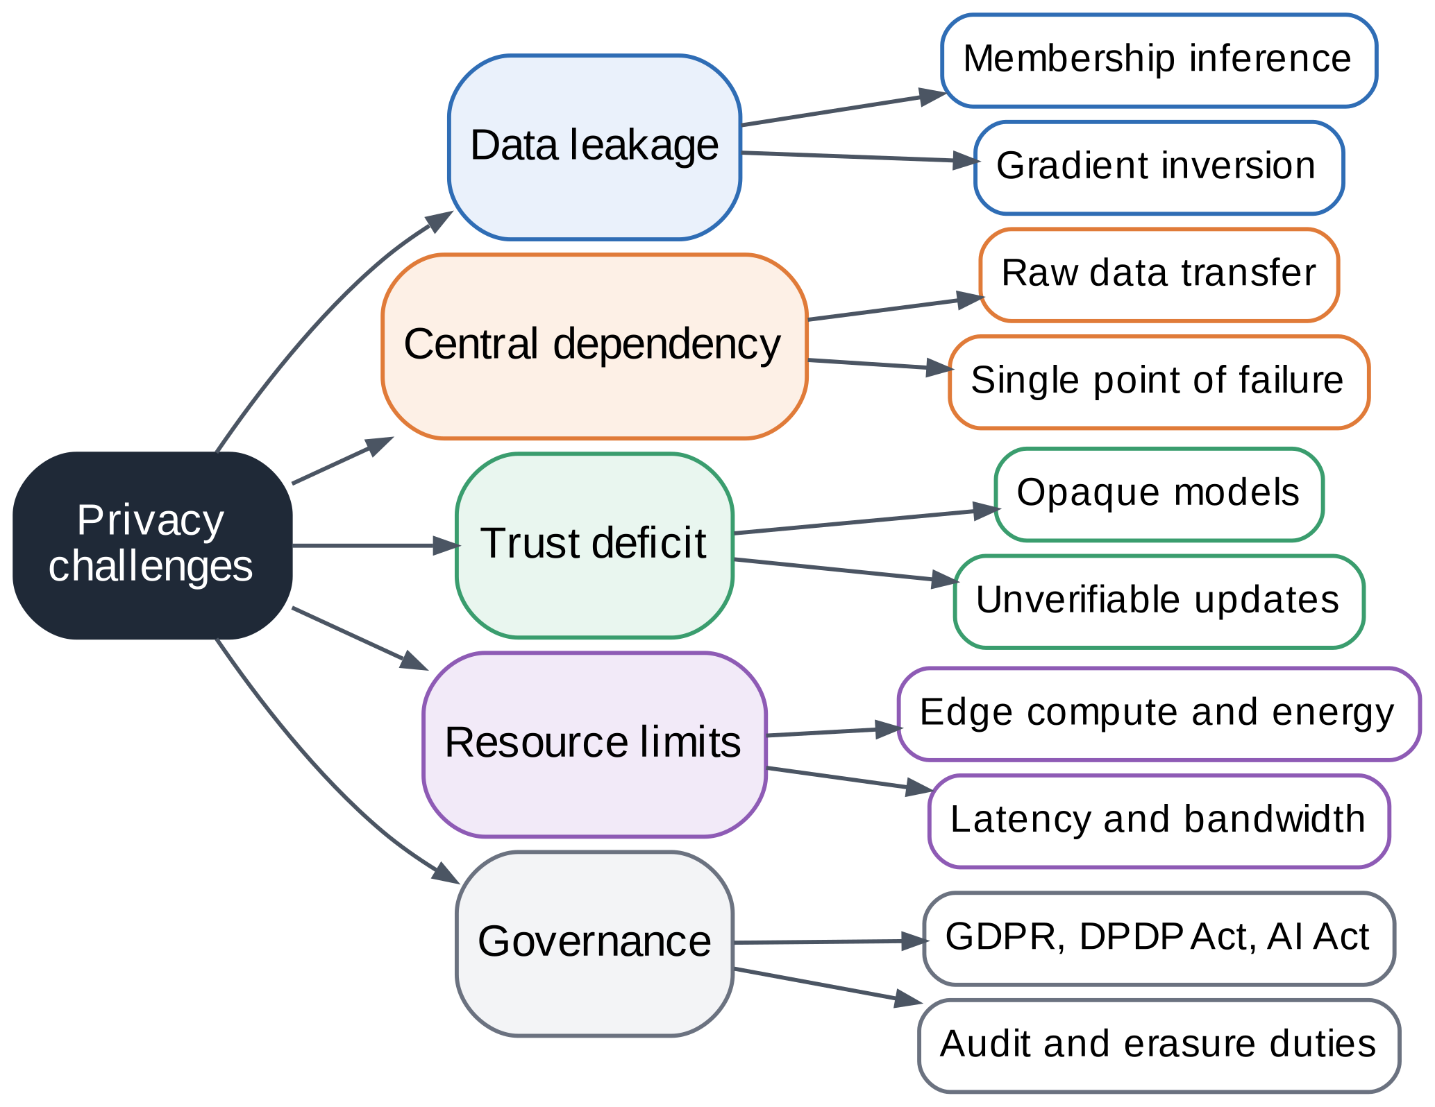
FIGURE 3. Privacy Challenges in Cloud–Edge Data Science Systems.
First, privacy leakage. Membership inference lets an adversary tell whether a record was used in training [22], and gradients can be inverted to recover training inputs [23]. A survey of membership inference in federated learning catalogs attacks and defenses for the federated setting [24], and a broader survey covers privacy attacks, defenses, and the policy landscape [25]. Second, centralized dependency. Pooling raw data creates a single point of failure and large transfers. Third, a trust deficit, because stakeholders cannot easily verify models or updates [26][27]. Fourth, resource and latency limits on edge devices. Fifth, governance complexity, since access, audit, and erasure duties must be enforced across many sites [3].

2.2 Threat model and assumptions
We assume three kinds of adversary. The first is an honest-but-curious cloud server that follows the protocol but tries to learn about individual clients from the updates it receives. The second is a set of malicious clients that submit poisoned updates, which we model as label flipping. The third is an external eavesdropper on the network. Compromised edge firmware, physical attacks on devices, and side channels in hardware are out of scope, although Section 17 discusses them for trusted execution environments [28].
The privacy goal is that the output of training, and every message the server sees, reveal only a bounded amount about any single training example held by a client. The security goals are that individual updates stay hidden from the server and that a minority of bad clients cannot arbitrarily steer the global model. These goals map to differential privacy [29], secure aggregation [20], and robust aggregation, respectively, and no single mechanism covers all three.
Two clarifications avoid common misreadings. First, differential privacy is a property of the training procedure and its accounting, not of one trained model, so a small budget is a design target rather than a measurement. Second, defending against poisoning and defending against inference pull in different directions, because the noise that hides a record also hides the signal that robust methods use to spot outliers. Section 15 shows the cost of noise under poisoning: DP-FedAvg falls to 62.9% at 30% label-flipping clients.

2.3 Gap analysis
Table 2 summarizes the research challenges and the gaps that this report addresses. The common thread is the lack of an integrated, measured, and governed design: privacy tools are usually evaluated alone, trust is rarely quantified, and regulatory duties are seldom traced to technical controls.
TABLE 2. Research Challenges and Gap Analysis
Challenge | Evidence in literature | Gap | Addressed
Leakage from updates | Membership inference and gradient inversion [22][23][24][25] | Defenses evaluated in isolation | Sec. 8, 15
Central dependency | Surveys of edge federated learning [7][30] | Few designs unite local inference, FL, and cloud backup | Sec. 5, 9, 10
Trust deficit | Trustworthy edge and FL surveys [9][26] | No shared, measurable trust score | Sec. 11
Resource limits | TinyML and TinyMLOps [31][32] | Privacy cost on small devices rarely reported | Sec. 6, 15
Governance and erasure | Compliance patterns, unlearning [33][34] | Weak link from law to control | Sec. 12
Continuum orchestration | Orchestration surveys [5][35] | Privacy not a first-class goal | Sec. 5

3. BACKGROUND AND LITERATURE REVIEW
Fig. 4 organizes the literature that informs this work, and Table 3 compares representative approaches.
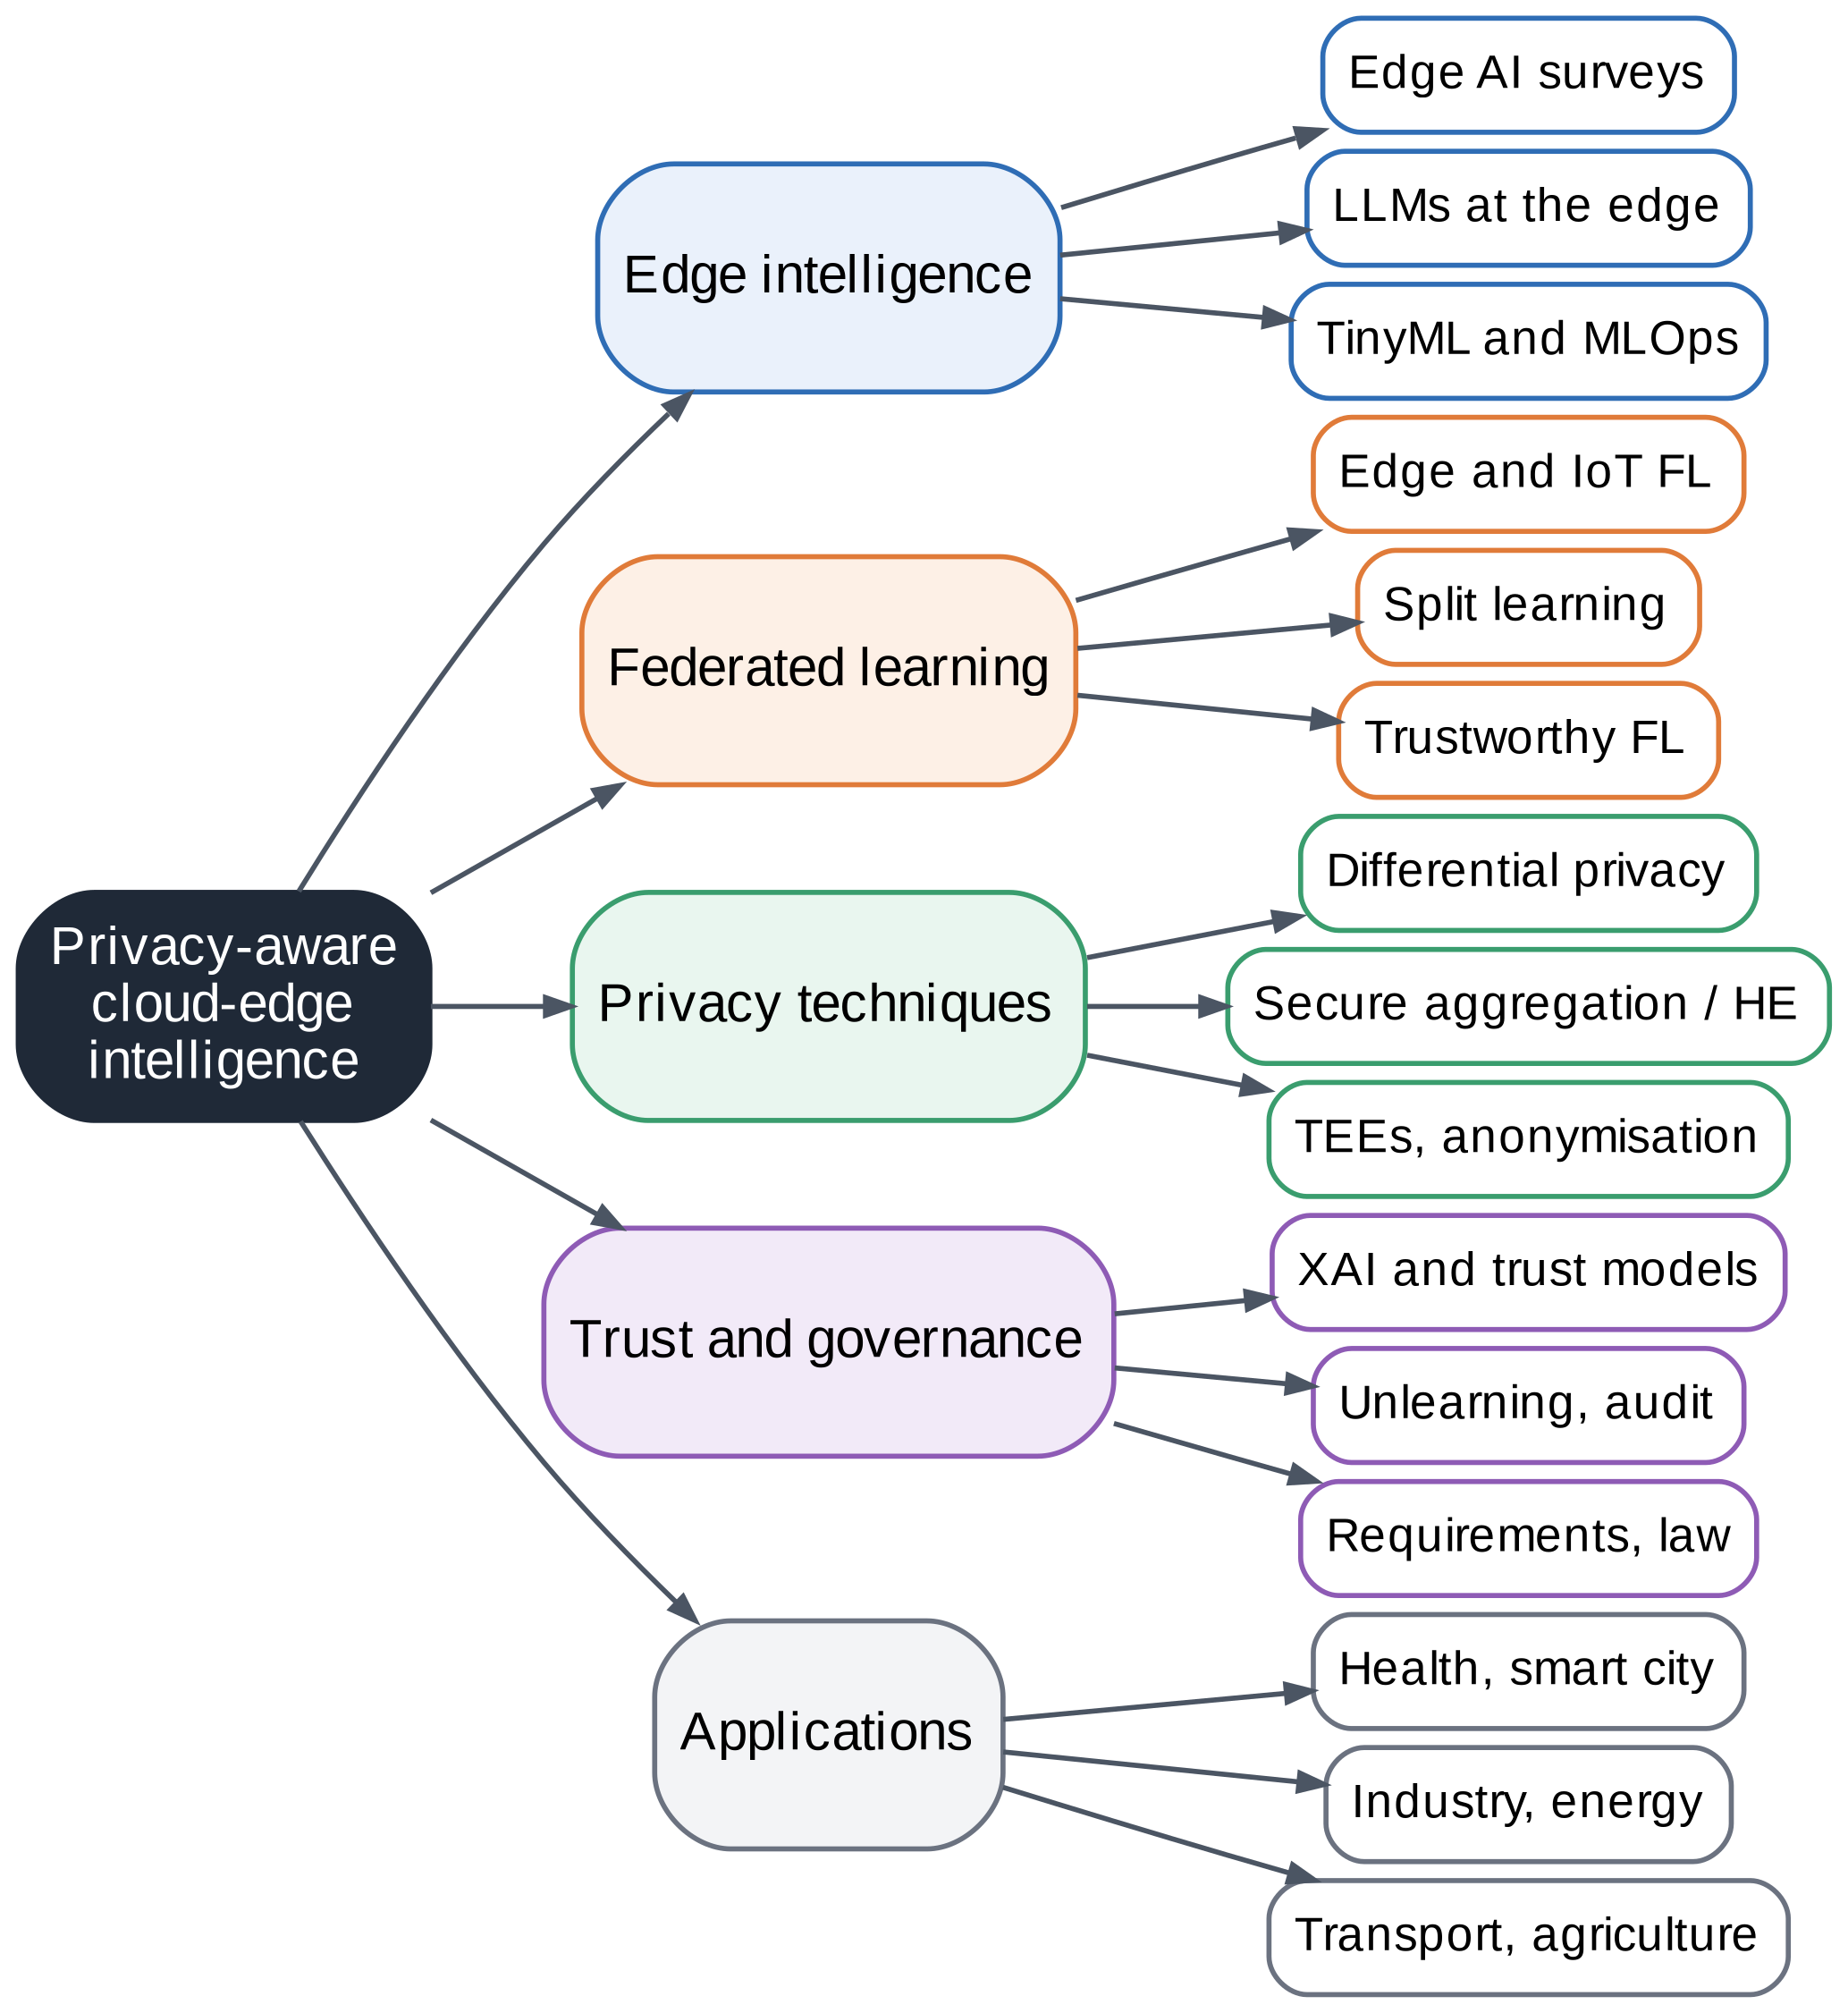
FIGURE 4. Literature Taxonomy Framework.

3.1 Cloud, edge, and the computing continuum
Edge intelligence surveys describe how learning and inference move toward the data source [1][4]. A systematic review of distributed intelligence on the edge-to-cloud continuum and surveys of orchestration across the cloud-to-things continuum discuss how workloads are placed and managed across tiers [5][35][36]. Studies of federated learning at the edge further discuss communication, heterogeneity, and resource limits [7][30][37].
Because workloads differ in how much they need the cloud, the literature stresses placement decisions: which model runs where, which data move, and how a system adapts when links degrade [5][36]. For privacy, these decisions matter as much as the algorithm, since every data movement is a possible exposure. This is why our architecture treats the routing of requests as a first-class design element and reports the share of data that leaves the device.

3.2 Federated and split learning
Federated averaging trains a shared model from locally computed updates without moving raw data [18], and a major review lists open problems in privacy, robustness, and efficiency [21]. Surveys address federated learning for IoT [2], for mobile edge networks [6], and for privacy-preserving IoT services [38], and a survey of the fusion of federated learning with industrial IoT covers factory settings [17]. Split learning partitions the model between device and server, and a recent review with experiments and a survey of federated split learning compare its trade-offs [39][40]. Open-source frameworks and benchmarks support experiments on edge testbeds [41][42].
Several themes recur across these surveys. Statistical heterogeneity means that clients hold different data distributions, which slows convergence and lowers accuracy for some clients. Systems heterogeneity means that devices differ in compute, memory, and connectivity. Communication is a bottleneck, so methods reduce the number or size of updates. Privacy and security are treated as open challenges even though federated learning is often described as privacy-preserving by design [2][6][21]. Our experiments therefore vary heterogeneity explicitly (Section 15) and measure communication and privacy cost alongside accuracy.

3.3 Privacy-preserving computing
Differential privacy gives a mathematical bound on what an output reveals about any one record [29], and differentially private training adds clipping and noise to gradients [19]. Reviews cover its use in federated learning [43], the optimization of its algorithms [44], its local variant [45], and its role in edge-based smart city applications [46], while an analysis of data privacy for edge systems examines the trade-offs on constrained hardware [47]. Secure aggregation hides individual updates from the server [20], and a systematization of knowledge compares cryptographic approaches [48], including threshold homomorphic encryption for private averaging [49]. Fully homomorphic encryption allows computation on encrypted data [50]. Trusted execution environments protect code and data in use, with a survey of confidential computing from edge to cloud [51], a survey of Intel SGX [52], and a survey of its vulnerabilities [28]. Anonymization of streams and IoT data are reviewed in [53][54], and a privacy-preserving data collection protocol shows an alternative to central collection [55]. A survey of developer support for privacy-preserving IoT shows how these tools reach practice [56]. For long-term security, surveys discuss post-quantum approaches for edge computing and for constrained IoT devices [57][58][59].
A recurring finding in the privacy literature is that mechanisms are rarely combined and compared on one workload. Differential privacy protects against inference from outputs but not against a curious server reading individual updates, while secure aggregation hides individual updates but does not limit what the aggregate reveals, and trusted hardware shifts trust to a vendor rather than removing it [20][29][51]. Layering these mechanisms, as this report does, is therefore a design choice with measurable costs, not a free addition.

3.4 Trust, explainability, and governance
Surveys of trustworthy edge intelligence and trustworthy federated learning organize security, robustness, transparency, and sustainability [9][26], and a research agenda argues for trustworthy and sustainable edge AI [27]. Explainable AI for the IoT is reviewed in [60][61], a framework for evaluating explainable systems is given in [62], and interpretable federated learning is explored in [63]. Trust management and trust evaluation models for IoT are surveyed in [64][65]. For governance, interaction patterns for regulatory compliance in federated learning, an accountable and reproducible federated learning approach, and GDPR-compliant IoT data policies show how rules become mechanisms [33][66][67]. Machine unlearning and federated unlearning address erasure duties [34][68][69]. A systematic review of privacy requirements engineering supports requirement design [70].
Trust and governance work is more fragmented than the algorithmic work. Trust models for IoT define scores from direct and indirect evidence about devices [64][65], whereas trustworthy-AI surveys list properties such as robustness and transparency without a shared numerical scale [9][26]. Compliance work, meanwhile, offers patterns and documentation templates but few empirical evaluations [33][66]. We take a middle path by defining a simple, transparent score whose inputs are measured in the testbed, and by tracing each legal duty to a named control.

3.5 Applications
Federated learning has been reviewed for smart healthcare [15], smart cities [16], power systems and smart grids [71][72], intelligent transportation and vehicular networks [73][74], and agriculture [75][76].
Across these domains the surveys report a similar pattern. In healthcare, records are spread across hospitals that cannot pool them, so federated training is attractive, but small sites and skewed patient populations make a single global model uneven across institutions [15]. In smart cities, sensing infrastructure is dense and owned by several agencies, and the main privacy risks come from video and from the location traces of residents [16][46]. In industrial settings, the data are less personal but commercially sensitive, so the concern shifts from individual privacy to the confidentiality of process knowledge [17].
Energy and transportation add real-time constraints. Smart-meter readings reveal household routines, which motivates privacy-preserving federated forecasting for power systems and smart grids [71][72]. Intelligent transportation and vehicular networks combine mobility, intermittent connectivity, and safety requirements, so surveys stress communication efficiency and reliability alongside privacy [73][74]. Agricultural data are often collected by small farms with limited connectivity, and they raise questions of data ownership as much as of personal privacy [75][76].
Two observations from this application literature shape our design. First, the same technical mechanisms recur in every domain, but the threat that matters most differs, which argues for a layered framework whose controls can be strengthened or relaxed per deployment rather than for a single fixed pipeline. Second, application surveys rarely report the privacy cost of a mechanism together with its accuracy and communication cost on a common workload, which is the gap that our testbed addresses in Sections 13 to 15.

3.6 Evaluation practice and open tooling
Evaluation practice varies widely. Papers report accuracy on standard datasets, privacy as a nominal budget or an attack success rate, and efficiency as rounds or bytes, but rarely all three together. Practical studies of private learning warn that nominal budgets and attack success can disagree [77], and surveys of membership inference list many attack types that are not always run against the defended model [24][25]. Open frameworks and benchmarks for federated learning reduce the effort of running such studies [41][42], which is why we document our code and results. For privacy metrics, recent surveys also consider how to compare mechanisms for generative models [78], which signals that metric choice remains unsettled.

3.7 Synthesis
The literature is rich in components but thin on integration. Few works combine differential privacy, secure aggregation, robust aggregation, trust measurement, and governance in one measured design, which is the contribution pursued here.
Three gaps follow. First, few studies measure the joint cost of differential privacy, secure aggregation, and robust aggregation on the same workload. Second, trust is discussed qualitatively far more than it is computed. Third, the path from a legal duty to a testable control is seldom shown. Table 3 summarizes how each family of approaches contributes and where it stops.

TABLE 3. Comparative Analysis of Existing Approaches
Approach | Representative work | Strength | Limitation relative to this work
Edge intelligence surveys | [1][4] | Taxonomy of edge training, inference, offloading | Privacy and governance are secondary topics
Federated learning for IoT and edge | [2][6][7] | Broad coverage of algorithms and challenges | No single measured end-to-end design
Split and federated split learning | [39][40] | Reduces on-device compute; experiments included | Intermediate activations may leak; less studied for governance
Differential privacy in FL | [43][44][45] | Formal guarantee; many optimization methods | Accuracy cost; budgets hard to interpret
Secure aggregation and encryption | [48][49][50] | Hides individual updates or data in use | Cost grows with clients or computation
Trusted execution environments | [28][51][52] | Protects code and data in use | Side-channel and fault vulnerabilities
Explainable AI for IoT | [60][61][62] | Methods and evaluation guidance | Little work on federated settings
Trust management for IoT | [64][65] | Trust models and metrics | Not linked to privacy budgets or fairness
Compliance patterns and unlearning | [33][34][66][68] | Reusable patterns; erasure methods | Not evaluated with a full testbed
Continuum orchestration | [5][35][36] | Placement and management across tiers | Privacy is not the primary objective

4. REQUIREMENTS ANALYSIS FOR PRIVACY-AWARE CLOUD–EDGE SYSTEMS
Requirements were elicited from the stakeholder needs and legal duties in Sections 1.3 and 12.1 and refined through the privacy requirements engineering process described in the literature [70]. Fig. 5 shows the framework: elicit, classify, specify, map to layers, and verify, with refinement after verification.
The stakeholders are data owners such as patients, citizens, and plant operators; operators of edge and cloud services; model consumers such as clinicians and planners; auditors and regulators; and developers. Each group states needs in its own terms. Data owners want control and minimal exposure. Operators want reliability and low cost. Consumers want accuracy and explanations. Regulators want evidence. Developers want tooling that makes the safe path the easy path [56].
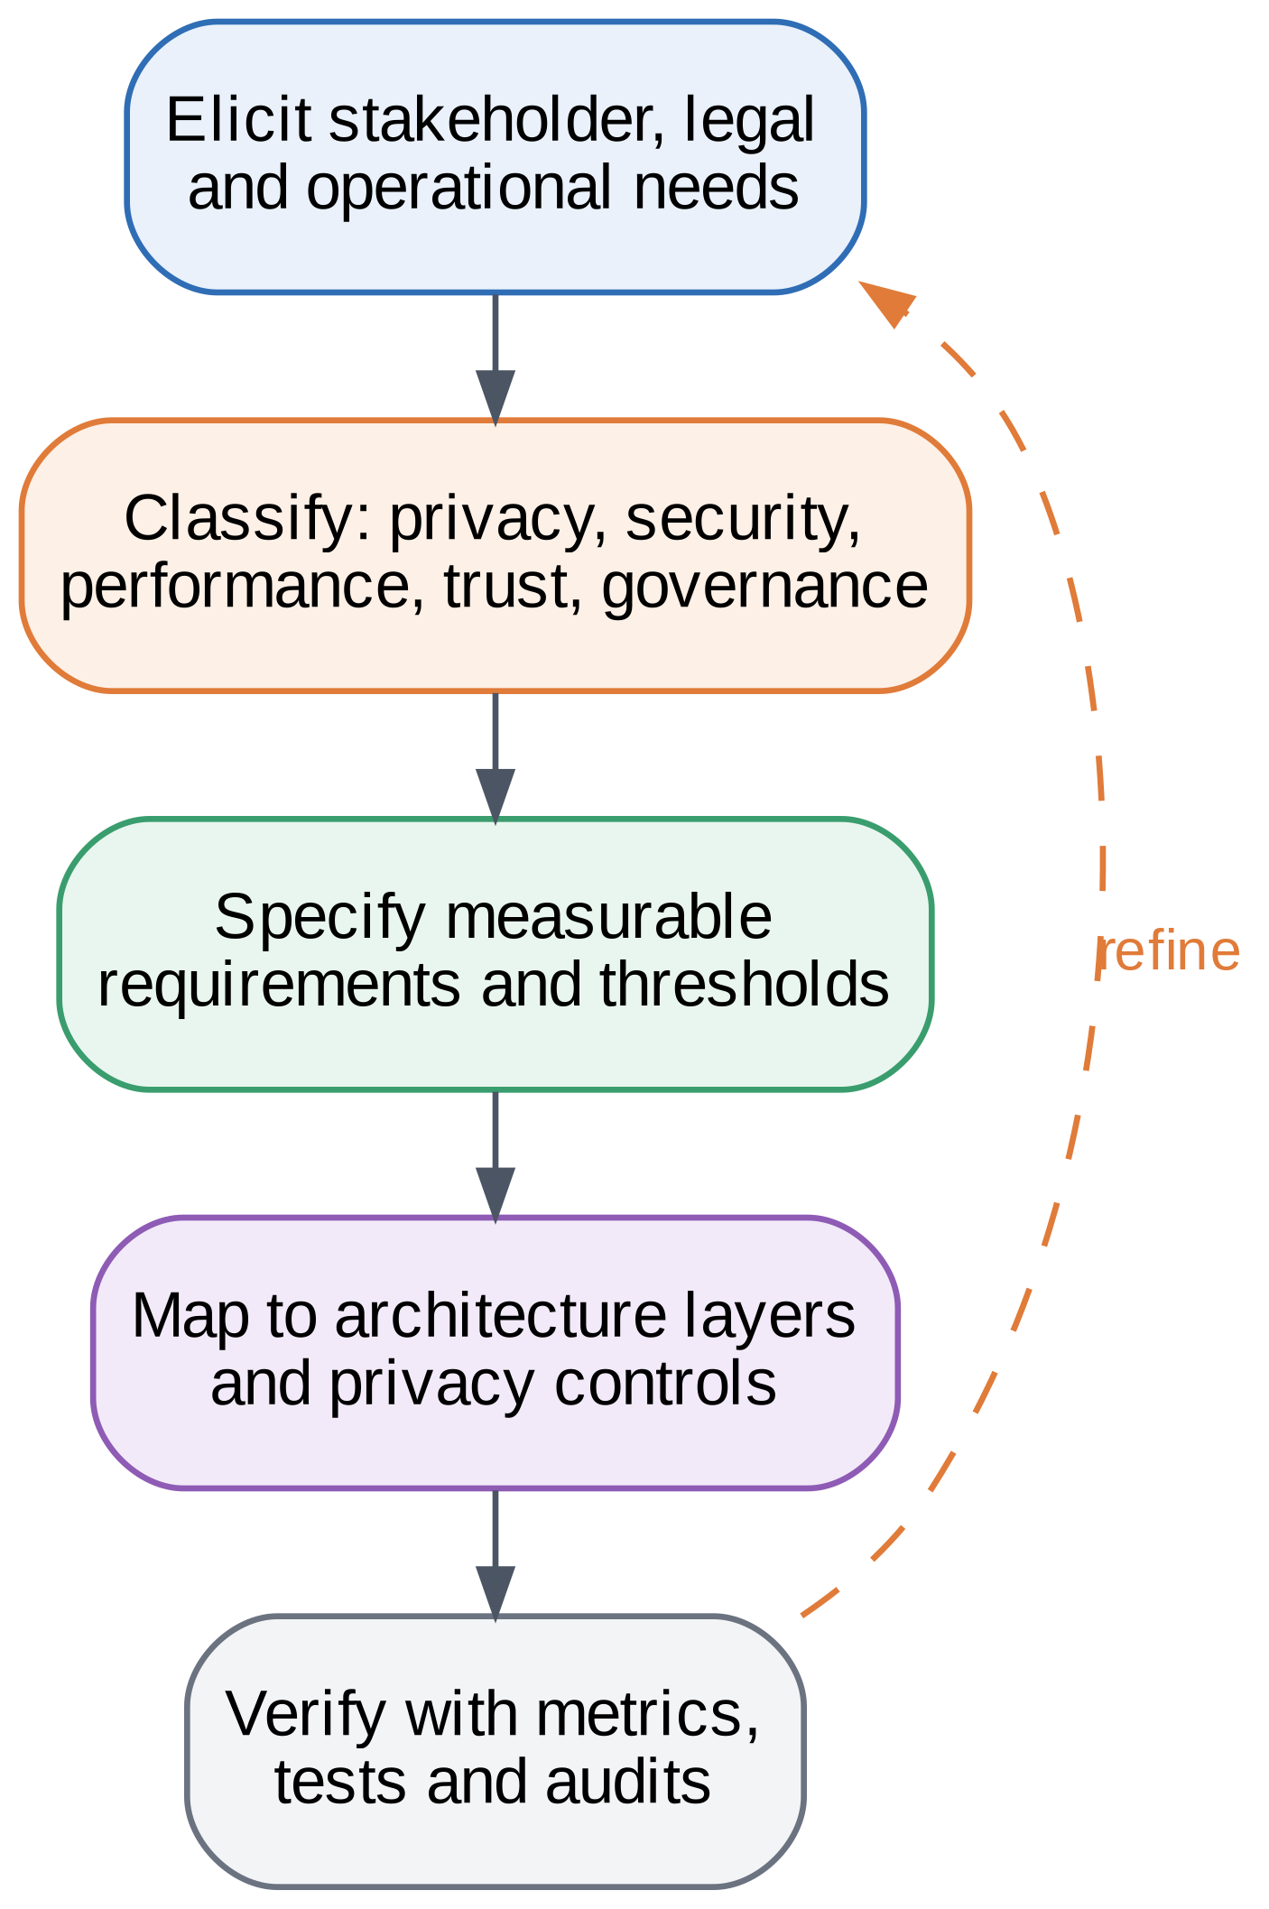
FIGURE 5. Requirements Engineering Framework.

4.1 Requirement classes
Privacy requirements demand data minimization, bounded leakage, and support for erasure. Security requirements cover authenticated and encrypted channels. Scalability and reliability requirements demand that the system works as clients join, leave, or fail. Latency requirements ask for local decisions when the network is slow. Explainability and trust requirements ask that model behavior can be inspected and summarized. Interoperability requires standard protocols and model formats. Governance requirements ask that policies be enforceable and auditable under the laws discussed in Sections 1.3 and 12.1 [3][10][11][12].

4.2 Requirements matrix
Table 4 lists functional and non-functional requirements with a measurable target and the layer that satisfies each one. Targets that depend on the deployment, for example latency bounds, are stated as parameters rather than fixed values.

TABLE 4. Functional and Non-Functional Requirements Matrix
ID | Requirement | Type | Measurable target | Layer
R1 | Keep raw data on the device | Functional | No raw record leaves the edge unless policy allows | L1, L2
R2 | Bound leakage from updates | Privacy | (ε, δ) reported for the worst-case client | L3
R3 | Protect links and storage | Security | Mutually authenticated encrypted channels; encryption at rest | L3
R4 | Aggregate without exposing updates | Functional | Masked sum equals plain sum within 10⁻⁹ | L4
R5 | Tolerate poisoned clients | Reliability | Accuracy loss reported at 10–40% malicious clients | L4
R6 | Meet application latency | Performance | Mean latency ≤ deadline (deployment parameter) | L1, L5
R7 | Scale with clients | Scalability | Round time reported for 5 to 80 clients | L4
R8 | Explain predictions | Explainability | Feature-level explanation per prediction | L6
R9 | Quantify trust | Trust | Six-pillar score per model version | L6
R10 | Support erasure | Governance | Contributor log per model; retrain or unlearn path | L7
R11 | Audit decisions | Governance | Every policy decision logged and exportable | L7
R12 | Interoperate | Interoperability | Open model formats and standard protocols | L2, L5

4.3 Trade-offs between requirements
Requirements conflict, and a design must say how it resolves them. Stronger privacy lowers accuracy, as Section 15 quantifies. Stronger robustness can reduce efficiency and can interfere with privacy noise. Lower latency favors local decisions, whereas higher accuracy may favor a larger cloud model. Secure aggregation improves confidentiality at a cost in computation that grows with the number of clients. The framework exposes these trade-offs through parameters, namely the noise multiplier, the aggregation rule, and the confidence threshold for offloading, and it reports the effect of each on the metrics defined in Section 14. A deployment then selects values that suit its risk appetite.

4.4 Traceability
Each requirement carries an identifier that is traced forward to a layer and a metric, and backward to a stakeholder need or legal duty. For example, requirement R2 (bounded leakage) traces back to the minimization and security duties in Table 7, forward to the accountant in Section 8, and is verified by the budget reported in Table 10. This traceability lets an auditor ask, for any control, which requirement it serves and what evidence shows that it works [70].

4.5 Verification approach
Each requirement in Table 4 is verified in one of three ways. Requirements with a numeric target, such as R2, R4, R5, and R7, are verified by measurement in the testbed, and their results are reported in Section 15. Requirements that describe a capability, such as R8 and R9, are verified by demonstration, for example by computing permutation importance and the trust score for each model version. Requirements that depend on organizational processes, such as R10 and R11, are verified by design review, because an emulated testbed cannot show that an audit trail is complete or that erasure requests are honored in practice. Table 12 records the gaps that remain, and Section 20 lists them among the limitations. Separating these three kinds of evidence prevents a design argument from being reported as a measured result [70].

5. PRIVACY-AWARE CLOUD–EDGE INTELLIGENCE ARCHITECTURE
Fig. 6 presents the core architecture and Fig. 7 gives a layered view. Data are acquired at the bottom, processed and protected on the way up, and used for decisions at the top, while a governance plane sets policy for every layer.
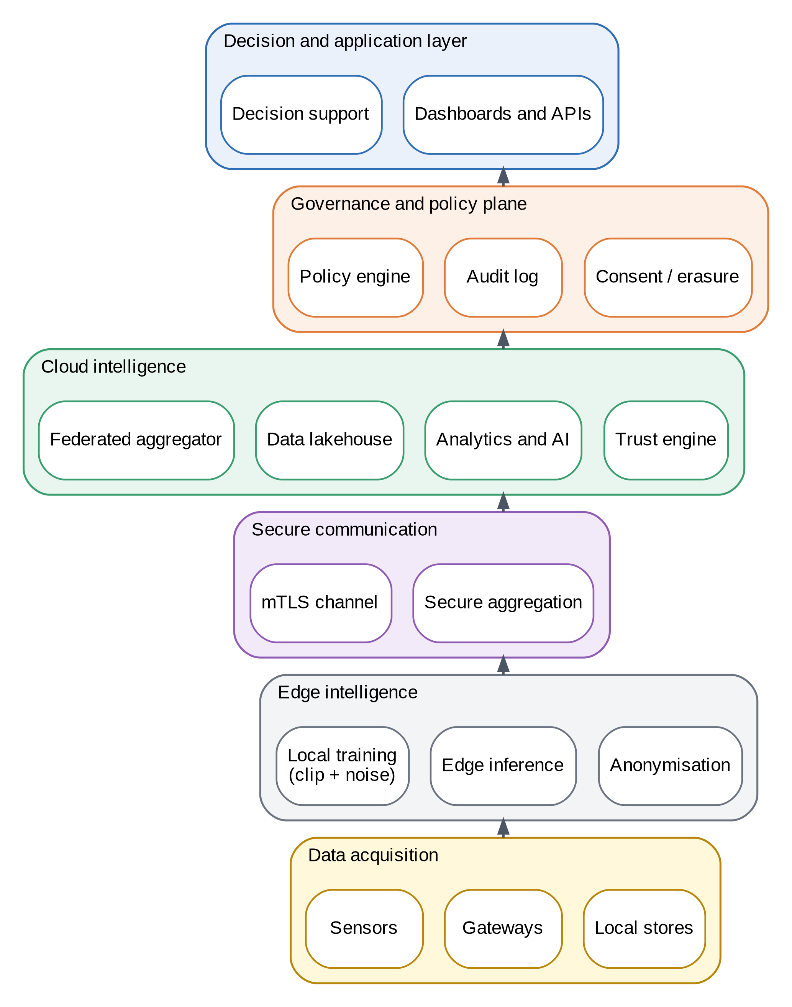
FIGURE 6. Privacy-Aware Cloud–Edge Intelligence Architecture for Distributed Data Science.

5.1 Layers and responsibilities
Layer 1 acquires and minimizes data and runs local intelligence on the device (Section 6). Layer 2 engineers data across edge and cloud (Section 7). Layer 3 protects data and computation with differential privacy, secure aggregation, encryption, and confidential computing (Section 8). Layer 4 runs federated analytics and learning (Section 9). Layer 5 provides cloud analytics and model operations (Section 10). Layer 6 explains models, scores trust, and supports decisions (Section 11). Layer 7 enforces policy and compliance (Section 12).
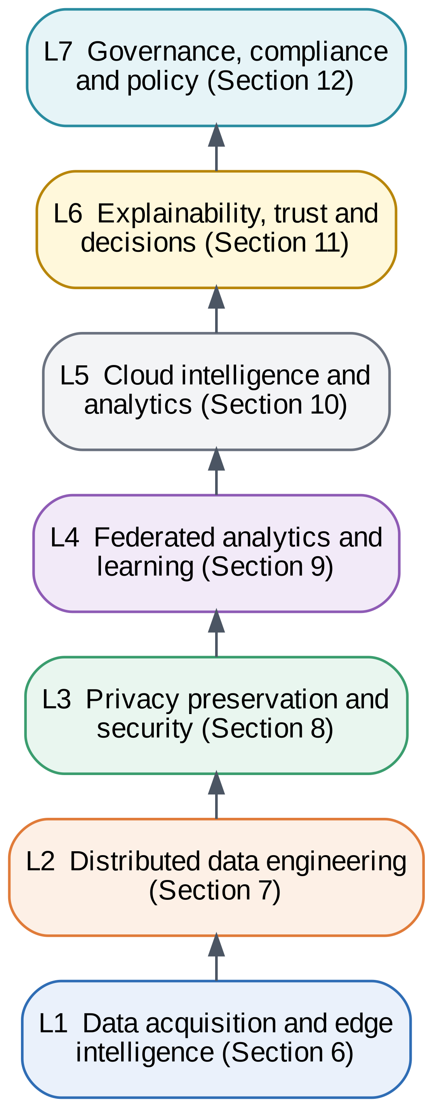
FIGURE 7. Multi-Layer Architectural View.

5.2 Design principles
Five principles guide the design. Data stay at the edge unless a policy allows otherwise. Whatever leaves a device is a clipped, noised, or masked artifact rather than raw data. Every release is accounted for, so the privacy cost can be reported. Failures degrade gracefully, with local fallback. Every control is observable and auditable. These principles follow the orchestration, resilience, and trust themes in the continuum and trustworthy-AI literature [5][9].

5.3 End-to-end walkthrough
Consider a reading from a roadside air-quality sensor. The sensor sends it to a street-level gateway, which validates and timestamps it and drops fields that the forecasting task does not need. A local model produces an estimate and a confidence. If the confidence is high, the gateway uses the result locally. If it is low, the gateway sends a compact feature vector to the regional cloud model, never the raw signal. Periodically, the gateway trains the local model on its own history, clips and perturbs the update, masks it, and sends it to the aggregator, which combines masked updates from many gateways and returns a new global model. Throughout, the policy engine checks that each flow matches a declared purpose and the audit log records the decision. The same pattern applies to hospital devices and plant machines, with different data and different policies.

5.4 Deployment options
The architecture supports three deployment patterns. In a single-owner pattern, one organization runs both the edge and the cloud, for example a utility with its own gateways, and the main protection is minimization and encryption. In a consortium pattern, several organizations, such as hospitals, keep their data and share a global model, so secure aggregation and differential privacy matter most. In a public-service pattern, devices belong to many individuals, and local differential privacy and strong consent controls become important [45]. The seven layers stay the same across patterns; what changes is the strength of the controls at each layer and who operates the aggregator.

5.5 Failure handling
Edges lose connectivity, clients drop out, and cloud services fail. The design keeps local inference available without the network, tolerates missing clients in a round by aggregating whoever responds, and retains the last good global model for rollback. Resilience studies in cloud, fog, and edge systems describe redundancy and graceful degradation as the main tools [79][80]. The dropout case needs care for secure aggregation, which Section 17 discusses.

5.6 Interfaces between layers
The layers communicate through a small set of interfaces, which keeps each one replaceable. Layer 1 passes minimized records and features to Layer 2 together with a purpose tag. Layer 2 passes training batches to the local trainer and features to the confidence router. Layer 3 receives local model updates and returns clipped, noised, and masked updates, together with the privacy cost of each step for the accountant. Layer 4 receives masked updates from many clients and returns a new global model, a contributor list, and an updated privacy budget. Layer 5 registers the model, serves offloaded requests, and publishes monitoring summaries. Layer 6 consumes predictions and test results and produces explanations and trust scores. Layer 7 sits beside all of them: every interface call is checked against a policy and recorded in the audit log.
Two properties follow from this arrangement. First, no interface carries raw records beyond the device unless a policy explicitly allows it, which implements requirement R1. Second, each interface produces evidence that a later layer or an auditor can check, such as the privacy cost of an update or the contributor list of a model version, which supports requirements R2, R10, and R11. Orchestration studies of the computing continuum recommend a similar separation of concerns so that components can be placed and replaced across tiers [5][35].

6. DATA ACQUISITION AND EDGE INTELLIGENCE LAYER

6.1 Acquisition and minimization
Sensors, wearables, cameras, and meters feed a gateway that translates protocols, checks data quality, and filters records, as shown in Fig. 8. The gateway then applies minimization and pseudonymization so that only the fields needed for the task are kept. Stream anonymization methods, such as those that relate to k-anonymity for data streams, and surveys of anonymization in IoT describe options for this step [53][54], and a cooperative data collection protocol shows how records can be gathered without a trusted central collector [55].
Data quality is a privacy issue as well as an accuracy issue. Records that are duplicated, out of range, or malformed waste storage and bandwidth, and they can leak identifiers through free-text fields. The quality filter therefore runs before anything is stored, and it logs the reason for every rejection so that data owners can see what was dropped. Minimization follows a purpose declaration: each task lists the fields it needs, and the gateway removes everything else. Coarsening, for example reducing a timestamp to the hour or a location to a grid cell, is often enough for analytics and lowers re-identification risk [53].
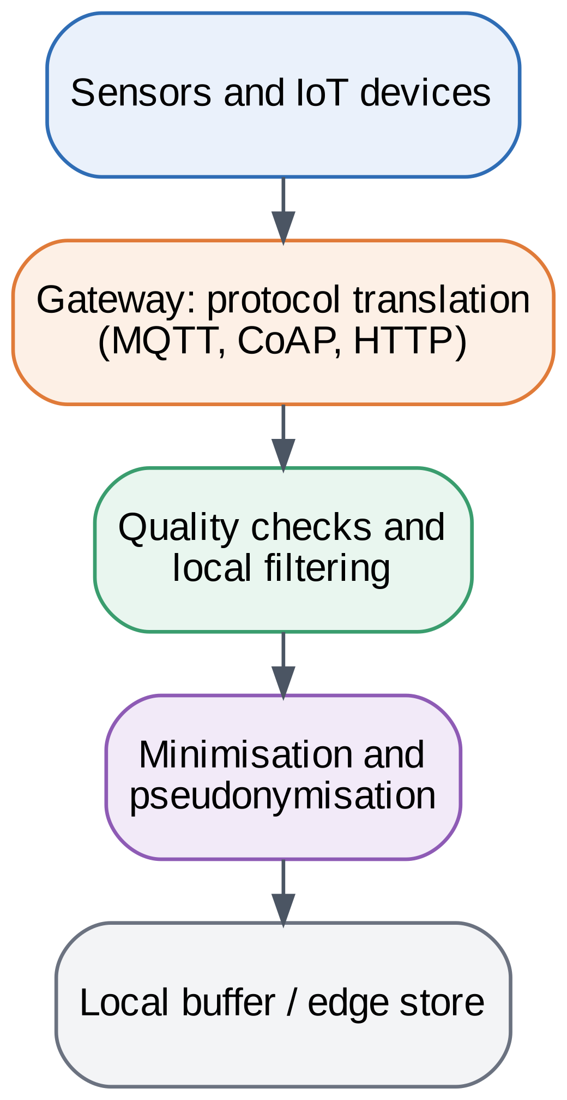
FIGURE 8. Edge Data Acquisition Framework.

6.2 Local intelligence
Edge nodes run compact models. Advances in tiny machine learning and the operational practice of TinyMLOps show how models are compressed, deployed, and monitored on constrained devices [31][32]. Our testbed uses a random-feature softmax classifier with 20.6 KB of parameters for the image task, small enough for a microcontroller-class device. Fig. 9 shows the processing pipeline. If the local model is confident, the device acts without any network traffic. If not, it sends extracted features, not raw data, to a larger cloud model.

6.3 Model sizing and routing
Model size determines where a model can run. In the testbed, the edge model has 2,570 parameters, or 20.6 KB at 64-bit precision, and the larger cloud model has 82 KB. Measured single-sample inference took 0.022 ms for the edge model and 0.058 ms for the cloud model on the testbed CPU, so for models this small the compute time is negligible and the network dominates. Real edge models are larger, so Section 15 also emulates a heavier model with 40 ms of edge compute. In both cases the routing rule is the same: compute the maximum class probability, act locally if it reaches a threshold τ, and otherwise send features to the cloud. Lowering τ keeps more requests local and exposes less data, whereas raising it improves accuracy at the cost of more offloading. Fig. 24(c) reports the trade-off that we measured.
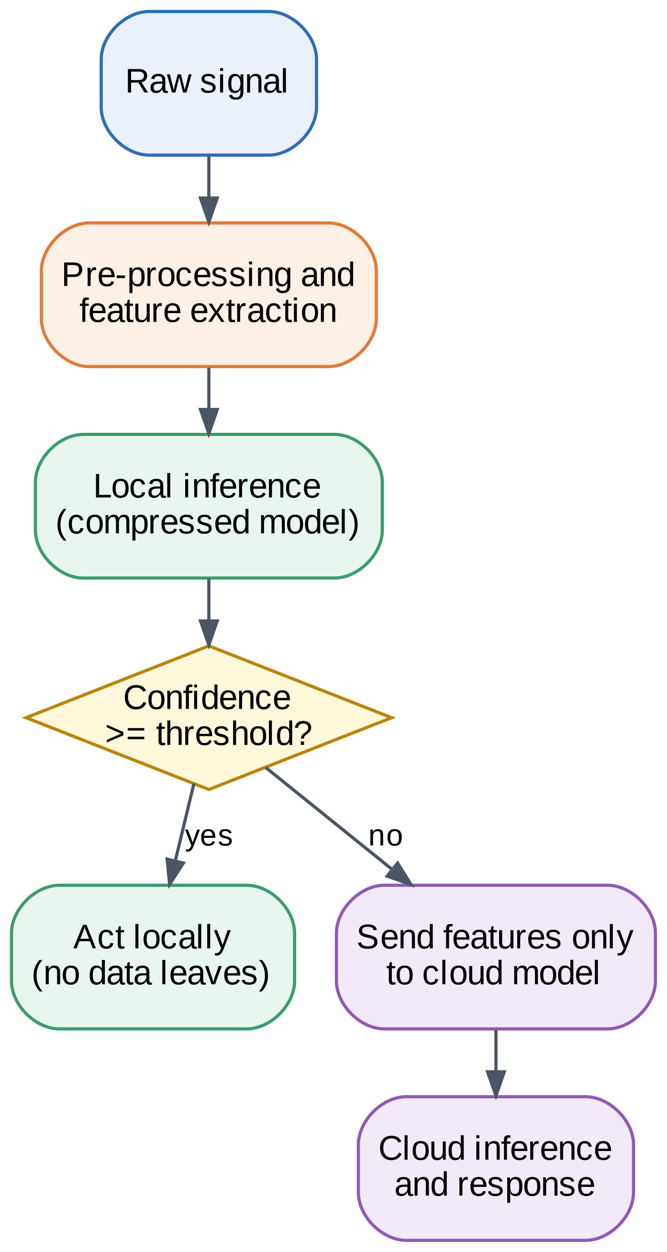
FIGURE 9. Edge Intelligence Processing Pipeline.

6.4 Edge analytics components
Table 5 lists the components of the edge analytics stack and their privacy roles. Studies of federated learning at the edge also stress that device heterogeneity and limited energy shape which components are feasible [7][30].
TABLE 5. Edge Analytics Components
Component | Function | Privacy role
Gateway | Protocol translation and routing | Single controlled exit point
Quality filter | Reject noisy or invalid records | Avoids storing useless data
Minimizer | Drop or coarsen unneeded fields | Data minimization
Pseudonymizer | Replace identifiers | Reduces re-identification
Feature extractor | Compute model inputs | Raw signal stays local
Edge model | Compressed local inference | No data sent when confident
Confidence router | Decide local or cloud | Sends features, not raw data
Local trainer | Clipped, noised gradient steps | Differential privacy
Update packer | Mask and send update | Secure aggregation

6.5 Energy and device constraints
Energy and memory budgets limit what the edge can do. Training costs more than inference, so devices may train only when plugged in or idle, a pattern discussed in surveys of federated learning at the edge [7][30]. Operational practice for small models adds monitoring and update mechanisms that fit these limits [32]. The framework therefore treats local training as optional per device: a device that cannot train still benefits from the global model and still protects its data by keeping them local. This makes the framework usable across heterogeneous fleets without forcing every device to meet the same requirements.

6.6 Local privacy at the device
Some deployments cannot trust even the aggregator to apply noise correctly, for example when devices belong to many individuals rather than to a few organizations. In that case each device can perturb its own data or statistics before they leave, which is local differential privacy [45]. Local privacy removes the need to trust the collector, but it requires much more noise for the same accuracy, because each device must hide its own contribution without the benefit of aggregation [45][47]. The framework supports it as an option at the gateway, for example for frequency counts sent to the city cloud, and keeps sample-level differential privacy in the local trainer as the default for model training, which is the setting evaluated in Section 15.

7. DISTRIBUTED DATA ENGINEERING LAYER

7.1 Ingestion and preparation
Fig. 10 shows the data engineering workflow. Streams and batches are ingested, validated, and deduplicated, then transformed into features that are stored in a feature store. A metadata and lineage catalogue records the origin, purpose, consent basis, and retention of every dataset, which makes later audits and erasure requests tractable [67][70].
The catalogue stores a small, fixed set of metadata for each dataset: its source and owner, the purpose and consent basis, the schema and sensitivity labels, the retention period, the transformations applied, and the models trained on it. These fields are the minimum an auditor needs to answer three questions: where did this data come from, why may we use it, and what depends on it [67][70]. Lineage links also support erasure, because a request about one person can be traced to the datasets and model versions that include that person's records.
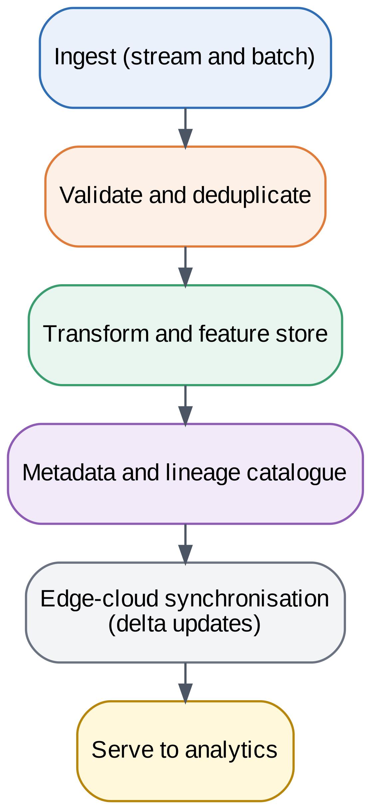
FIGURE 10. Distributed Data Engineering Workflow.

7.2 Edge–cloud synchronization
Edge and cloud copies of data and models must stay consistent without moving everything. Delta updates, versioned models, and policy-aware replication carry only what is needed. Studies of the edge-to-cloud continuum discuss how data movement and processing are placed across tiers [5][35], and Fig. 11 shows the data flow used here. Only features and masked updates cross the secure channel, and the global model flows back to the edge.
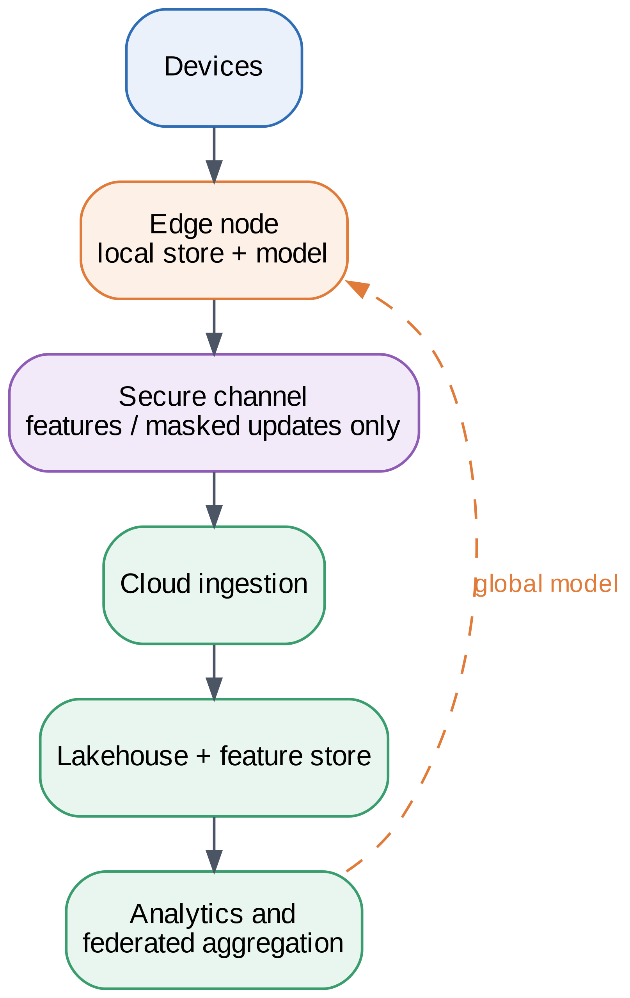
FIGURE 11. Edge-to-Cloud Data Flow Architecture.

7.3 Design guidance
Three practices make this layer privacy-aware. Purpose tags travel with data, so downstream jobs can be checked against consent. Schema validation rejects unexpected personal fields before storage. Developer tooling and privacy-by-design guidance reduce misconfiguration, a need noted in surveys of privacy-preserving IoT development [56].

7.4 Retention and deletion
Data that are kept longer than needed increase risk without adding value. Each dataset carries a retention period, and a scheduled job deletes or aggregates records that pass it. Deletion has to reach the feature store, backups, and any derived tables, which is why the catalogue records derived assets. In the business model of Section 19, the share of raw data held in the cloud and the number of months it is retained are the two inputs that drive storage cost and expected breach loss, so retention policy has both a legal and an economic effect.

7.5 Interoperability
Edge and cloud components come from different vendors, so the layer relies on open formats and protocols: standard message protocols at the gateway, open columnar formats in the lakehouse, and portable model formats for deployment. This keeps the framework from being tied to a single platform and lets the governance plane inspect data flows in a uniform way.

7.6 Data quality at scale
When thousands of devices contribute data, quality problems become a privacy and fairness problem as well as an engineering one. A device with a faulty sensor can bias its local model, and its update then affects the global model. The layer therefore applies the same validation rules at the gateway and in the cloud, records the share of rejected records per device, and flags devices whose rejection rate changes sharply. Because raw data stay at the edge, the cloud sees only these summaries, which can themselves be coarsened or noised before they are sent [45][53]. Schema changes are handled by versioning: a new schema is deployed to gateways together with the model that needs it, and records produced under the old schema keep their original tag so that lineage remains correct.

7.7 Lineage in federated settings
Lineage is harder when the training data never reach the cloud. The catalogue cannot list individual records held by clients, so it records lineage at the level of client and dataset version instead: for each global model version it stores which clients took part in each round, which dataset version each client declared, and the privacy cost charged to each client. This record answers the three audit questions of Section 7.1 at the granularity that federated learning allows, and it is the input that erasure handling needs, because retraining or unlearning starts from the list of affected clients and rounds [34][69]. Accountability approaches for federated learning recommend recording the same information as structured documentation for every training run [66].

8. PRIVACY PRESERVATION AND SECURITY LAYER
Fig. 12 organizes the privacy techniques by the level at which they act, and Table 6 compares them.
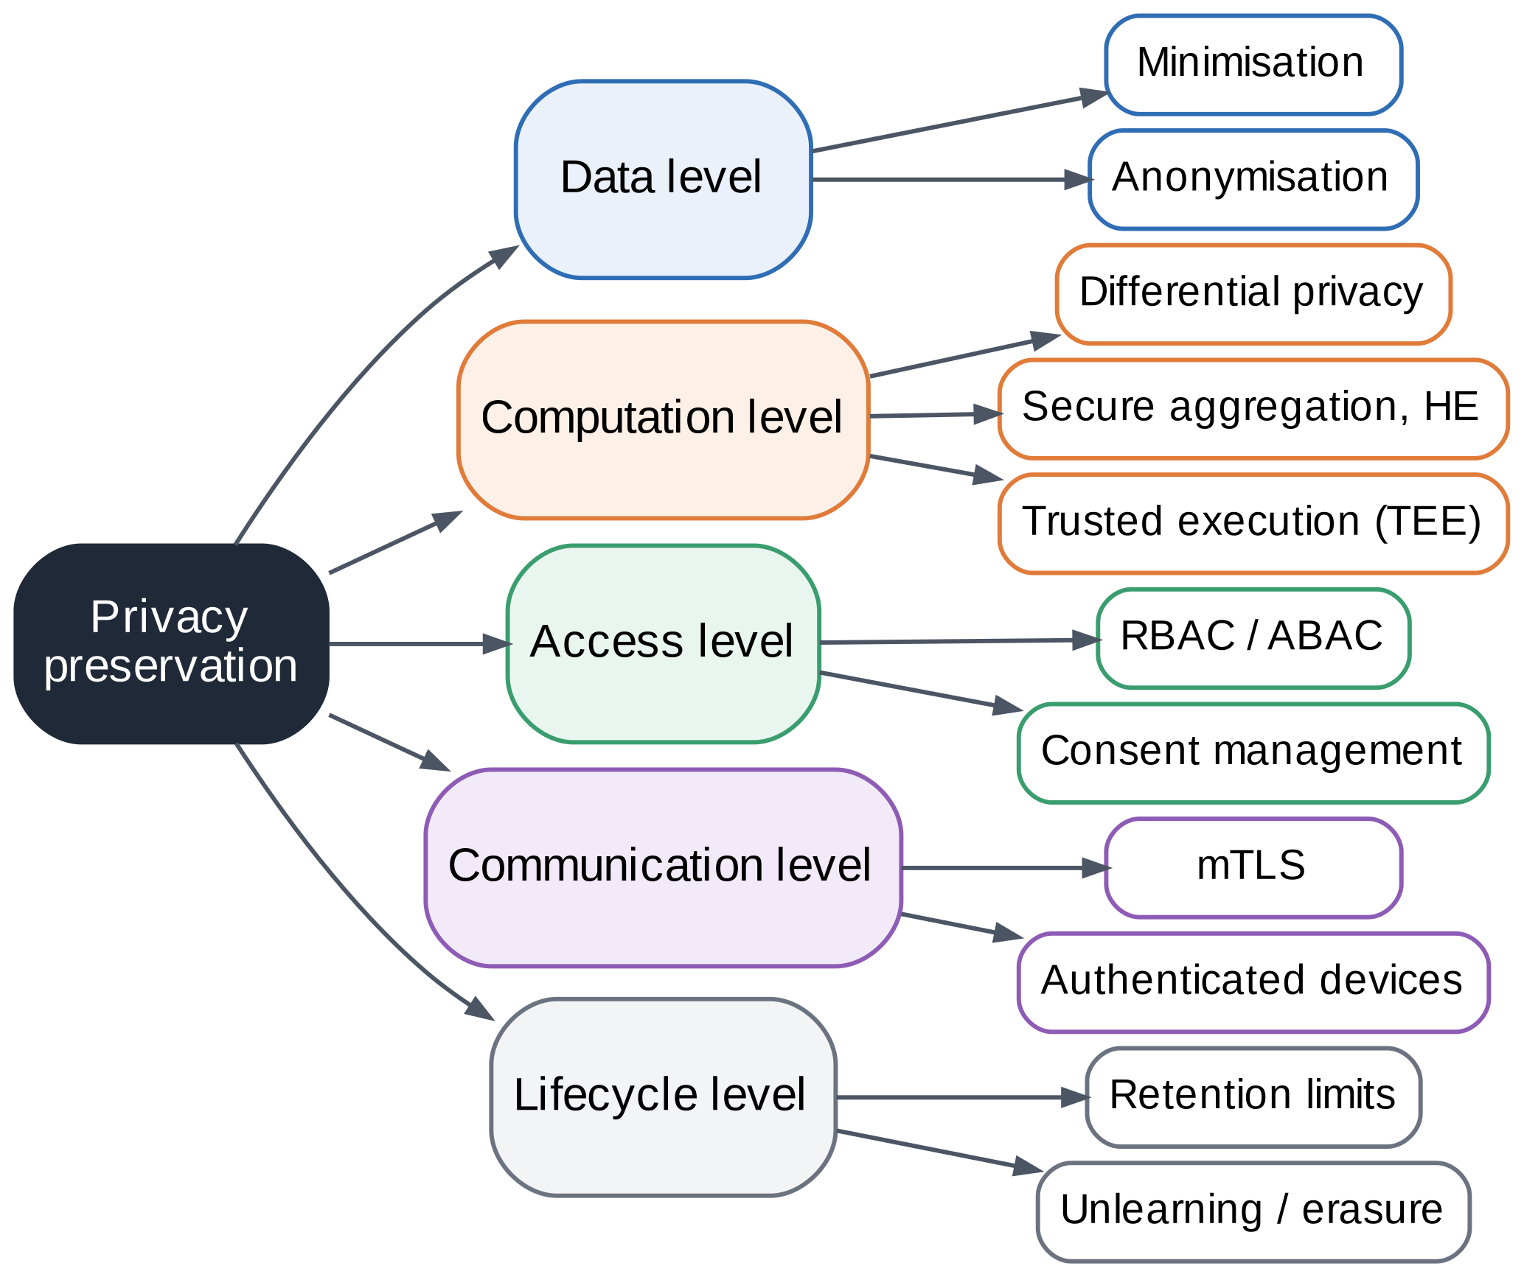
FIGURE 12. Privacy Preservation Framework.

8.1 Differential privacy at the client
Differential privacy bounds how much any single record can change an output [29]. We use the standard recipe for private training: clip each example’s gradient and add Gaussian noise to the sum [19]. With per-example gradient g_{i} and clipping norm C, the clipped gradient is given by (1), and the noisy step uses the batch B and noise multiplier σ as in (2).
$g_{i}^{clip}=\frac{g_{i}}{max\left(1,\frac{‖g_{i}‖₂}{C}\right)}$ (1)
$g_{priv}=\frac{1}{B}\left(\sum_{i∈B}{g_{i}^{clip}}+N\left(0,σ^{2}C^{2}I\right)\right)$ (2)
Local variants and edge-specific uses are reviewed in [45][46][47], and the optimization of differentially private federated learning is surveyed in [43][44].

8.2 Choosing the parameters
Three parameters control the privacy–utility trade-off. The clipping norm C limits each example's influence; if it is too small, useful gradient signal is cut, and if it is too large, the noise needed grows with it. We used C = 1. In the Digits testbed the per-example gradient norm at initialization has a median of 1.35, so every early step is clipped, whereas after differentially private training at σ = 1.0 the median is about 0.5 and roughly a fifth of the examples are still clipped (a three-seed check run separately from the saved experiments). The noise multiplier σ sets the noise relative to C: larger values give stronger privacy and lower accuracy, and our sweep covers σ from 0.8 to 3.0. The sampling rate q = B/n_{k} sets how much of a client's data are touched in each step; smaller rates give stronger accounting for the same σ. A practical procedure is to fix δ well below the inverse of the dataset size, pick the largest acceptable ε, and search σ for the best accuracy that meets it, which is the logic behind the sweep in Table 10.

8.3 Privacy accounting
We account for each release with Rényi differential privacy. For a Poisson sampling rate q, noise multiplier σ, and integer order α, the Rényi cost of one step of the sampled Gaussian mechanism is given by (3) and (4).
$ε_{α}=\frac{1}{α-1}\log{A_{α}}$ (3)
$A_{α}=\sum_{k=0}^{α}{C\left(α,k\right){\left(1-q\right)}^{α-k}q^{k}e^{\frac{k²-k}{2σ²}}}$ (4)
Here A_{α} is the sampled-Gaussian moment term and C(α, k) is the binomial coefficient. After T steps, the guarantee converts to (ε, δ) by taking the best order, as in (5). We report the worst case over clients, because the client with the least data has the largest sampling rate.
$ε=\min_{α}\left(Tε_{α}+\frac{\log\left(\frac{1}{δ}\right)}{α-1}\right)$ (5)

8.4 What the accountant does and does not cover
The accountant in (3) to (5) covers one training run in which each client uses sample-level differential privacy with Poisson sampling. It does not cover several tasks trained on the same data, which would require composing their budgets, nor does it protect a client as a whole, because client-level privacy needs a different sensitivity analysis. Our reported ε is the maximum over clients, which is conservative because the smallest client sees the highest sampling rate. Federated averaging itself costs no extra budget, since it is post-processing of already private updates [29]. These boundaries explain why budgets in Section 15 look large and why Section 20 lists client-level privacy as a limitation.

8.5 Cryptographic protection
Secure aggregation hides each update behind pairwise masks that cancel in the sum [20], and a systematization of knowledge compares cryptographic constructions, including threshold homomorphic encryption [48][49]. Fully homomorphic encryption is more general but costlier [50]. Trusted execution environments protect code and data while in use, as reviewed for the edge-to-cloud setting [51], with Intel SGX as a main example [52]. Its known vulnerabilities mean that enclaves complement, rather than replace, other controls [28].
The two mechanisms protect against different parties and work best together. Secure aggregation stops the server from reading any one client's update, but the aggregate it reveals can still carry information about contributors. Differential privacy limits that information but does not hide the individual update from a curious server unless the noise is large. Together they give a layered defense: the server sees only a sum, and the sum is itself noisy. Surveys of privacy and security in distributed cloud computing and of confidential computing present such layering as a common design pattern [3][51].

8.6 Secure communication and storage
Fig. 13 shows the secure channel and storage design. Edge nodes hold device identities and keys, communicate over mutually authenticated encrypted tunnels, pass through an access-controlled gateway, and write to encrypted storage whose keys are managed centrally, with an audit log. Looking ahead, post-quantum cryptography will need to replace today’s key exchange; surveys study this for edge computing and for constrained IoT devices [57][58][59].
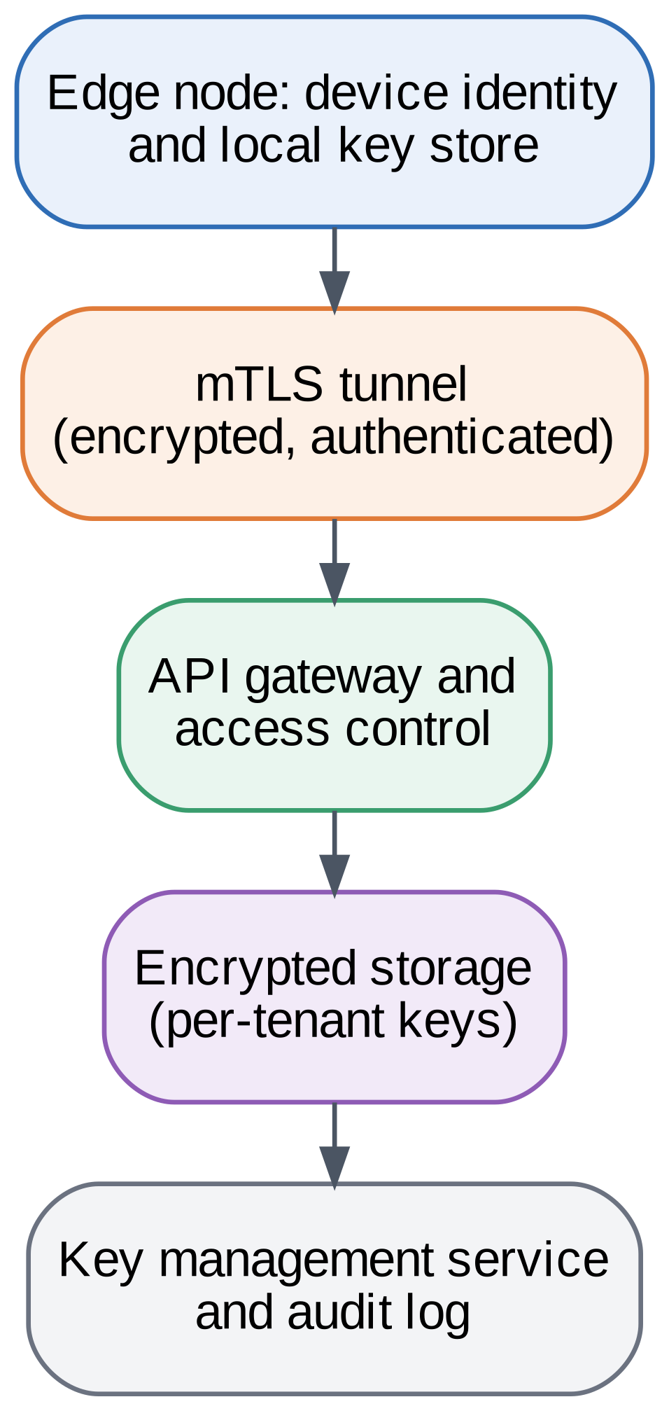
FIGURE 13. Secure Communication and Storage Architecture.

TABLE 6. Privacy Protection Techniques
Technique | What it protects | Cost or limitation | Evidence
Differential privacy | Individual records in training | Accuracy loss: 92.3% to 86.2% at σ = 1.0 (Digits) | [19][29][43][44]; Sec. 15
Local differential privacy | Data before collection | Larger utility cost than central DP | [45][46][47]
Secure aggregation | Individual updates from the server | Round time: plain averaging 9.2 ms at 5 clients and 14.8 ms at 80 clients; secure aggregation 9.5 ms at 5 clients and 349.0 ms at 80 clients (Section 15.2 scalability experiment). | [20][48][49]; Sec. 15
Homomorphic encryption | Data while computed on | High compute and memory cost | [50]
Trusted execution | Code and data in use | Side channels; hardware dependence | [28][51][52]
Anonymization of streams | Identifiers in released data | Utility loss; re-identification risk remains | [53][54][55]
Data minimization | Everything not collected | Needs purpose definitions | Sec. 6, 7
Unlearning | Past contributors on request | Exactness versus cost trade-off | [34][68][69]

9. FEDERATED ANALYTICS AND LEARNING LAYER

9.1 Architecture and workflow
Fig. 14 shows the federated analytics architecture and Fig. 15 shows one training round. The server sends the global model to clients, each client trains on private data, clips its update and adds noise, masks it, and returns it. The server sums the masked updates, the masks cancel, and the aggregate updates the global model. Federated averaging combines client models in proportion to their data size [18], as in (6), where n_{k} is the number of samples at client k and n is their total.
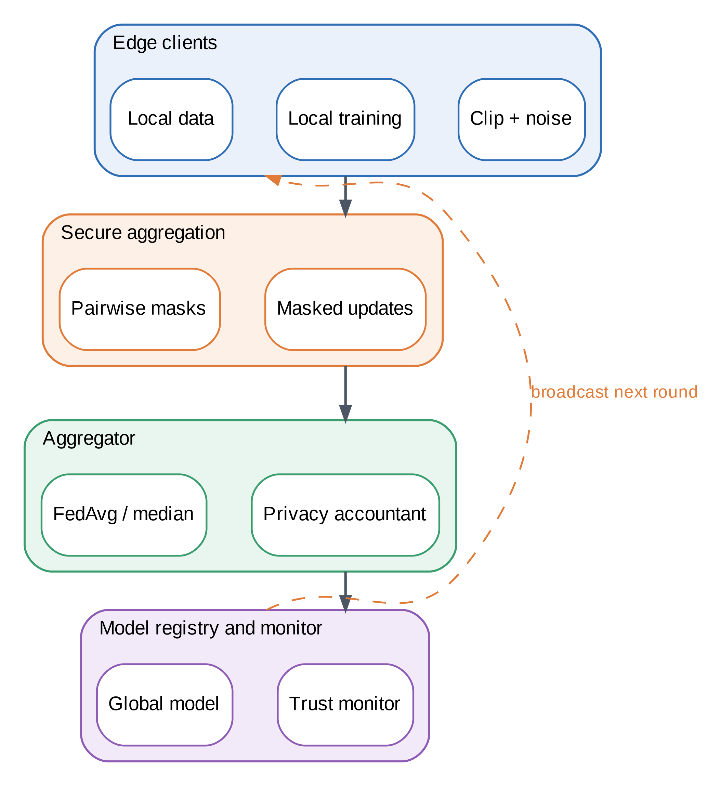
FIGURE 14. Federated Analytics Architecture.
$w_{t+1}=\sum_{k=1}^{K}{\frac{n_{k}}{n}w_{t+1}^{k}}$ (6)
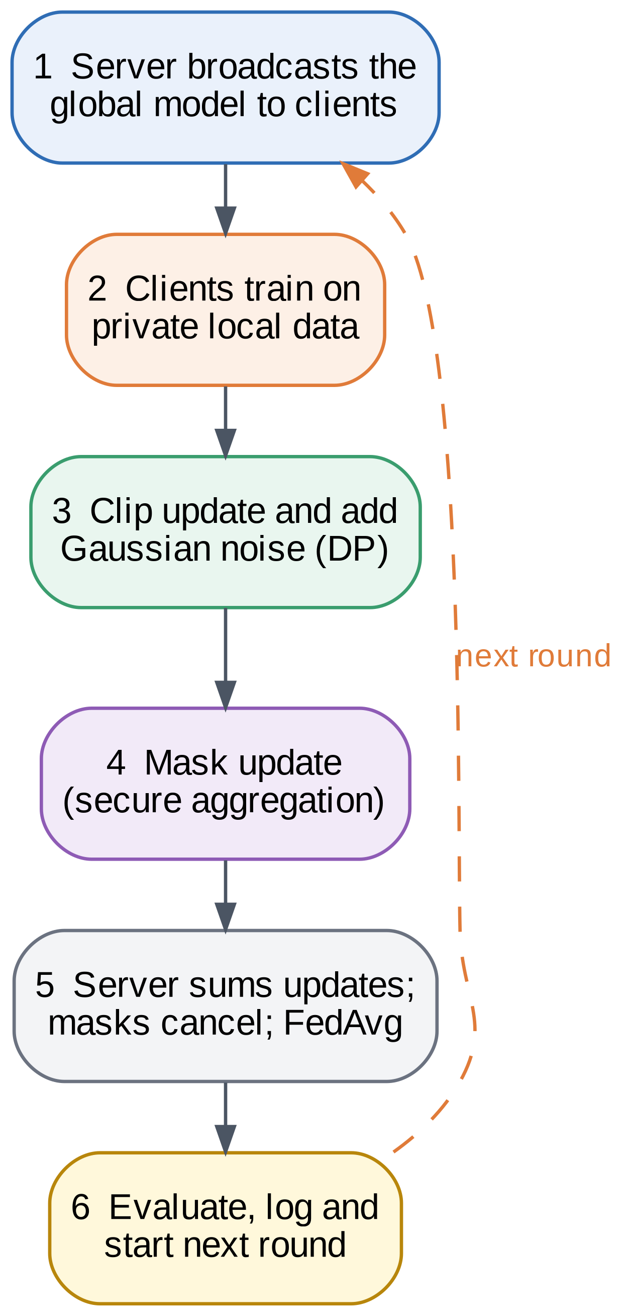
FIGURE 15. Federated Learning Workflow.

9.2 Algorithm summary
One round proceeds as follows.
- The server sends the current global model w_{t} to all clients that are available.
- Each client runs local steps on its own data. With privacy enabled, it samples a batch with rate q, clips per-example gradients, adds Gaussian noise, and updates its local copy.
- Each client forms its update and applies a pairwise mask before sending it.
- The server sums the masked updates, in which the masks cancel, and divides by the total weight to obtain the new global model.
- The server logs the round, tests the model on held-out data, and updates the privacy accountant.
The testbed runs 20 such rounds with one local epoch each. On Digits with 10 clients and 2,570 parameters, a round exchanges 2 × 10 × 2,570 × 8 = 411,200 bytes, so 20 rounds exchange 8.2 MB, as reported in Section 15.

9.3 Secure aggregation
With pairwise masks m_{ij}, client i sends a masked update y_{i}, which equals its true update x_{i} plus the masks shared with higher-indexed peers minus the masks shared with lower-indexed peers. Every mask appears once with each sign, so the masked updates sum to the true sum, as in (7). A production protocol also handles client dropouts and key agreement [20][48]; our simulation checks the cancellation property and the cost of the pairwise structure.
$\sum_{i=1}^{K}{y_{i}}=\sum_{i=1}^{K}{x_{i}}$ (7)

9.4 Robust aggregation
Plain averaging is vulnerable to poisoned updates. A coordinate-wise median, given by (8), tolerates a minority of bad clients at some cost in efficiency.
$w_{t+1,j}={median}_{k}\left\{w_{t+1,j}^{k}\right\}$ (8)

9.5 Heterogeneity and personalization
When client data differ strongly, a single global model fits some clients poorly. Our heterogeneity sweep shows worst-client accuracy falling from 87.8% to 66.2% as the Dirichlet parameter drops from 100 to 0.1. Standard remedies include fine-tuning the global model on each client, clustering clients with similar data, and training personalized heads on shared features [6][21]. Personalization also interacts with privacy, because local fine-tuning can use a separate budget or none at all if the personalized layers never leave the device. We did not evaluate personalization here and list it as future work.

9.6 Collaborative and split variants
When models are large, split learning places part of the network on the server, and reviews compare it to federated learning [39][40]. The right choice depends on device memory, bandwidth, and the privacy of intermediate activations. Frameworks and benchmarks help compare these choices on realistic testbeds [41][42]. When a client withdraws consent, unlearning methods remove its influence, a topic surveyed for federated settings [34].

9.7 Communication cost
Federated learning replaces one upload of raw data with repeated exchanges of model updates. The cost per round is 2 K |w| bytes for K clients and |w| parameters at 8 bytes each, and the total scales with the number of rounds. Compression, sparsification, and fewer rounds reduce the cost, and surveys of federated learning at the edge discuss these methods [2][7][30]. In our testbed the model is large relative to the dataset, so federated training moves 12.8 times as many bytes as a raw upload. The picture reverses when each device generates large volumes of data over time and the model stays fixed in size, which is the premise of the business model in Section 19.

9.8 Client participation
In the testbed every client takes part in every round, which is the simplest case. Real deployments sample a subset of the available clients in each round, because devices are offline, busy, or low on battery [7][30]. Partial participation changes three things. Convergence becomes slower and noisier, because each round sees only part of the data. The privacy accounting must include the probability that a client is selected, which can strengthen the guarantee through amplification by sampling but requires the selection to be genuinely random [43][44]. Secure aggregation must tolerate clients that drop out after the masks are agreed, which is why production protocols include mask recovery [20][48]. We kept full participation so that these effects do not confound the comparison, and Section 20 lists the missing dropout handling as a limitation.

10. CLOUD INTELLIGENCE AND ADVANCED ANALYTICS LAYER
Fig. 16 shows the cloud analytics framework. Streaming and batch ingestion feed a lakehouse and feature store, analytics engines process the data, a model lifecycle service trains and registers models, and a serving tier exposes inference and monitoring.
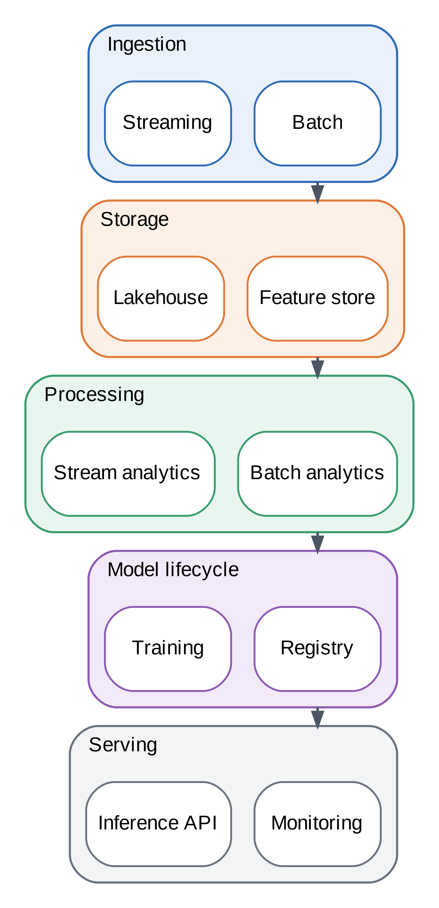
FIGURE 16. Cloud Analytics Framework.

10.1 Model registry and versioning
Every model that reaches the edge comes from a registry that stores its version, training data lineage, privacy accounting, test results, and approval status. Rollback is a registry operation, and so is the answer to an auditor who asks which model made a decision on a given date. For federated models, the registry also stores the list of contributing clients for each version, which is needed for erasure requests (Section 12). This record keeping is cheap relative to the cost of being unable to answer such questions [66].

10.2 AI model deployment
Fig. 17 shows the pipeline from features to monitored deployment. Models are validated for accuracy, privacy, and fairness before release, compressed for the edge, and deployed in stages with drift monitoring and retraining. Operational practice for small models is discussed in [32], and recent surveys describe how large language models are adapted to the edge and used for edge data analysis [8][14].
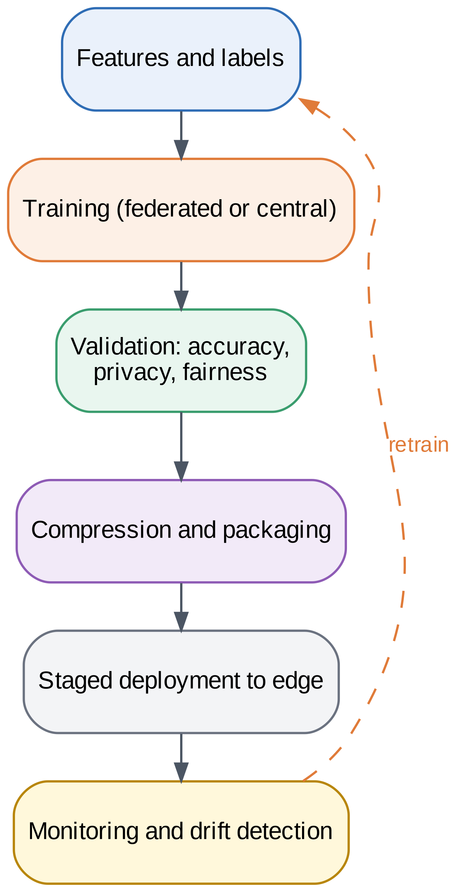
FIGURE 17. AI-Powered Intelligence Pipeline.

10.3 Large-scale and predictive analytics
Cloud-side analytics add value that edge devices cannot provide alone: forecasting across sites, anomaly detection on combined features, and benchmarking against historical data. In our hybrid policy the cloud also acts as a second opinion for low-confidence cases, as measured in Section 15. Frameworks for emulated edge testbeds help check such designs before field deployment [42].
Monitoring closes the loop. The cloud compares edge inputs and outputs against expectations, flags drift, tracks the trust score of each model version, and triggers retraining when quality drops. Because raw data stay at the edge, monitoring relies on summaries such as confidence histograms, class frequencies, and feature statistics, which can themselves be protected with noise. This differs from conventional cloud MLOps and is one reason why edge operations practice is still maturing [31][32].

10.4 Placement of cloud workloads
Not every analytics task belongs in the cloud. Tasks that combine many sites, such as cross-site forecasting or fleet-wide anomaly detection, need the cloud's view, whereas tasks that act on a single device's data, such as local alarms, are better kept at the edge, where they avoid network delay and exposure. The hybrid policy of Section 6.3 applies this principle per request: easy cases stay local, and only uncertain ones use the larger cloud model. In our routing experiment the cloud model scored 98.1% against 92.6% for the edge model, so the cloud adds accuracy, but only 24.4% of requests needed it. Studies of the total cost of ownership of edge and cloud deployments show that placement also changes cost, which Section 19 models explicitly [82].

10.5 Privacy of cloud-side services
Cloud services handle features, updates, and summaries rather than raw records, but these can still leak information. Offloaded feature vectors are derived from personal data and are therefore treated as personal data: they are encrypted in transit, processed only for the declared purpose, and not retained after the response is returned. Model updates reach the cloud only in aggregated, masked form, and the released global model carries the privacy accounting of its training run. Monitoring summaries are aggregated across devices before storage. Confidential computing can add a further layer by running the aggregator or the serving tier inside an enclave, although known side-channel attacks mean that this reduces rather than removes the need to trust the operator [28][51].

11. EXPLAINABILITY, TRUST, AND DECISION INTELLIGENCE LAYER

11.1 Explainability
Explainable AI methods help users understand what drives a prediction, and surveys of explainable AI for the IoT and for systems in general provide taxonomies and evaluation advice [60][61][62]. In federated settings, interpretability is harder because no party sees all the data, and recent work studies interpretable federated learning [63]. Fig. 18 shows the framework: outputs feed explainers, trust assessment, transparency reports, and human oversight.
In the testbed we use permutation importance, which measures how much accuracy drops when one input is shuffled. It is model-agnostic, works for a federated model because it needs only the final model and some test data, and is easy to explain to non-experts. Its weaknesses are that it can be noisy and can mislead when inputs are correlated, which is why we report it as a single, qualified run in Appendix A. In practice, an explanation service should also state how stable its explanations are across seeds and privacy settings [62].
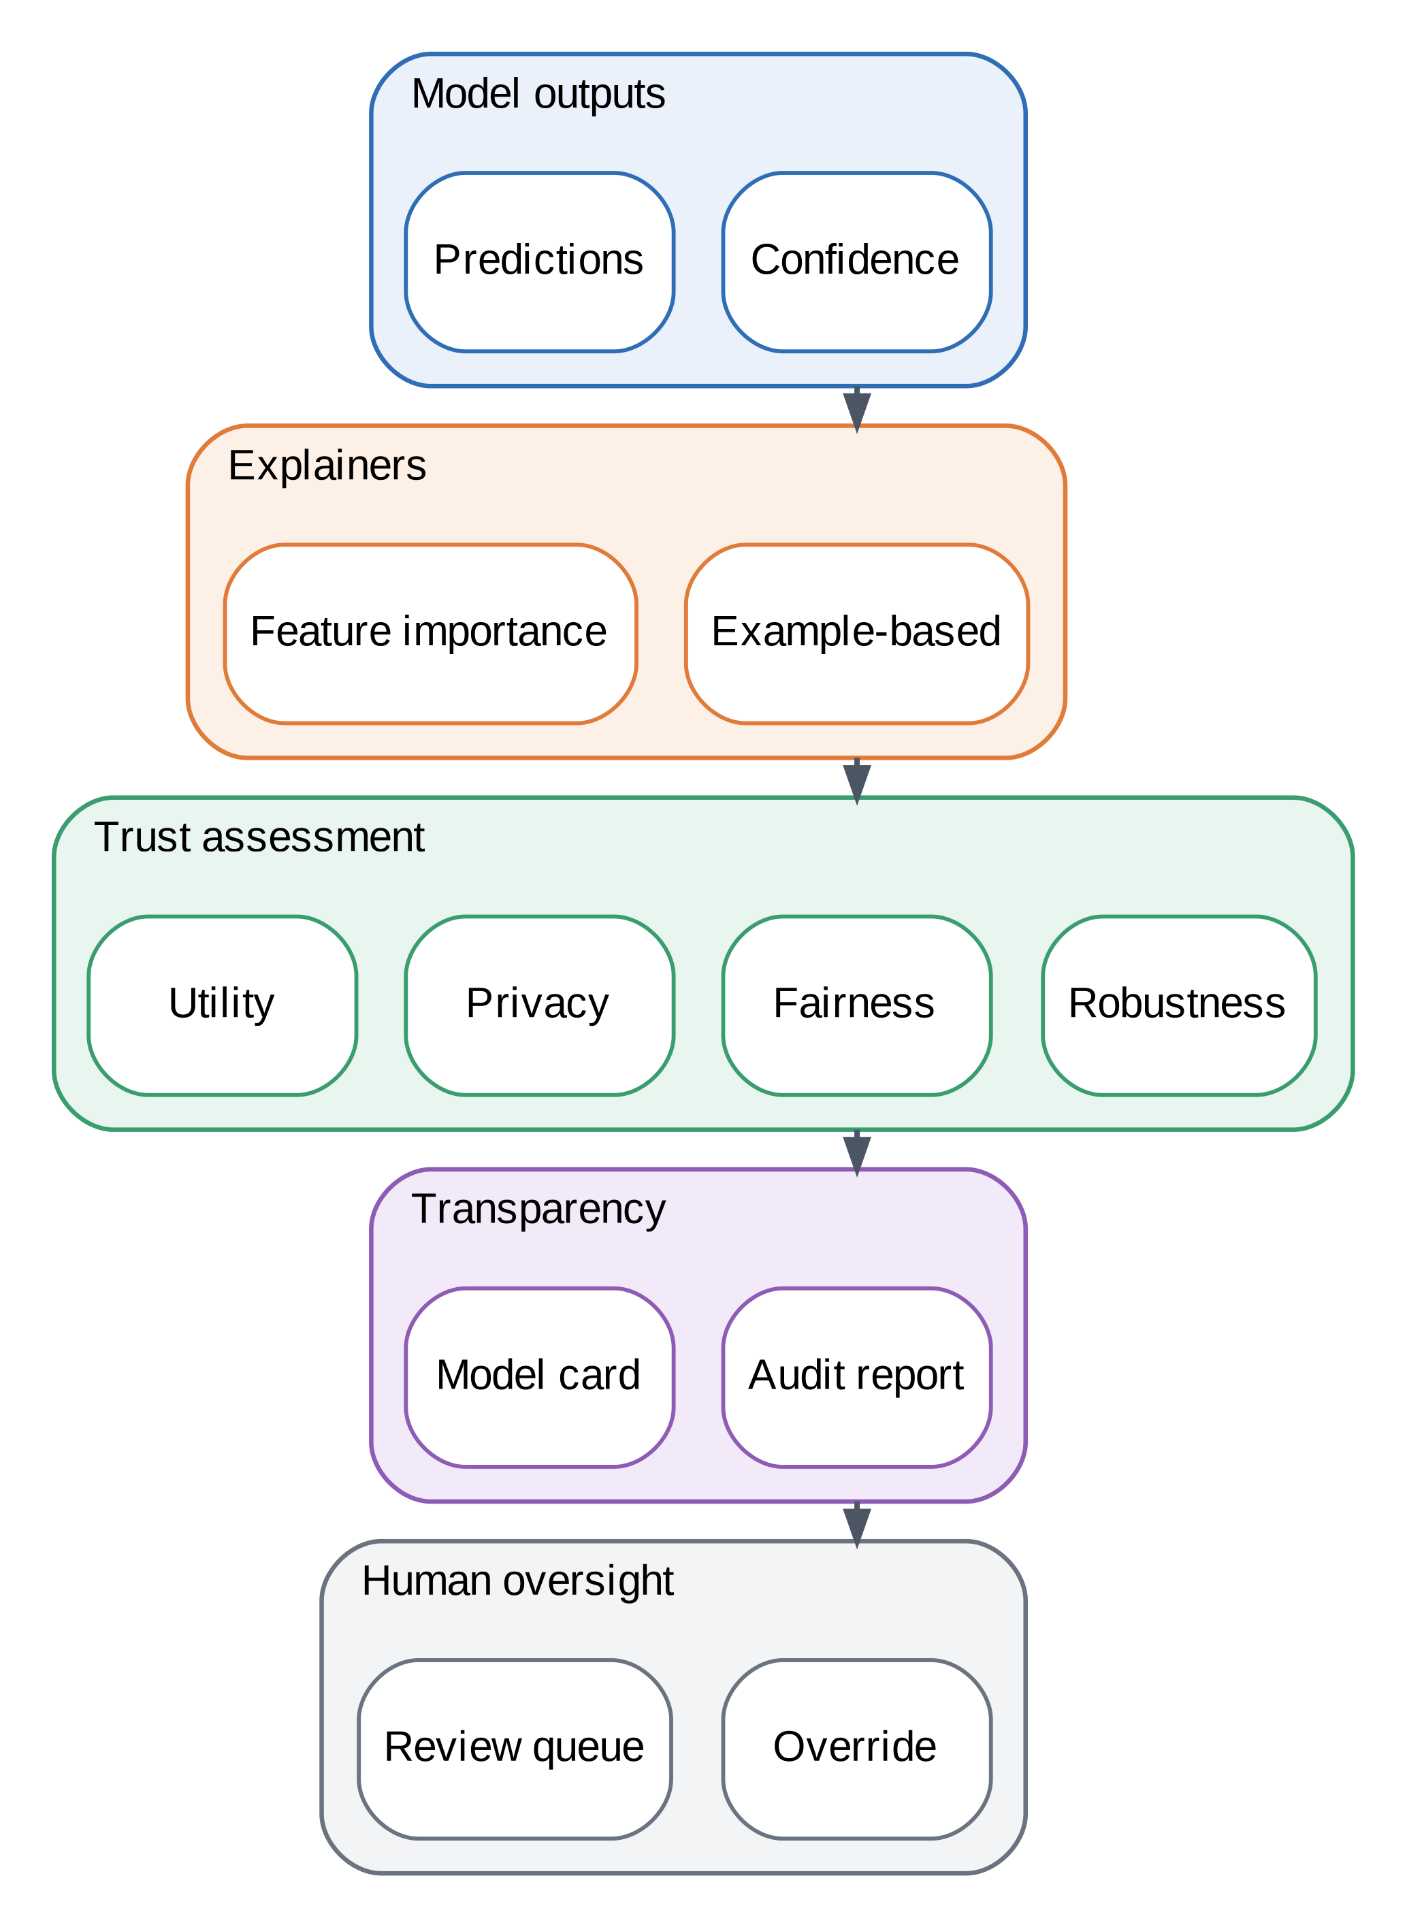
FIGURE 18. Explainability and Trust Framework.

11.2 Trust score
Trust management and trust evaluation for IoT systems are widely surveyed [64][65], and trustworthy edge and federated intelligence surveys name the pillars of security, robustness, fairness, privacy, and transparency [9][26]. We define a trust score as a weighted sum of six pillar scores, given by (9): utility, data minimization, formal privacy, fairness, robustness, and communication efficiency. Weights are non-negative and sum to one, and they can be set by policy.
$T=\sum_{i=1}^{6}{w_{i}s_{i}}$ (9)
The formal privacy pillar maps the privacy budget to a score through (10), where ε_{ref} is a reference budget (20 in our experiments) and ε = 0 gives 1 and an unbounded budget gives 0. This mapping is a modeling choice, and Section 20 discusses its limits.
$s_{priv}=e^{-\frac{ε}{ε_{ref}}}$ (10)

11.3 Pillar definitions
The six pillars are defined from measurements that the testbed already produces, so that the score can be recomputed by anyone who runs the code.
- Utility is the test accuracy of the global model.
- Data minimization is the share of raw data that never leaves the device: 0 for the centralized cloud and 1 for all other systems.
- Formal privacy is given by (10) from the Rényi-accounted ε, with 1 for ε = 0 and 0 when no bound exists.
- Fairness is the lowest accuracy over clients, each measured on that client’s own test slice. Local-only edge models are scored with each client’s own model, so this pillar can exceed their utility, which is measured on the pooled test set.
- Robustness is accuracy with 20% label-flipping clients divided by clean accuracy, both taken from the robustness experiment of Section 15.4, which uses Dirichlet α = 1.0.
- Communication efficiency is the raw-data size divided by the bytes exchanged, capped at 1.
These definitions are simple on purpose. They make the score transparent, but they also make it blunt, and Section 16 shows that the order of the other systems is sensitive to the weights.

11.4 Decision intelligence
Fig. 19 shows how predictions, explanations, and trust scores feed policy rules, recommendations, and dashboards, with feedback from outcomes. A trust-aware policy can, for example, route a low-trust prediction to a human reviewer or to the cloud model. The research agenda for trustworthy and sustainable edge AI motivates this human-in-the-loop design [27].
The decision layer also records what was decided and why. A decision record holds the prediction, the explanation, the trust score of the model version, the policy that applied, and any human override. These records feed the audit trail of Section 12 and supply the outcome feedback that retraining needs. Because the records may themselves contain personal data, they follow the same retention and access rules as other data.
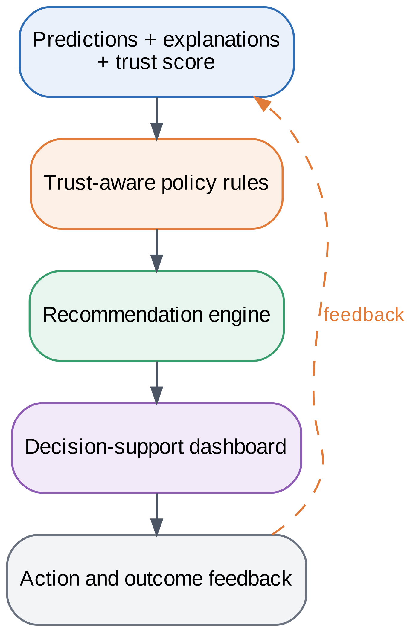
FIGURE 19. Decision Intelligence Architecture.

12. GOVERNANCE, COMPLIANCE, AND POLICY ENFORCEMENT LAYER

12.1 Regulatory landscape
Three laws shape the design: the GDPR [10], India’s Digital Personal Data Protection Act 2023 [11], and the EU AI Act [12]. They require lawful processing, purpose limitation, data subject rights such as erasure, and risk-based controls for AI systems. A compliance-by-design view turns each duty into a requirement and then into a control, as in Table 7. Interaction patterns for regulatory compliance in federated learning give reusable templates [33].
The laws differ in scope, but their duties overlap enough to share controls. All three expect that personal data be processed for stated purposes, kept secure, and handled accountably, and the AI Act adds obligations that depend on the risk class of the system [10][11][12]. Rather than building separate pipelines per law, the governance layer expresses each duty once as a policy and tags each policy with the laws it supports. This keeps the control set small and makes it easier to see which controls serve several laws.

12.2 Policy enforcement and audit
Fig. 20 shows the governance architecture. Regulations become policy-as-code, enforcement points at the edge, gateway, and cloud apply the policies, and an audit trail records decisions for compliance reports. A study of GDPR-compliant user data policies for IoT shows how consent and purpose can be encoded [67], and an accountability approach for federated learning proposes structured documentation to make training reproducible and auditable [66].
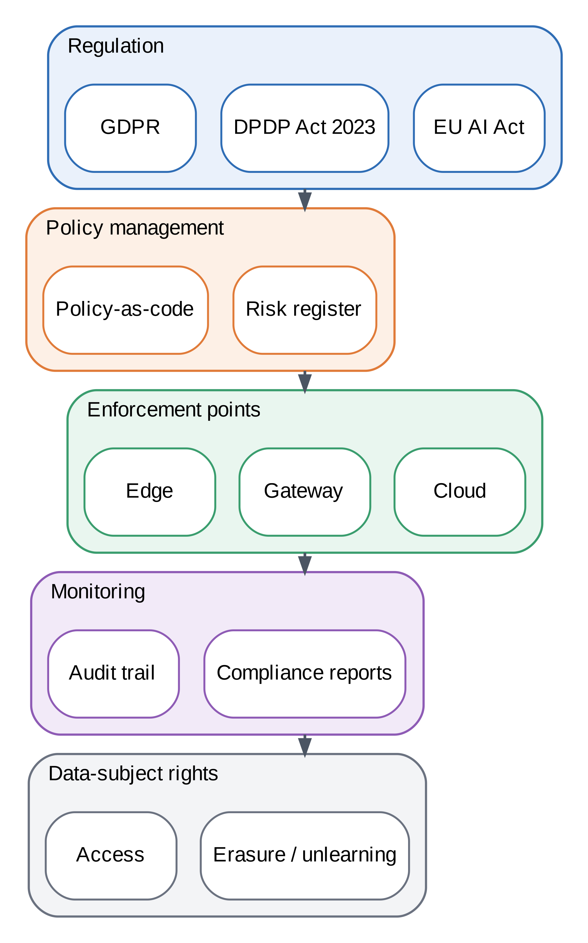
FIGURE 20. Governance and Compliance Architecture.

12.3 Data subject rights
Erasure is the hardest right for learned models. Machine unlearning surveys describe methods for removing the influence of data from a model [68], and federated unlearning surveys extend the topic to the case where data never leave clients [34][69]. The governance layer therefore stores which clients contributed to which model version, so that erasure requests can be handled by retraining or by an unlearning method.

12.4 Roles and responsibilities
Governance works only if people own it. The data owner defines purposes and consent. The platform operator runs enforcement points and keeps keys. The model owner is accountable for each model version, including its trust score and documentation. A compliance officer reviews audit reports and handles data subject requests, and an independent reviewer samples decisions and tests controls. Table 7 names the control for each duty, and this section names the role that runs it.

12.5 Audit evidence
Evidence has to exist before an audit asks for it. The platform therefore keeps four kinds of records: policy versions and their effective dates, data flows with their purposes, model versions with their accounting and test results, and data subject requests with their handling. Structured documentation of the training process, as in accountability approaches for federated learning, makes these records reproducible rather than anecdotal [33][66]. The audit trail should be append-only and protected from the operators it audits.

12.6 Compliance monitoring
Compliance is not a one-time check, because data flows, models, and laws change. The governance layer therefore runs continuous checks that compare actual behavior with declared policy: flows whose purpose tag does not match a registered purpose are blocked and logged, model versions whose privacy budget exceeds the approved limit cannot be promoted in the registry, and datasets that pass their retention period are flagged for deletion. A periodic report summarizes these events for the compliance officer, together with the status of open data subject requests. The AI Act adds obligations that depend on the risk class of a system, so the report also records the class assigned to each deployed model and the controls that the class requires [12]. In this study these checks are specified but not automated, which Table 12 lists as a remaining gap.

TABLE 7. Governance Controls and Compliance Requirements
Duty (summary, not legal advice) | Technical control | Layer | Evidence or reference
Lawful basis and consent | Consent tags in the metadata catalogue | L2, L7 | [10][11][67]
Purpose limitation | Purpose checks in the policy engine | L2, L7 | [67][70]
Data minimization | Gateway minimization; raw data stay local | L1 | Sec. 6
Security of processing | Encrypted channels and storage, secure aggregation, DP | L3 | Sec. 8, 15
Rights of access, correction, erasure | Contributor log; retrain or unlearning | L7 | [34][68][69]
Accountability and records | Audit trail; structured model documentation | L7 | [33][66]
Risk management for AI systems | Trust score, robustness tests, human oversight | L6, L7 | [9][12]
Transparency | Explanations and model documentation | L6 | [60][62]
Cross-border transfers | Keep data at the edge region; policy-as-code | L7 | [10][11]

13. EXPERIMENTAL SETUP

13.1 Testbed and datasets
All experiments run in a single-process emulation of edge clients and a cloud aggregator, shown in Fig. 21. We used two public datasets that ship with scikit-learn. The Digits dataset contains 1,797 images of 8 × 8 handwritten digits in 10 classes, split 70/30 into 1,257 training and 540 test samples across 10 clients. The Breast Cancer Wisconsin diagnostic dataset contains 569 samples with 30 clinical features in 2 classes, split into 398 training and 171 test samples across 5 clients. Training data were divided across clients with a Dirichlet distribution over classes (α = 0.5 for Digits, α = 1.0 for Breast Cancer), which creates the non-identical client distributions typical of the edge [21].
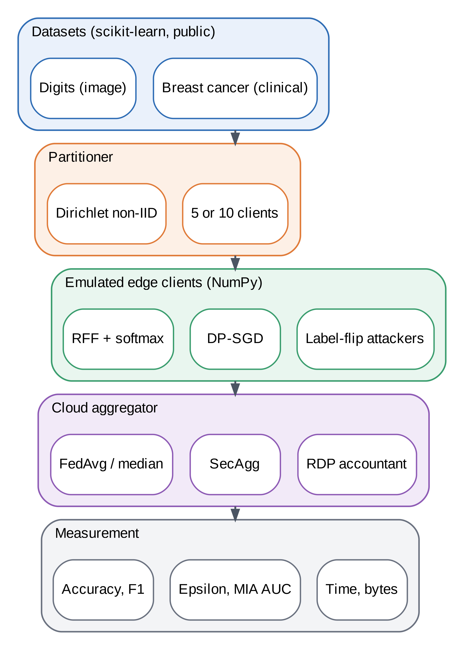
FIGURE 21. Experimental Testbed Architecture.

13.2 Model and training
The model is a random-Fourier-feature map followed by a softmax classifier, with 256 features for Digits (2,570 parameters, 20.6 KB) and 128 features for Breast Cancer (258 parameters). Its loss is convex and its per-example gradients have a closed form, so per-example clipping is exact and simple to implement. Training ran for 20 rounds with one local epoch, batch size 16, and a learning rate of 10 without privacy and 5 with privacy. Differentially private runs used a clipping norm of 1 and noise multipliers from 0.8 to 3.0, with δ = 10⁻⁵. Each result is the mean of three seeds, which vary the data split, partition, feature map, and sampling. Table 8 lists the configuration.
TABLE 8. Experimental Configuration Details
Parameter | Digits | Breast Cancer
Samples / features | 1,797 / 64 | 569 / 30
Classes | 10 | 2
Train / test | 1,257 / 540 | 398 / 171
Clients | 10 | 5
Dirichlet α | 0.5 | 1.0
Feature map | 256 random Fourier | 128 random Fourier
Parameters | 2,570 (20.6 KB) | 258
Rounds / local epochs | 20 / 1 | 20 / 1
Batch size | 16 | 16
Learning rate | 10 (no DP), 5 (DP) | 10 (no DP), 5 (DP)
Clipping norm C | 1.0 | 1.0
Noise multiplier σ | 0.8, 1.0, 1.5, 2.0, 3.0 | same
δ | 10⁻⁵ | 10⁻⁵
Seeds | 0, 1, 2 | 0, 1, 2

13.3 Compared systems and limits of the testbed
We compared a centralized cloud model, local-only edge models, federated averaging, federated averaging with simulated secure aggregation, and differentially private federated averaging with secure aggregation. Federated learning benchmarks and frameworks for real edge testbeds exist [41][42], and a study of data privacy on edge systems shows how to measure it on real hardware [47]. Our emulation measures computation on one CPU and models the network analytically, so latency and throughput results in Section 15 are emulated, not measured on devices.

13.4 Implementation and reproducibility
The testbed is implemented in Python with NumPy, SciPy, and scikit-learn. The core library provides the random-feature model, Dirichlet partitioning, per-example clipped training with Poisson sampling, the Rényi accountant, federated and median aggregation, simulated secure aggregation, and the membership attack. A separate script runs every experiment and writes all results to a structured file, another script generates every figure at 600 dpi, and a log records the execution. Randomness comes from seeded generators, so a run with the same seed gives the same accuracy, privacy, and attack results; only timing measurements vary with hardware and load. Table 15 lists the environment, and the repository contains the exact entry points.

13.5 Why a small testbed
We chose a deliberately small, convex setup for three reasons. First, exact per-example gradient clipping is simple for a softmax model, so the privacy accounting matches the code exactly. Second, the data ship with scikit-learn, which removes download and licensing questions and lets anyone rerun the study in minutes. Third, a small model makes the cost of each mechanism visible without the confounding effect of tuning a deep network. The price is limited external validity, which Section 20 discusses openly.

13.6 Fairness of the comparison
All compared systems share the same data splits, client partitions, feature maps, model, and number of passes over the data, so the differences in Table 10 come from the training procedure rather than from the setup. The centralized model trains on the pooled training set for 20 epochs, matching the 20 rounds of one local epoch used by the federated models, and the local-only models train for the same number of epochs on their own client's data. The differentially private runs use a lower learning rate than the non-private runs (5 instead of 10), because the added noise makes large steps unstable; this choice was made in preliminary runs, as Section 20.2 notes. Communication and timing are measured in the same process for every system, so they are comparable with each other but not with real networks.

14. EVALUATION METRICS
Fig. 22 shows the evaluation framework and Table 9 defines each metric.
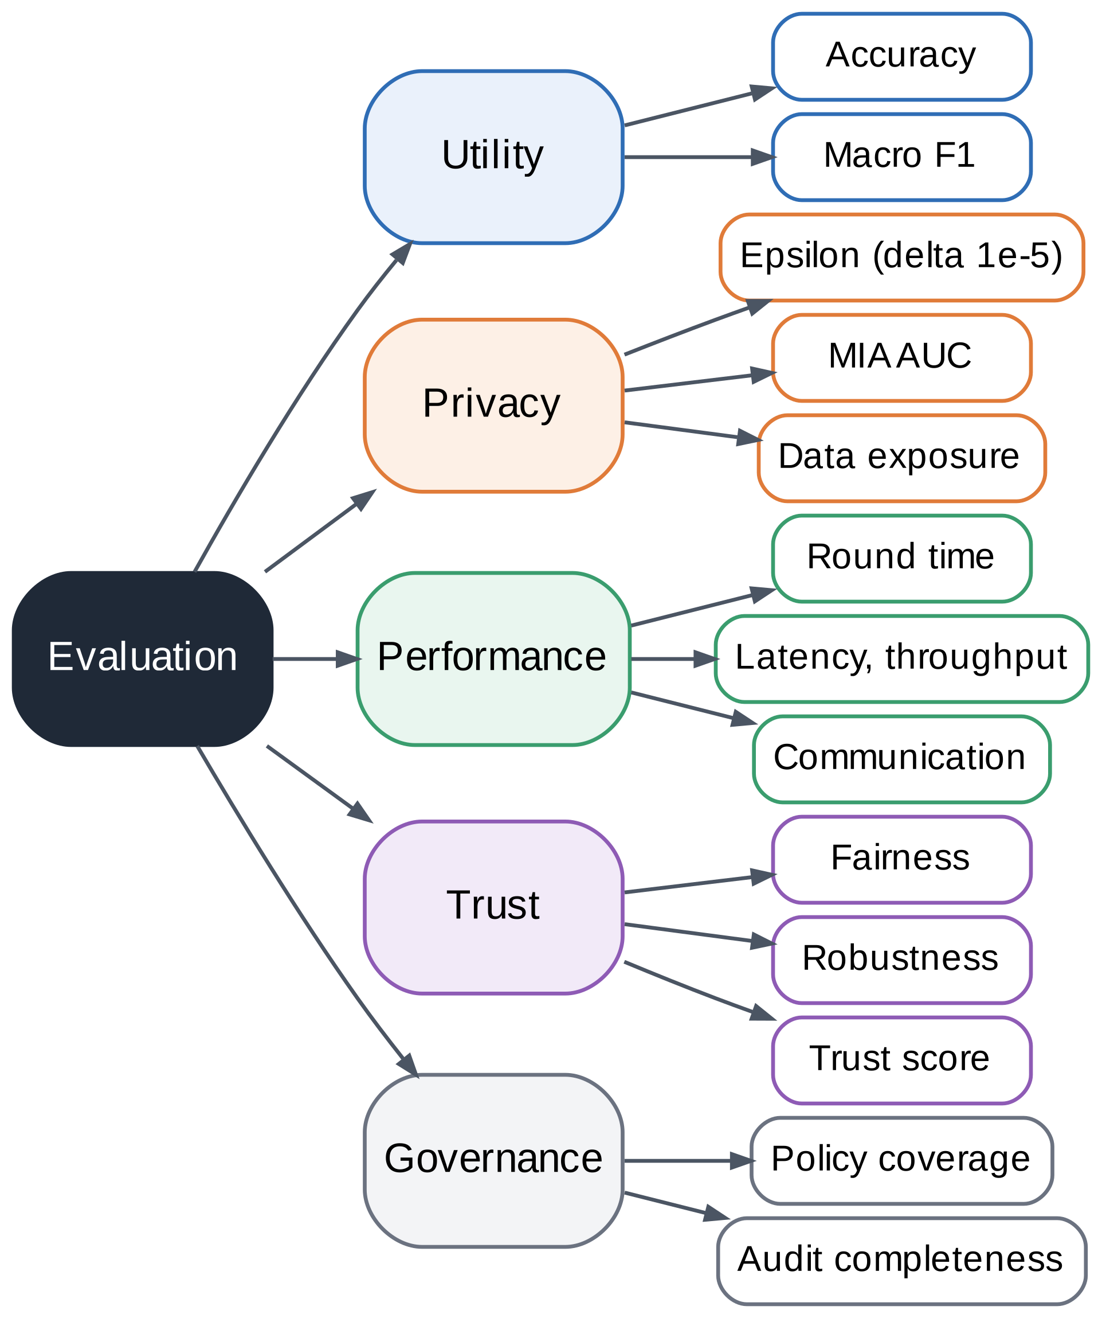
FIGURE 22. Evaluation Framework.

TABLE 9. Metrics Definition Matrix
Metric | Definition | Better | Section
Accuracy, macro F1 | Share correct on the pooled test set; mean per-class F1 | Higher | 15
Privacy budget ε | Rényi-accounted (ε, δ) at δ = 10⁻⁵, worst-case client | Lower | 8, 15
Membership AUC | ROC area of a loss-threshold attack on members versus non-members | Closer to 0.5 | 15
Data exposure | Share of raw data that leaves the device | Lower | 16
Round time | Mean wall-clock time per round on the testbed CPU | Lower | 15
Communication | Bytes exchanged over all rounds (float64) | Lower | 15
Latency and throughput | Mean latency per (11); requests per second | Lower / higher | 15
Fairness | Worst-client test accuracy | Higher | 15, 16
Robustness | Accuracy at 20% label-flipping clients divided by clean accuracy | Higher | 15, 16
Trust score T | Weighted sum of six pillars per (9) | Higher | 16

14.1 Utility, privacy, and trust
Utility is test accuracy and macro F1. Privacy has three parts: the formal (ε, δ) budget from the accountant, the area under the ROC curve (AUC) of a loss-threshold membership inference attack, which generalizes the attack of Shokri et al. [22], and the share of raw data leaving the device. Practical evaluations of private learning warn that formal budgets and empirical attack success can disagree [77], and recent work surveys privacy metrics for generative models [78]. We use the membership AUC as a sanity check, not as proof of privacy, because an attack that fails may simply be weak [24]. Trust combines six pillars through (9) and (10).

14.2 Performance
Performance covers time per round, communication volume, inference latency, and throughput. For a request of size b with link bandwidth B, round-trip time RTT, edge time t_{e}, and cloud time t_{c}, a hybrid policy that offloads a fraction p of requests, sending a feature payload of size b_{f}, has mean latency given by (11). Setting p = 1 and omitting t_{e} gives cloud-only latency with b in place of b_{f}. Some symbols are reused across sections: here B is link bandwidth rather than the batch in (2); T is the number of training steps in (5) but the trust score in (9); α is the Rényi order in Section 8 but the Dirichlet concentration in Section 13; and C is the clipping norm, while C(α, k) is a binomial coefficient and C_{cloud} and C_{hyb} in (12) are annual costs.
$L_{hyb}=t_{e}+p\left(RTT+\frac{b_{f}}{B}+t_{c}\right)$ (11)

14.3 Statistical treatment
Each result is the mean and standard deviation over three seeds, where a seed changes the train–test split, the client partition, the random feature map, and the sampling. Three seeds are enough to show the size of the effects reported here but not to support fine-grained significance tests, so we avoid claims about small differences. For example, the difference between federated averaging with and without simulated secure aggregation is under one point and within the spread across seeds, which is why we describe it as no meaningful change in accuracy. Timing results are means over repeated rounds on one CPU and will vary with hardware load.

14.4 Limits of the metrics
Each metric has a known blind spot. Accuracy hides class-level and client-level differences, which is why we also report worst-client accuracy. A budget ε does not say how likely an attack is to succeed. A membership AUC near 0.5 may mean that the model leaks little or that the attack is weak [24][77]. The trust score compresses six numbers into one and depends on its weights. We therefore present the pillars alongside the score and recommend that readers consult the pillars first.

15. RESULTS AND FINDINGS

15.1 Privacy and utility
Table 10 and Fig. 23 summarize the privacy–utility results. Centralized training reached 97.0% accuracy on Digits and 92.2% on Breast Cancer. Federated averaging reached 92.3% and 91.8%, so keeping data local cost 4.7 points on Digits and 0.4 points on Breast Cancer. Local-only models reached 63.6% on Digits and 82.1% on Breast Cancer, which shows the value of collaboration. Simulated secure aggregation reproduced the plain sum to within 10⁻¹³ in every run (largest error 7.4 × 10⁻¹⁴, at σ = 0.8) and changed accuracy by less than one point, from 92.3% to 92.1%.

TABLE 10. Experimental Results Summary (mean over 3 seeds; ± standard deviation)
System | Digits acc. (%) | ε | MIA AUC | Cancer acc. (%) | ε | MIA AUC
Centralized cloud | 97.0 ± 0.4 | – | 0.520 | 92.2 ± 1.2 | – | 0.521
Local-only edge | 63.6 ± 0.6 | – | – | 82.1 ± 5.0 | – | –
FedAvg | 92.3 ± 0.6 | – | 0.513 | 91.8 ± 1.7 | – | 0.522
FedAvg + SecAgg | 92.1 ± 0.8 | – | 0.514 | 91.0 ± 1.7 | – | 0.538
DP-FedAvg + SecAgg, σ=0.8 | 87.5 ± 1.0 | 34.8 | 0.502 | 88.7 ± 3.6 | 42.2 | 0.526
DP-FedAvg + SecAgg, σ=1.0 | 86.2 ± 1.1 | 23.6 | 0.504 | 86.9 ± 3.7 | 28.0 | 0.523
DP-FedAvg + SecAgg, σ=1.5 | 79.7 ± 1.8 | 13.0 | 0.507 | 83.8 ± 5.9 | 16.1 | 0.529
DP-FedAvg + SecAgg, σ=2.0 | 72.5 ± 4.2 | 8.7 | 0.499 | 82.5 ± 7.0 | 11.0 | 0.517
DP-FedAvg + SecAgg, σ=3.0 | 58.5 ± 5.3 | 5.3 | 0.507 | 80.3 ± 8.4 | 6.7 | 0.529

Two observations help in reading the table. First, variation across seeds grows as privacy grows: on Digits the standard deviation rises from 1.0 points at σ = 0.8 to 5.3 points at σ = 3.0, and on Breast Cancer, where the test set has only 171 samples, it reaches 8.4 points. Small test sets and heavy noise both make single runs unreliable. Second, the larger privacy budgets belong to Breast Cancer for the same σ (for example 28.0 against 23.6 at σ = 1.0), because its five clients hold fewer samples each and so are sampled at a higher rate.

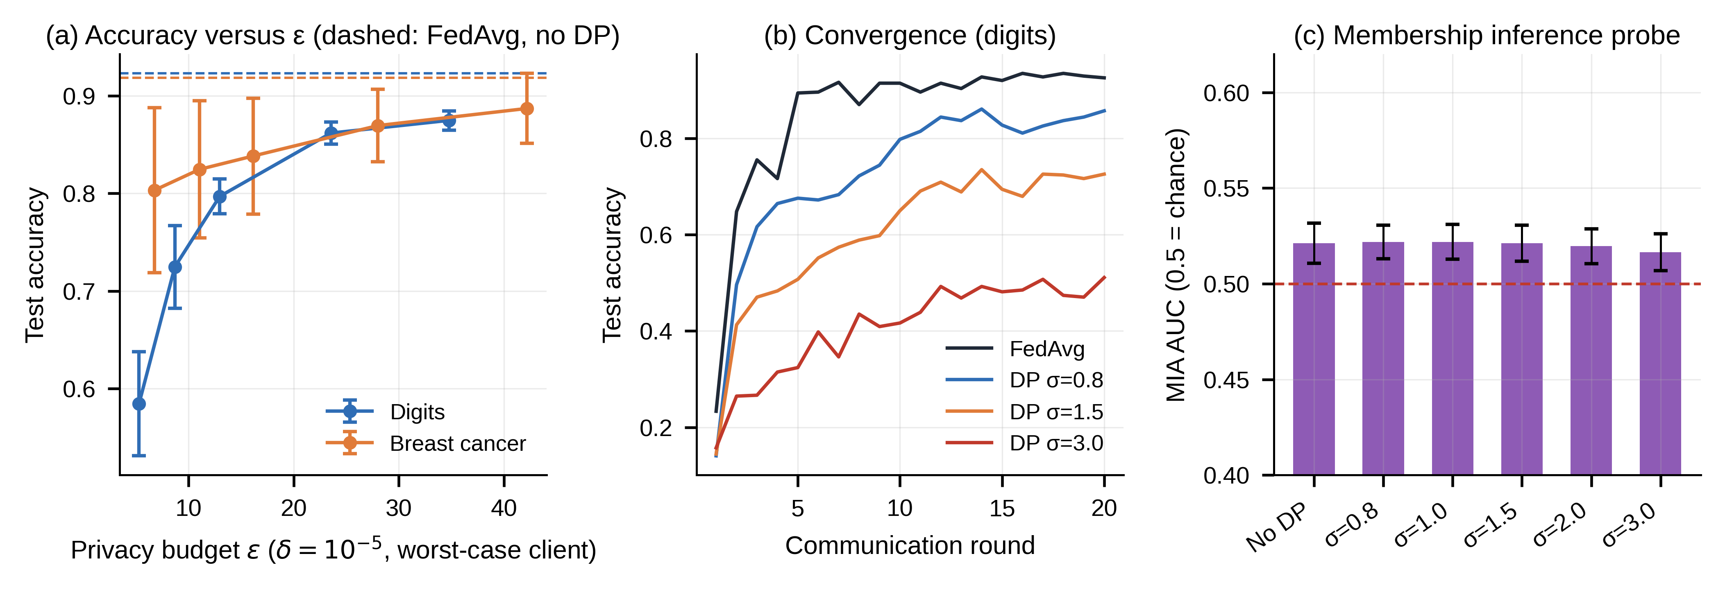
FIGURE 23. Privacy Preservation Performance Analysis. (a) Mean ± s.d. over three seeds; dashed lines are FedAvg without DP. (b) Digits, seed 0. (c) Over-parameterized probe; dashed line is chance.

Differential privacy lowered accuracy as the noise grew. On Digits, the worst-case budget fell from ε = 34.8 at σ = 0.8 to ε = 5.3 at σ = 3.0, and accuracy fell from 87.5% to 58.5%. At σ = 1.0 (ε = 23.6), Digits kept 86.2% and Breast Cancer kept 86.9% at ε = 28.0. These budgets are large by the standards of strong privacy, because the clients hold only dozens to a few hundred samples, which raises the sampling rate and the number of noisy steps per sample. Larger datasets or more clients would permit smaller budgets for the same accuracy.
The membership attack was not informative. Its AUC stayed between 0.50 and 0.54 for every model, with and without differential privacy, and an over-parameterized probe with 1,024 features gave 0.52 without noise and 0.52 with noise. The low-capacity convex model barely overfits, so this attack has little to detect. We therefore report no empirical privacy improvement; the guarantee rests on the formal budget alone.
Why was the attack weak? The model has few parameters relative to the training data and uses a convex loss, so the loss on training samples is only slightly lower than on unseen samples. Stronger attacks that use shadow models or calibrated thresholds could do better, and attacks on gradients can recover inputs from individual updates [22][23], which is the main reason to hide updates with secure aggregation. Our conclusion is narrow: a standard loss-threshold attack finds nothing to exploit in this workload, and the formal budget is the only privacy evidence we have.

15.2 Latency, throughput, and scalability
Fig. 24 shows the performance results. On the testbed CPU, single-sample inference took 0.022 ms for the edge model and 0.058 ms for the larger cloud model, so computation is negligible for models this small. To study the regime that matters in practice, the emulation assumes a heavier model, with 40 ms inference at the edge and 4 ms in the cloud, a 64 KB request, a 6.4 KB feature payload, and a 50 ms round trip. Under these assumptions at 10 Mbps, cloud-only latency is 105 ms, edge-only latency is 40 ms, and a hybrid policy that offloads 24.4% of requests has 54 ms. At 1 Mbps, cloud-only latency rises to 566 ms but the hybrid policy needs only 66 ms. Throughput follows the same pattern: at 10 Mbps a cloud-only deployment sustains 19.5 requests per second, bounded by the uplink, against 25 for the edge and hybrid designs.

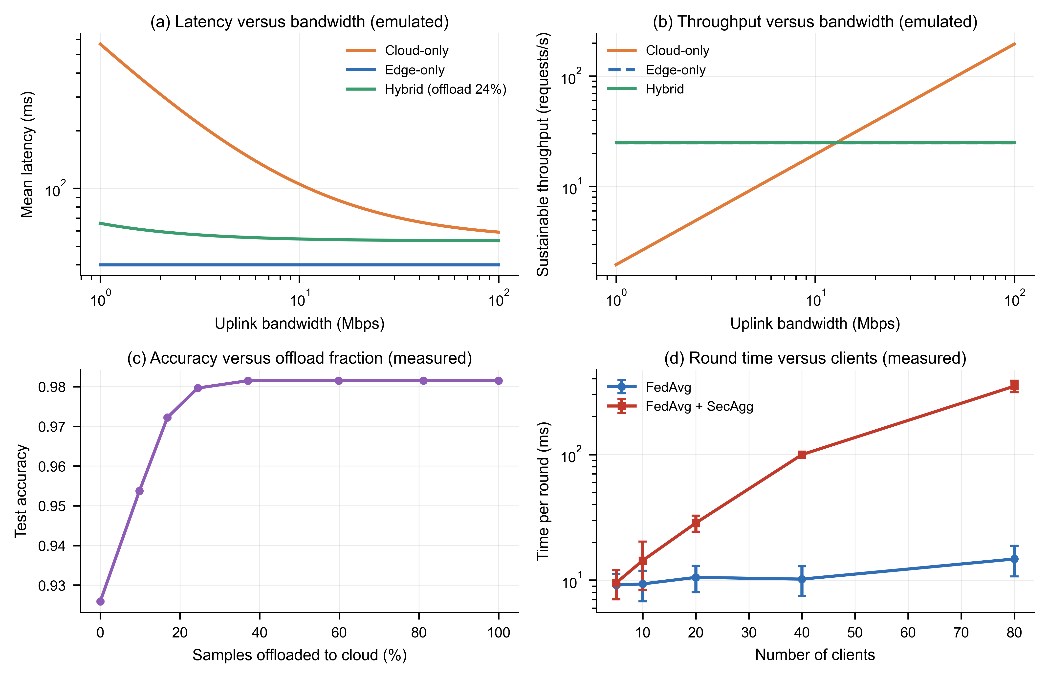
FIGURE 24. Latency and Throughput Evaluation. Panels (a) and (b) are emulated with assumed parameters: 40 ms edge and 4 ms cloud inference, 64 KB request, 6.4 KB features, 50 ms round-trip time. Panels (c) and (d) are measured.

The hybrid policy was measured, not assumed, for accuracy. In the routing experiment, the edge model alone scored 92.6% (a single routing-experiment result, not the three-seed mean in Table 10) and the cloud model scored 98.1%. The 98.1% result comes from the larger 1,024-feature, 82 KB cloud model used for the routing experiment, not the centralized model reported in Table 10 (97.0%). Offloading 24.4% of samples with confidence below 0.7 gave 98.0%, recovering about 97% of the gap using unrounded results (about 98% when calculated from the displayed rounded values), while keeping 75.6% of requests entirely local.
The cost of secure aggregation grew quickly with the number of clients. In the scalability experiment, which uses Digits with an 80/20 split, Dirichlet α = 5.0, and 5 rounds per run, mean round time for plain averaging rose from 9.2 ms at 5 clients to 14.8 ms at 80, whereas with secure aggregation it rose from 9.5 ms to 349.0 ms, consistent with the quadratic growth of pairwise masking work. On communication, federated training exchanged 8.2 MB in total on Digits, against 0.64 MB for a one-off upload of the raw training set, a factor of 12.8, and 0.41 MB against 0.10 MB on Breast Cancer. At this scale federated learning therefore does not save bandwidth; its benefit is that raw records stay on the device. Savings appear only when data volumes far exceed model sizes, as discussed in Section 19.

15.3 Practical guidance from the results
Four rules of thumb follow from the measurements. First, use federated learning when raw data are sensitive or too large to move, not because it saves bytes on small datasets. Second, use secure aggregation when the server is not fully trusted, but expect quadratic cost in the number of clients unless the protocol uses a sparser mask graph. Third, choose the noise level from the budget you need, and expect a large accuracy loss for budgets near 10: relative to FedAvg, σ = 2.0 reduced accuracy by about 19.8 percentage points on Digits and 9.4 points on Breast Cancer in Table 10. Fourth, add a robust aggregator when clients are not fully trusted, because it protected accuracy at modest cost and plain averaging did not.

15.4 Trust, robustness, and heterogeneity
Fig. 25 shows the trust results. Data heterogeneity hurt: from α = 100 to α = 0.1, global accuracy fell from 93.5% to 88.1% and worst-client accuracy from 87.8% to 66.2%. In the separate label-flipping robustness experiment, which partitions Digits with Dirichlet α = 1.0 rather than the α = 0.5 of Table 8 (hence 93.0% clean FedAvg accuracy rather than the 92.3% of Table 10), the three-seed mean for plain FedAvg fell from 93.0% with no malicious clients to 81.9% with 20% malicious clients and 76.1% with 30%; the coordinate-wise median retained 91.0% at 20% and 89.3% at 30%. The differentially private variant fell from 86.2% with no malicious clients to 71.2% at 20% and 62.9% at 30%. The trust-score robustness pillar uses the 20% results, as defined in Section 11.3. Differential privacy also lowered worst-client accuracy, from 85.0% to 75.8% at σ = 1.0 on Digits, a fairness cost that matches the known tension between privacy and equal performance. Pixel-importance maps for the centralized, federated, and private models are given in Appendix A.

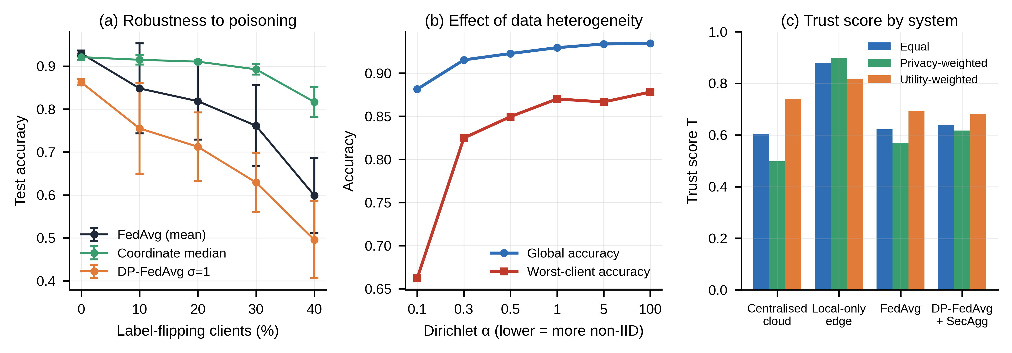
FIGURE 25. Trustworthiness Assessment Results. (a) and (b) Mean ± s.d. over three seeds. (c) Trust score under three weightings of the six pillars.

16. COMPARATIVE ANALYSIS
Fig. 26 and Table 11 compare four systems over the six trust pillars. The centralized cloud model has the best utility and fairness but zero data minimization and zero formal privacy. Local-only edge models never share information, so they score perfectly on minimization and formal privacy, but they have the lowest utility. Federated averaging keeps raw data local and offers high utility but no formal guarantee and the highest communication cost relative to its data volume. Differentially private federated averaging with secure aggregation adds a formal budget at some cost in utility and fairness.
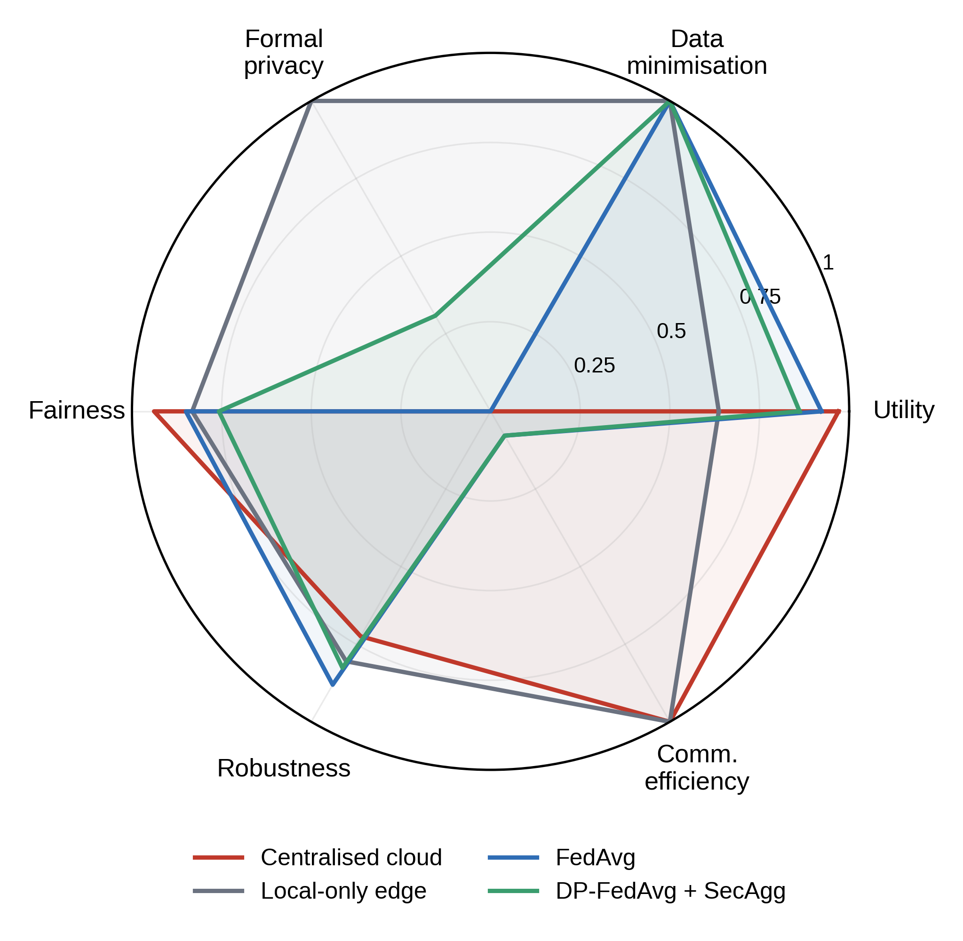
FIGURE 26. Comparative Radar Chart. Pillar scores in [0, 1]; larger is better. Definitions are given in Section 11; the values are in Table 11.

16.1 Reading the trust score
With equal weights the scores were 0.61 for the centralized cloud, 0.88 for local-only edge, 0.62 for federated averaging, and 0.64 for the private federated system. With privacy-weighted scores they were 0.50, 0.90, 0.57, and 0.62, and with utility-weighted scores 0.74, 0.82, 0.69, and 0.68. Local-only edge ranks first under all three weightings, but the order of the other three systems changes (utility weighting puts the centralized model ahead of the private federated system). Local-only edge models score highest in this simple model largely because it counts the absence of sharing as perfect privacy while treating accuracy as only one of six pillars. The score is a way to expose trade-offs, not a ranking to optimize blindly.

TABLE 11. Comparative Benchmark Analysis (pillar scores in [0, 1]; T under three weightings)
System | Utility | Data min. | Formal priv. | Fairness | Robust. | Comm. eff. | T equal | T priv. | T util.
Centralized cloud | 0.97 | 0.00 | 0.00 | 0.94 | 0.72 | 1.00 | 0.61 | 0.50 | 0.74
Local-only edge | 0.64 | 1.00 | 1.00 | 0.83 | 0.81 | 1.00 | 0.88 | 0.90 | 0.82
FedAvg | 0.92 | 1.00 | 0.00 | 0.85 | 0.88 | 0.08 | 0.62 | 0.57 | 0.69
DP-FedAvg + SecAgg | 0.86 | 1.00 | 0.31 | 0.76 | 0.83 | 0.08 | 0.64 | 0.62 | 0.68

16.2 System-by-system discussion
The centralized cloud model is the utility benchmark, and it is the right choice when data may be pooled lawfully and securely. Its weakness is that it concentrates risk and offers no data minimization. Local-only edge models are the privacy benchmark, and they are the right choice when collaboration is impossible, but they lose a large share of accuracy when each device has little data, as the 63.6% score on Digits shows. Federated averaging recovers most of the accuracy of centralized training while keeping data local, but it provides no formal privacy bound and, in this testbed, the highest communication cost. Differentially private federated averaging with secure aggregation adds a bound and hides individual updates at a cost in accuracy, fairness, and time per round.

16.3 When to choose each design
A short decision rule follows from the comparison. If pooling is lawful and risk is acceptable, use the centralized model. If no collaboration is possible, use local models. If data must stay local and the server is trusted, use federated averaging with a robust aggregator. If the server is not trusted or a formal bound is needed, add secure aggregation and differential privacy and choose the noise level from the required budget. In regulated domains such as health, the last option is the most defensible, and the hybrid routing of Section 15 can recover accuracy for hard cases without moving data in bulk [15].

16.4 Relation to existing approaches
Table 3 grouped prior work into families, and the comparison above shows where the proposed framework sits among them. Like the federated learning surveys, it keeps raw data local [2][7], but it combines a formal privacy budget, secure aggregation, and robust aggregation in one measured design rather than treating them separately. Like trust management work, it scores systems, but its scores are computed from measured accuracy, privacy, fairness, robustness, and communication rather than from device reputation [64][65]. Like compliance pattern work, it links legal duties to controls, but it also attaches each control to a measurable requirement [33][70]. The framework does not match the centralized model on accuracy, and it was not compared against split learning or homomorphic encryption, which remain options for deployments with different constraints [39][50].

17. RELIABILITY, SECURITY, AND TRUSTWORTHINESS ASSESSMENT
Fig. 27 shows the security and reliability framework: threats, defenses, resilience mechanisms, and assurance activities. Surveys of architectural resilience, fault tolerance, and resilience in edge computing describe how replication, redundancy, and graceful degradation keep services running [79][80][81].
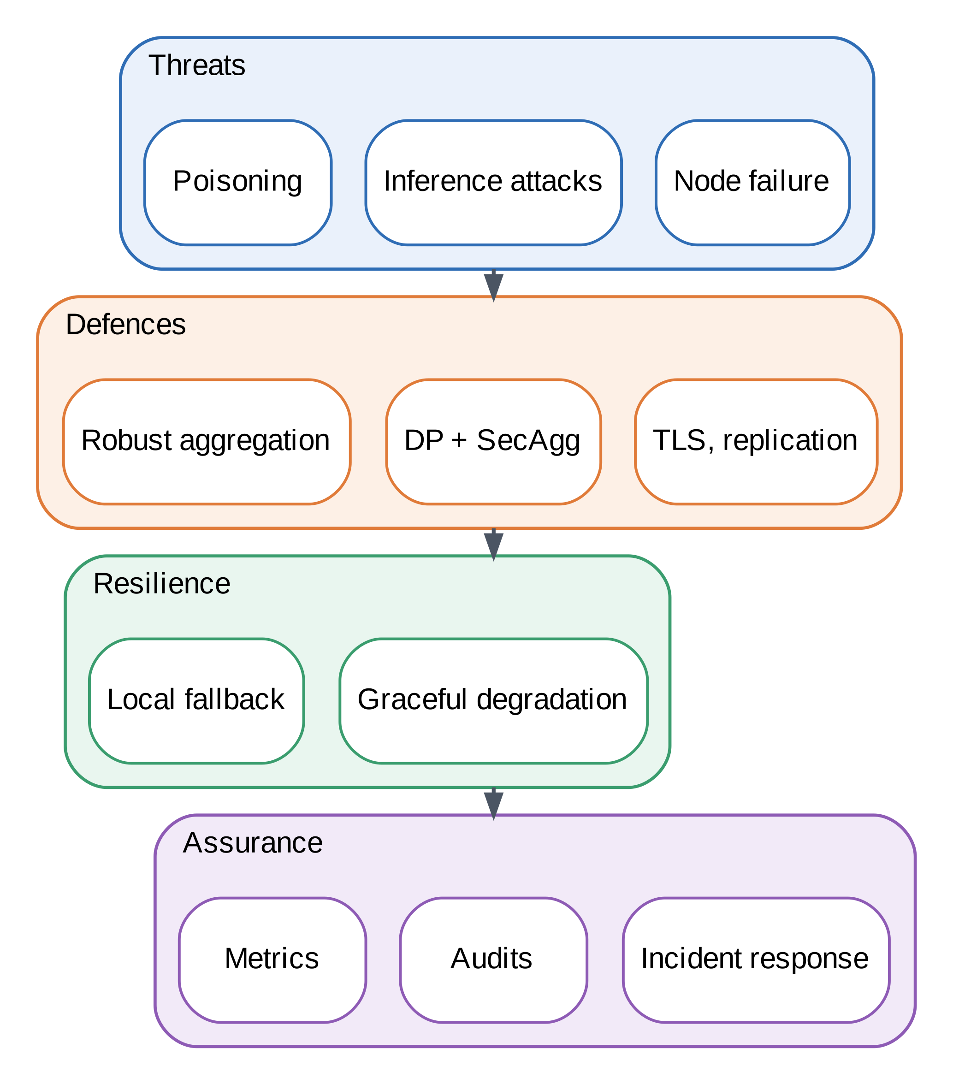
FIGURE 27. Security and Reliability Framework.

17.1 Evidence from the testbed
Three results bear on this section. Robust aggregation protected the model against label-flipping clients, as shown in Section 15. Secure aggregation reproduced the exact sum, but it depends on all masked contributions arriving, so a production protocol needs dropout handling [20]. For trusted execution environments, known side-channel and fault attacks mean that enclaves reduce, rather than remove, trust assumptions [28]. Table 12 assesses each trustworthiness dimension, the evidence we have, and the remaining gap.

TABLE 12. Trustworthiness Assessment Matrix
Dimension | Evidence collected | Result | Remaining gap
Privacy | Rényi ε; membership AUC | ε = 23.6 at σ = 1.0; AUC 0.50–0.54 for all models | Attack too weak to show benefit
Security | Label-flipping at 10–40% | Median 89.3% vs mean 76.1% at 30% | Other attacks untested
Fairness | Worst-client accuracy | 85.0% (FedAvg) to 75.8% (DP σ = 1.0) | No fairness mitigation
Reliability | Round time for 5–80 clients | SecAgg 349.0 ms at 80 clients | Client dropout not simulated
Transparency | Pixel-importance maps | Rank correlation 0.52–0.68 vs centralized | Single noisy run
Governance maturity | Requirement-to-control table | Nine duties mapped (Table 7) | No automated compliance check
Operational trust | None | Not assessed | Needs field deployment

17.2 Failure scenarios
Three failure scenarios guide the assessment. In a client failure, some clients drop out of a round. Averaging copes by using whoever responds, but a masked sum needs every masked contribution, so production secure aggregation adds recovery of masks for missing clients [20][48]. In a network failure, the edge keeps serving local predictions and queues updates, which is why the hybrid policy degrades gracefully to edge-only behavior. In a cloud failure, the last good global model remains at the edge and the registry supports rollback. None of these scenarios was simulated beyond the label-flipping and scalability tests, so the claims here are design arguments rather than measurements [79][81].

17.3 Operational trustworthiness
Operational trust grows with evidence over time, such as uptime, incident history, audit results, and the stability of trust scores across model versions. These cannot be produced in a short experiment, and Table 12 correctly marks them as not assessed. Edge resilience research treats such operational evidence as essential for dependable deployments [80].

17.4 Privacy guarantees
The privacy evidence is of two kinds, and they should be read separately. The formal evidence is the Rényi-accounted budget: at σ = 1.0 the worst-case client has ε = 23.6 at δ = 10⁻⁵ on Digits and ε = 28.0 on Breast Cancer. These are valid upper bounds for sample-level privacy within a single training run, but they are large, so they bound leakage only loosely. The empirical evidence is the membership attack, whose AUC stayed between 0.50 and 0.54 for every model, including the models trained without differential privacy. Because the attack also failed against the unprotected models, it cannot show that differential privacy helped, only that this workload gives a simple attack little to exploit [24][77]. Secure aggregation adds a different guarantee: under the honest-but-curious server model, the server sees only the sum of masked updates, which the simulation reproduced to within 10⁻¹³.

17.5 Security robustness and residual risks
Robust aggregation was the clearest security gain. With 30% label-flipping clients, the coordinate-wise median kept 89.3% accuracy, whereas plain averaging fell to 76.1%. Privacy noise made poisoning worse under plain averaging: the differentially private variant, which averages its updates, fell to 62.9% under the same attack, which matches the tension described in Section 2.2. The combination of the median with differential privacy was not tested. Several other risks also remain untested. Only label flipping was simulated, so targeted backdoor and model-replacement attacks are not covered. The secure aggregation simulation does not handle dropouts or key agreement, so a production deployment would need the full protocol [20][48]. Gradient inversion attacks on individual updates were not run, although secure aggregation is designed to keep those updates from the server [23]. These gaps mean that the assessment supports the design choices but does not certify the system.

18. INDUSTRY USE CASES AND CASE STUDY EVALUATION
Table 13 maps the framework to seven domains, and Figs. 28 and 29 illustrate two of them.

18.1 Smart cities
Street-level nodes anonymize camera and sensor data locally, regional edge clouds aggregate, and the city cloud supports forecasting and services (Fig. 28). Surveys cover federated learning for smart cities and differential privacy in edge-based smart city applications [16][46].
Typical analytics include traffic-flow forecasting, air-quality prediction, and energy demand estimates. The privacy risk lies in cameras and in location traces, which can single out people. Running detection on the device and sending only counts or aggregate features removes the need to move video, and noise on the aggregates limits what a city-level observer can infer about one road user.
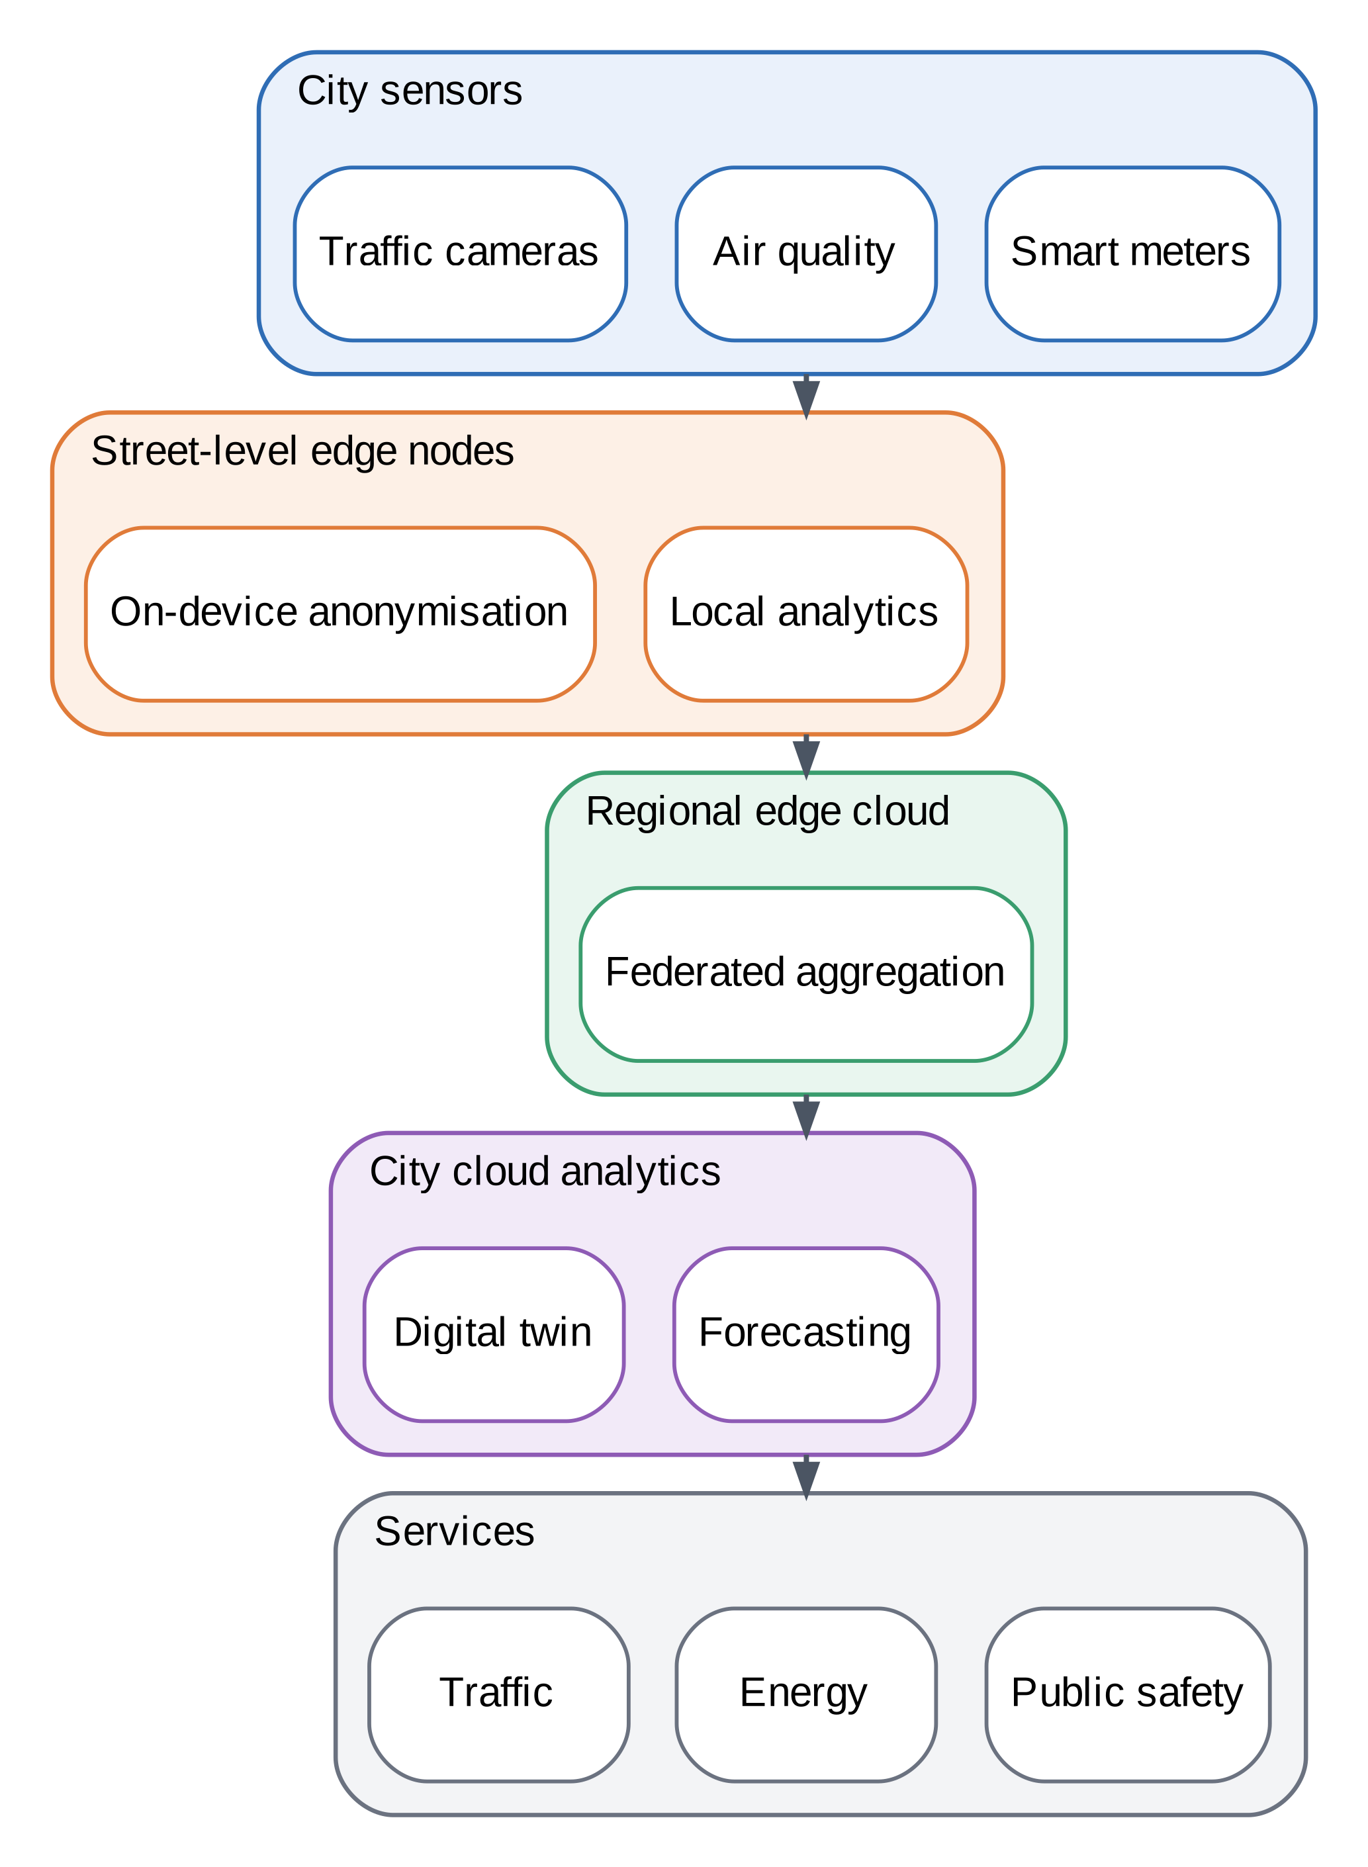
FIGURE 28. Smart City Cloud–Edge Ecosystem.

18.2 Healthcare
Hospitals de-identify and train locally and share only protected updates across institutions, as in Fig. 29, which matches the structure of our Breast Cancer experiment. A survey covers federated learning for smart healthcare [15].
Typical tasks include diagnostic support, readmission risk, and wearable monitoring. Hospitals differ in equipment and patient mix, so non-identical data are the norm and fairness across sites matters, as our heterogeneity results show. Small sites have the highest sampling rates and hence the highest privacy cost, so a consortium may need to agree on shared accounting rules before training.
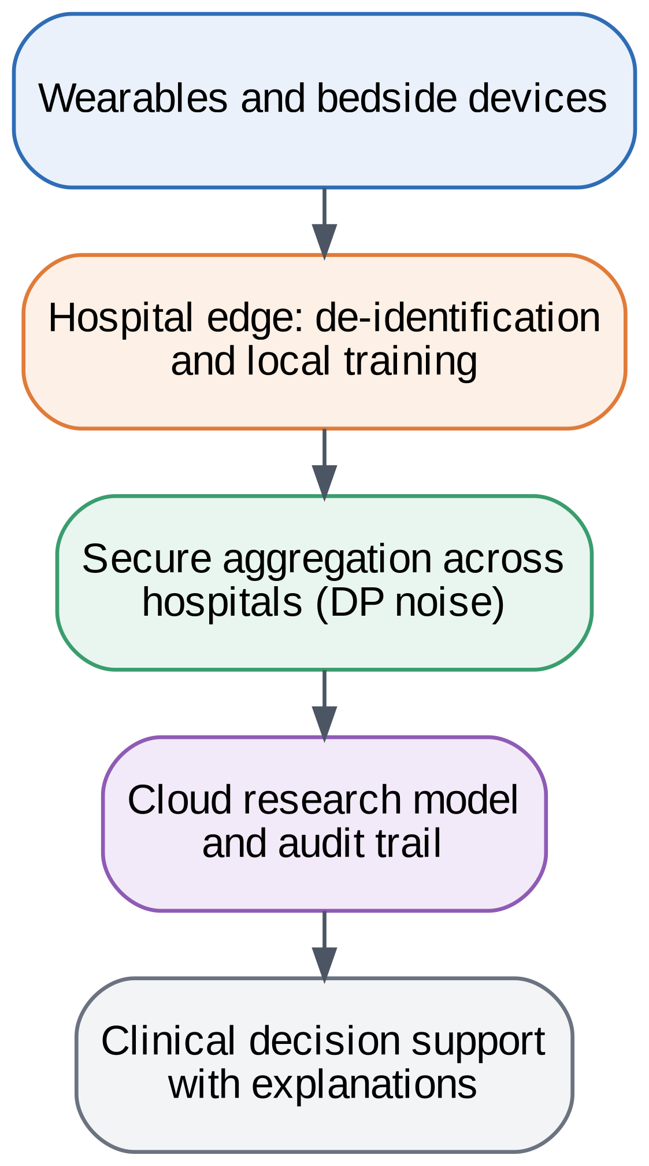
FIGURE 29. Healthcare Edge Intelligence Framework.

18.3 Industry, energy, transportation, and agriculture
In manufacturing, federated learning combined with industrial IoT supports predictive maintenance on private plant data [17][38]. In energy, reviews cover privacy-preserving federated learning for power systems and smart grids [71][72]. In transportation, surveys cover intelligent transportation systems and vehicular networks [73][74]. In agriculture, reviews address data privacy and the use of federated learning in farming [75][76].
Plants prefer to keep process parameters private because they encode know-how, yet shared models of failure patterns benefit every plant. Cyber-physical systems add safety: control loops must keep working when the network does not, which favors local decisions with cloud analytics as an advisory layer, consistent with the resilience guidance in [79][80].

TABLE 13. Industry Use Cases Matrix
Domain | Data | Privacy concern | Framework role | Refs.
Smart cities | Cameras, air quality, meters | Tracking of individuals | On-device anonymization; DP aggregates | [16][46]
Healthcare | Wearables, clinical records | Patient identifiability | Hospital-edge training; secure aggregation | [15]
Cyber-physical systems | Control and telemetry | Operational secrets; safety | Local control with cloud analytics; resilience | [79][80]
Manufacturing | Machine and process data | Trade secrets | Plant-level federated models | [17][38]
Transportation | Vehicle and traffic data | Location trails | Vehicle-edge learning; robust aggregation | [73][74]
Agriculture | Field and farm data | Farm-level commercial data | Farm-edge models | [75][76]
Energy | Smart meters, grid data | Household behavior | Federated forecasting with DP | [71][72]

18.4 Cross-domain lessons
Three lessons recur across the domains. Minimization at the edge removes the most risk for the least cost. Heterogeneous clients need fairness checks, since the smallest or most unusual client is often the one that suffers. Governance has to be designed in, because the legal duties differ by domain even when the technology is the same. Reviews of federated learning in each domain make similar points [15][16][73][75].

18.5 Evaluating the case studies against the testbed
The testbed covers parts of these use cases directly and others only by analogy. The Breast Cancer experiment matches the healthcare consortium pattern: five clients with non-identical data, a small total sample, and a higher privacy cost because each client holds few records, which our results confirm (ε = 28.0 against 23.6 on Digits at σ = 1.0). The hybrid routing experiment matches the smart city and transportation patterns, in which most requests can be answered locally and only uncertain cases need the cloud. The poisoning experiment is relevant to every domain in which clients are not fully trusted, such as vehicle fleets or open sensor networks. Manufacturing, agriculture, and energy were not simulated, so their rows in Table 13 rest on the literature rather than on our measurements [17][71][75].

19. BUSINESS IMPACT ASSESSMENT
This section presents a transparent cost–benefit model. Every input is an assumption chosen to be plausible and is not a measurement or an industry figure, so the results show how the pieces interact and should be replaced with an organization’s own numbers. Studies of the total cost of ownership of edge versus cloud deployments motivate this comparison [82].

19.1 Model
We consider a fleet of 10,000 devices, each producing 200 MB of data per day, a network price of $0.05 per GB, storage at $0.023 per GB-month for six months of retention, an edge hardware uplift of $12 per device per year, governance tooling of $25,000 per year, an annual breach probability of 3%, and a breach cost of $2 million. In the hybrid design only the 24.4% of requests that need cloud help are sent, as features that are 10% of the raw size, plus model-update traffic of 5 MB each way per client per round for 52 rounds. The expected loss from a breach scales with the share of raw data held in the cloud. The net annual benefit, given by (12), adds the difference in operating costs (network, storage, edge, and governance) to the reduction in expected breach loss, where P_{b} is the breach probability, L_{b} is the breach cost, and x is the share of raw data exposed in the cloud under the hybrid design (1 for cloud-only; 0.024 here).
$ΔC=\left(C_{cloud}-C_{hyb}\right)+P_{b}L_{b}\left(1-x\right)$ (12)

19.2 Results
Under these assumptions, the cloud-only design costs about $194,000 per year and the hybrid design $150,000, a saving of about $44,000 (22.7%), as shown in Table 14 and Fig. 30. The saving comes mostly from storage and expected breach loss, which fall from $98,000 and $60,000 to $2,400 and $1,500, and it is partly offset by $145,000 per year of edge and governance spending. The benefit equals 30% of that incremental spend. The hybrid design breaks even at an annual breach probability of about 0.74% for a $2 million breach, and it loses money if breaches are rarer or cheaper than that. Business value is therefore driven by data volume and risk exposure, not by the privacy techniques alone.

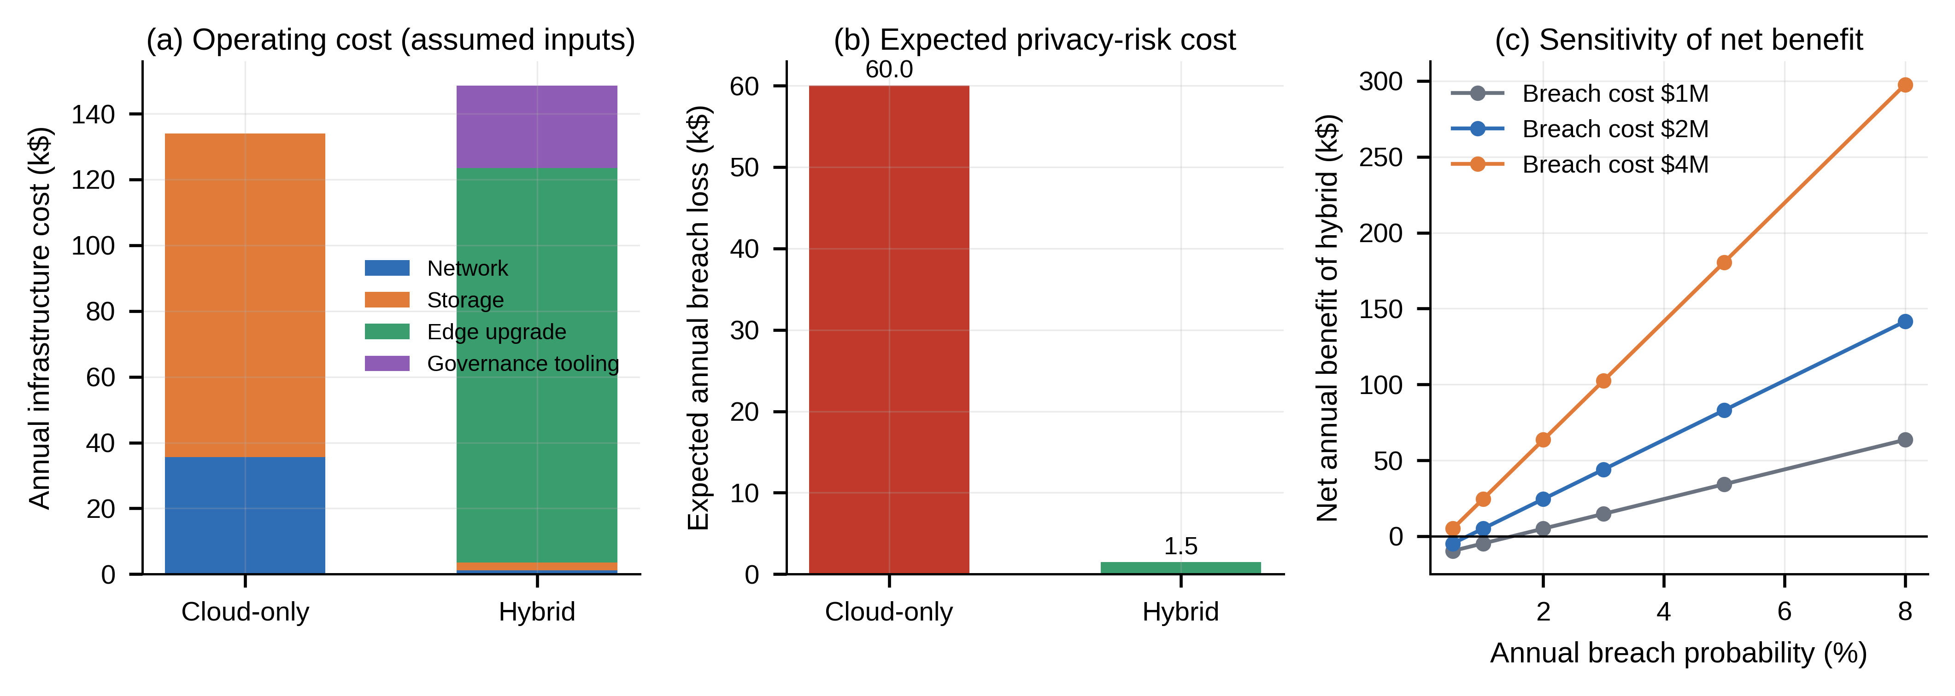
FIGURE 30. Business Impact Dashboard. All inputs are assumptions stated in Section 19; the figure shows model behavior, not measurements.

TABLE 14. Cost–Benefit Analysis (assumed inputs; US$ per year)
Item | Cloud-only | Hybrid | Basis
Network transfer | $35,645 | $1,125 | $0.05 per GB
Storage | $98,379 | $2,405 | $0.023 per GB-month, 6 months
Edge hardware uplift | $0 | $120,000 | $12 per device
Governance tooling | $0 | $25,000 | Assumed flat
Expected breach loss | $60,000 | $1,467 | 3% × $2M × exposure
Total | $194,023 | $149,997 | Saving $44,027 (22.7%)

19.3 Interpreting the model
Four points qualify the result. First, the saving depends on a risk term that is hard to estimate; Fig. 30(c) shows that the benefit disappears if the annual breach probability is low or the breach cost is small. Second, the model does not include the cost of engineering effort or of slower development, which can be significant. Third, the edge uplift of $12 per device assumes hardware that is mostly in place, and a fleet that needs new devices would face higher costs. Fourth, the model charges nothing for the accuracy lost to privacy noise, even though Section 15 shows it is real; in a fuller analysis that loss would be a cost. Organizations should replace the assumed inputs with their own, and should treat the output as a structured way to discuss trade-offs rather than a forecast [82].

19.4 Compliance value
Beyond direct cost, keeping personal data local can reduce the scope of compliance work, because fewer systems hold regulated data and fewer transfers need justification [10][11]. This benefit is real but hard to quantify, so the model captures it only through the expected-loss term.

20. CHALLENGES AND LIMITATIONS
Fig. 31 summarizes the main challenges and the mitigation directions.
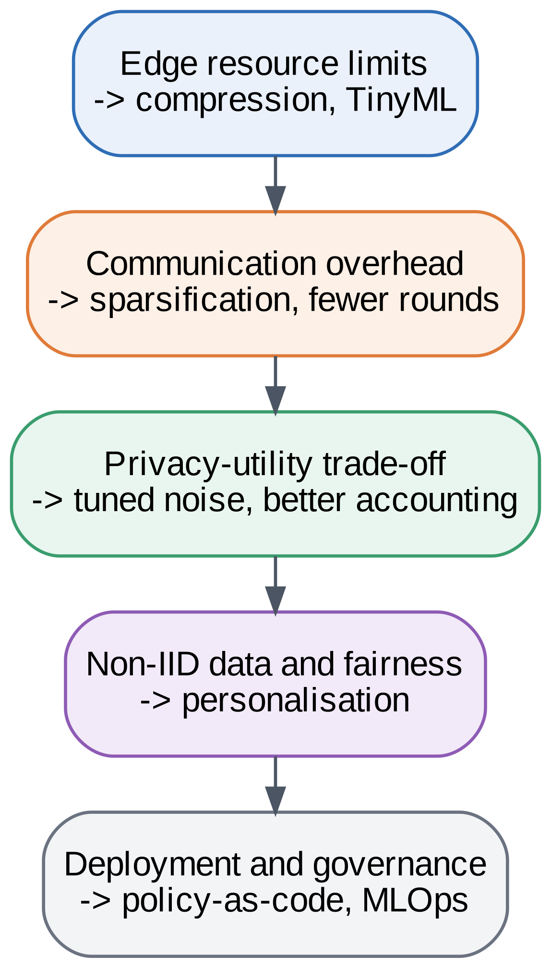
FIGURE 31. Challenges and Limitations Roadmap.

20.1 Limitations of this study
Several limits should be kept in mind. The datasets are small and the model is convex, so the results do not transfer directly to deep models, large data, or real devices. The edge is emulated on one machine, and the network model is analytical. Differential privacy is sample-level within each client, not client-level, and the budgets are large for the reasons given in Section 15. The membership attack was too weak to measure empirical privacy. Secure aggregation is simulated without dropout handling or key agreement. The trust score depends on subjective weights and on a modeling choice for the privacy pillar. Only label-flipping attacks were tested. The business model is assumption-based. Finally, the governance mapping is a design aid, not legal advice.

20.2 Threats to validity
Several issues could affect the results. The learning rate and the number of rounds were selected in preliminary runs, and those runs evaluated accuracy on the same test split of the first seed that is used for reporting, so the reported accuracies may be slightly optimistic; a clean replication would hold out a separate validation set for tuning. The clipping norm and the other privacy parameters were fixed after a small exploratory sweep and not tuned further. Three seeds limit the precision of the estimates. The emulation runs all clients in one process and ignores stragglers and network loss. The two datasets are small and clean, and results on large, noisy, real-world data may differ. None of these issues changes the qualitative findings, but they call for caution about the exact numbers.

20.3 Practical challenges
Edge devices have limited memory and energy, which restricts model size and local training [7][31]. Communication overhead can exceed the data volume when models are large relative to datasets. The privacy–utility trade-off requires tuning and good accounting [44][77]. Non-identical data hurt both accuracy and fairness. Deployment adds orchestration and governance complexity across the continuum [5][36].
Mitigations exist for each challenge. Model compression and tiny machine learning address resource limits [31]. Update sparsification and fewer rounds address communication. Calibrated noise and better accounting address the privacy–utility trade-off [43][44]. Personalization and robust aggregation address heterogeneity and poisoning [21]. Policy-as-code and registry-based operations address governance and deployment complexity [32][33].

20.4 Organizational challenges
Some challenges are organizational rather than technical. Consortium members must agree on a shared privacy budget, on who operates the aggregator, and on how to handle a member that leaves, and each of these choices affects the guarantees that the system can offer. Operators need skills in privacy accounting and secure deployment that are still uncommon, which is why developer tooling and clear documentation matter [56][66]. Finally, legal requirements differ by jurisdiction and change over time, so the mapping in Table 7 must be reviewed regularly rather than treated as settled [10][11][12].

21. FUTURE RESEARCH DIRECTIONS
Fig. 32 shows the roadmap and Fig. 33 shows a next-generation ecosystem.
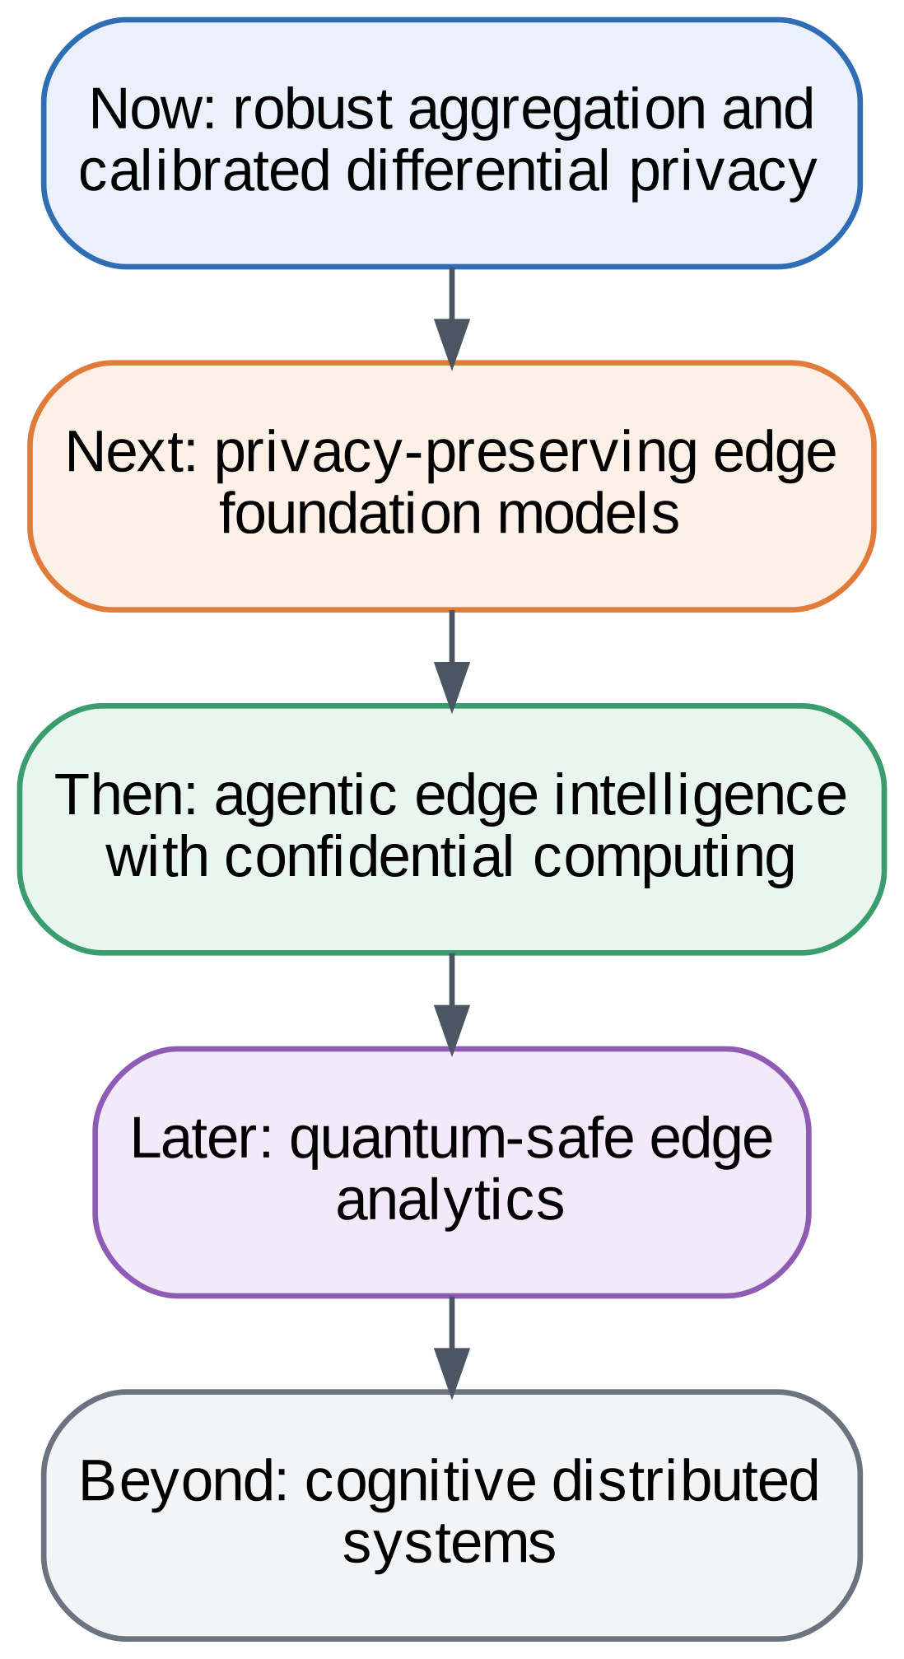
FIGURE 32. Future Research Roadmap.

21.1 Edge foundation models and agents
Large models are moving to the edge, and surveys describe mobile edge intelligence for language models, edge data analysis with language models, and agents that run on the edge with attention to privacy, scalability, heterogeneity, and autonomy [8][13][14]. A related line of work studies cognitive edge computing for large models and agents [83]. Privacy-preserving fine-tuning of such models with secure aggregation and differential privacy is an open problem.

21.2 Confidential computing and quantum-safe analytics
Confidential computing could protect aggregation servers and agent tools, but side-channel risks need continued study [28][51][52]. Quantum-safe edge analytics will need post-quantum key exchange that suits constrained devices, and surveys already compare candidate approaches [57][58][59].

21.3 Autonomous, cognitive systems
Orchestration across the continuum is moving toward self-managing systems, with research on autonomy and intelligence in the computing continuum [35][36]. Combining such orchestration with continuous compliance, including unlearning, is a promising direction [34][69]. Open metrics for privacy and trust, building on work such as [78], would make claims comparable across systems.
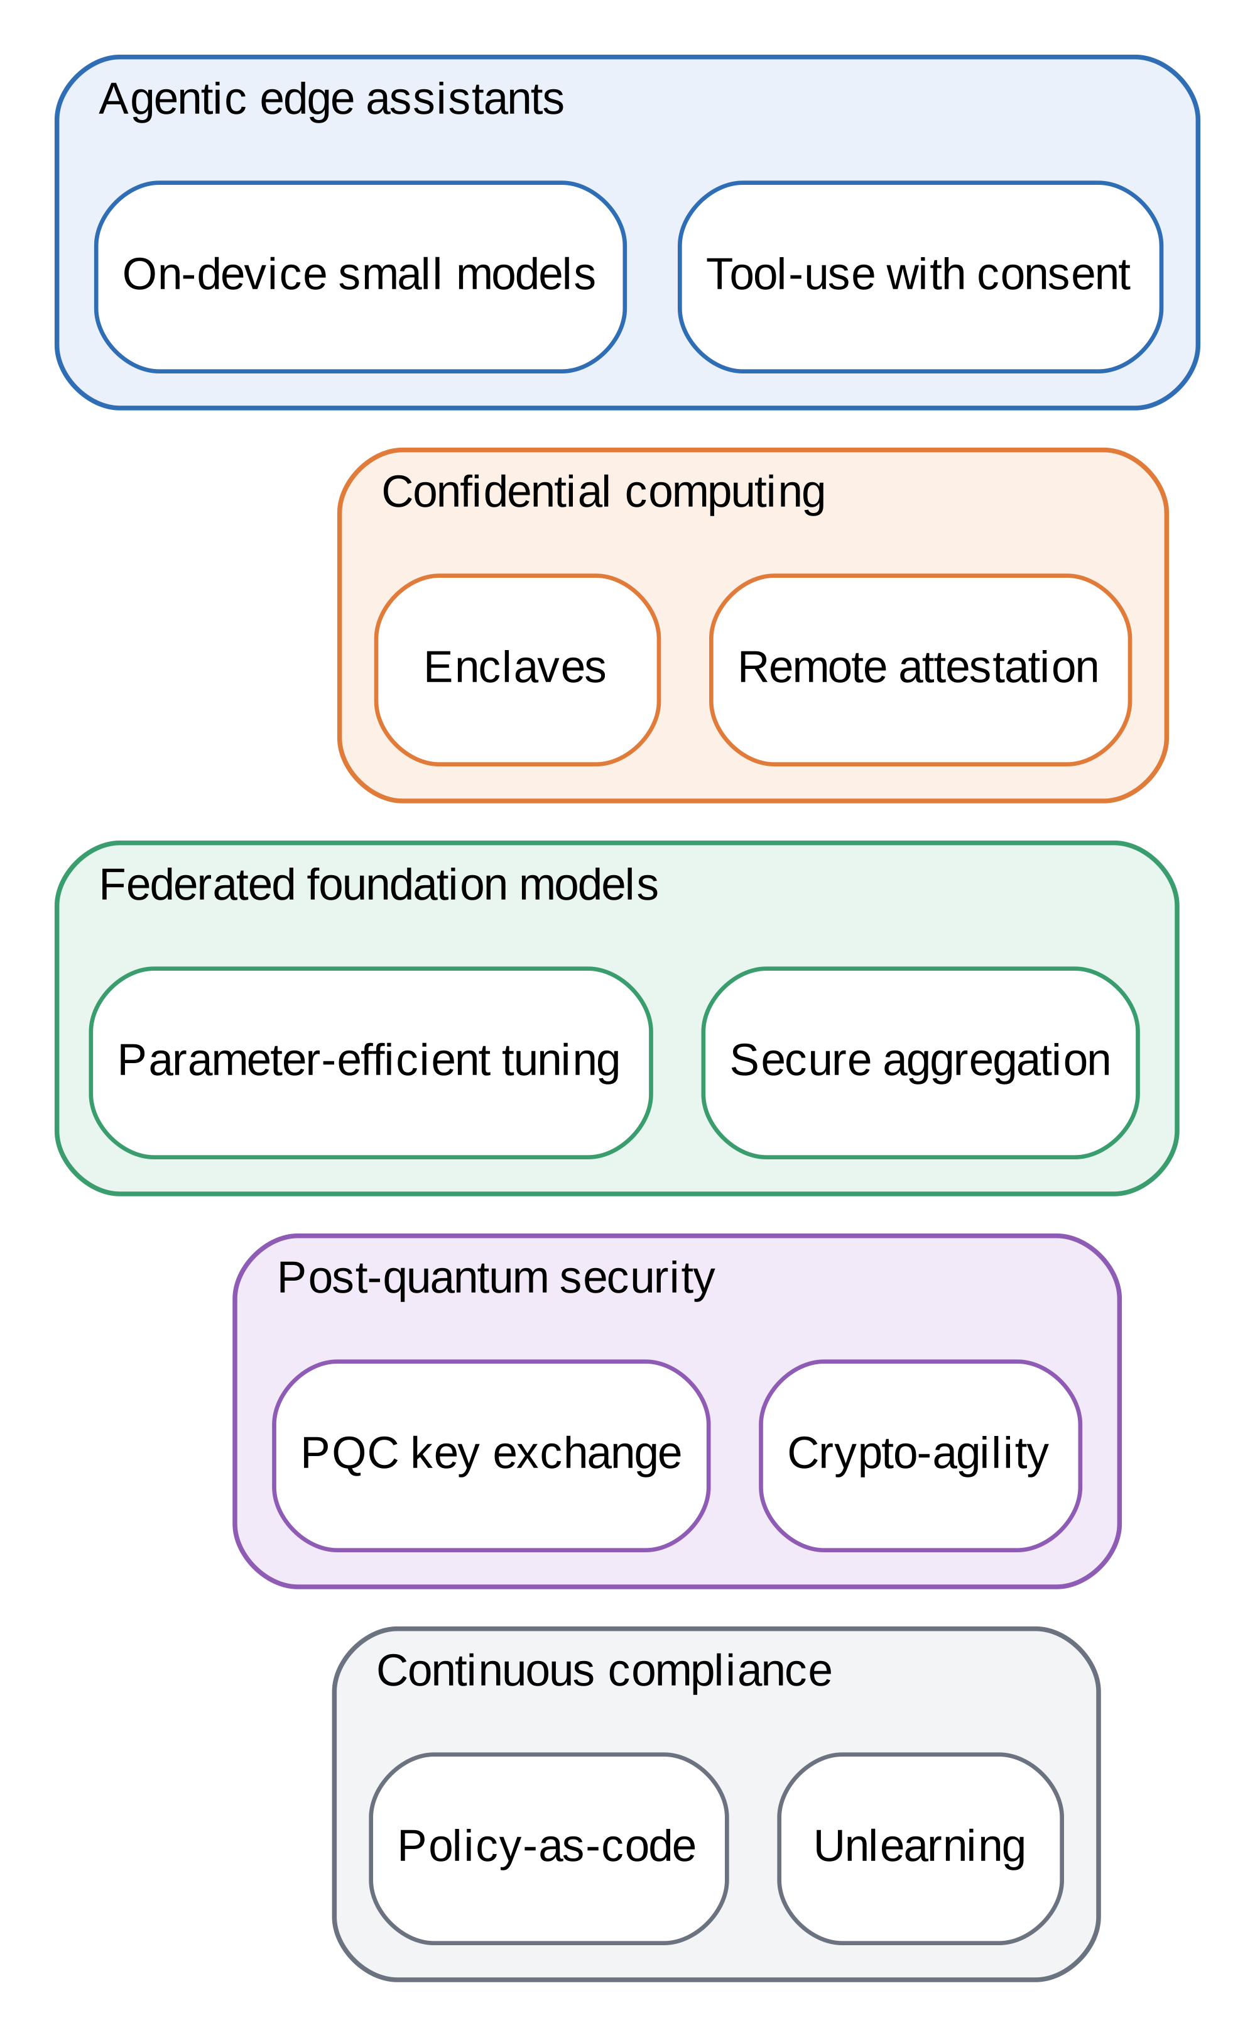
FIGURE 33. Next-Generation Cloud–Edge Intelligence Ecosystem.

21.4 Open research questions
Six questions stand out.
- How can differential privacy be tuned for small clients so that budgets below 10 become practical without large accuracy loss?
- How should the privacy budget be shared across several tasks trained on the same edge data?
- Can client-level guarantees be obtained with acceptable utility for cross-silo consortia of a few dozen institutions?
- Which attacks should be standard in evaluations so that empirical privacy results are comparable across studies [24][78]?
- How can unlearning be made cheap enough to honor erasure requests routinely in federated systems [34][69]?
- How should agents and foundation models at the edge be governed, given that they act on behalf of users [13][83]?
Progress on these questions would turn many of the design arguments in this report into measured results.

21.5 Research roadmap
Fig. 32 orders these directions as a sequence. The first step builds on what this study measured: robust aggregation and calibrated differential privacy, extended to deep models, larger datasets, real edge hardware, client-level guarantees, and secure aggregation with dropout handling, so that the current design arguments become measurements. The next step is privacy-preserving fine-tuning of foundation models at the edge, using parameter-efficient updates combined with secure aggregation [8][14]. After that comes agentic edge intelligence protected by confidential computing, in which agents act on behalf of users inside attested enclaves [13][51][83]. Quantum-safe edge analytics follows as post-quantum key exchange becomes practical on constrained devices [57][58], and the final stage is cognitive distributed systems that orchestrate themselves across the continuum while remaining compliant [35][36]. Progress along this roadmap would also make the trust score more meaningful, because its pillars could then be computed from field data rather than from a small emulation.

22. CONCLUSION
We presented a seven-layer, privacy-aware cloud–edge intelligence framework for distributed data science and evaluated its core privacy mechanisms in an open testbed. The contributions are summarized in Fig. 34. Keeping data local cost 4.7 accuracy points on image data and 0.4 on clinical data. Differentially private training offered a quantified budget in exchange for accuracy, secure aggregation was exact but quadratic in the number of clients, and a median aggregator materially improved robustness to poisoning. Three results run against simple expectations: the membership attack showed no difference, federated training moved more bytes than raw upload at this scale, and the trust score depends strongly on its weights.
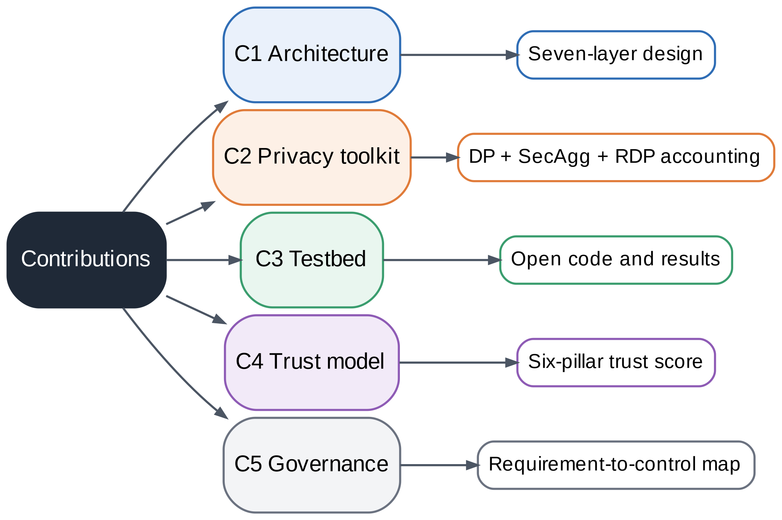
FIGURE 34. Research Contribution Framework.
Three recommendations summarize the report for practitioners. First, begin with minimization and encryption, which are cheap and effective, and add differential privacy and secure aggregation where the threat model needs them. Second, measure privacy, utility, robustness, fairness, and cost together, and publish the cases where a mechanism does not help. Third, tie every control to a requirement and a legal duty so that the system can be audited as well as built.
The practical lesson is that privacy-aware design is a set of trade-offs, and the framework helps make them visible and auditable. Future work should repeat the evaluation with larger datasets, deep models, real edge hardware, stronger attacks, and client-level privacy, and should connect the governance mapping to automated compliance checks.
Within its limits, the study shows that a privacy-aware cloud–edge system can be designed, measured, and governed as one artifact rather than as separate pieces. The framework, testbed, and governance mapping are released together so that others can rerun the experiments, change the parameters, and test whether the trade-offs reported here hold on their own data and hardware.

DATA AND CODE AVAILABILITY
The datasets generated and/or analysed during the current study are available in the GitHub repository, https://github.com/lakshay-chauhan/data-privacy-project. The two source datasets, Digits and Breast Cancer Wisconsin (Diagnostic), are public datasets distributed with scikit-learn and are also stored in the repository folder 03_Datasets; no private or patient-level data were used. The results reported in this study are recorded in 03_Datasets/results.json, 03_Datasets/derived.json, and 03_Datasets/extra_robustness.json, and the source code, execution log, and diagram sources are in the folders 02_Source_Code, 04_Execution_Logs_and_Videos, and 01_Diagrams.

ACKNOWLEDGMENT
The authors thank Dr. M. Rajasekhara Babu for guidance during the BCSE318L Data Privacy course at Vellore Institute of Technology.

REFERENCES
[1] D. Xu et al., “Edge intelligence: Empowering intelligence to the edge of network,” Proc. IEEE, vol. 109, no. 11, pp. 1778–1837, Nov. 2021, https://doi.org/10.1109/JPROC.2021.3119950
[2] D. C. Nguyen, M. Ding, P. N. Pathirana, A. Seneviratne, J. Li, and H. V. Poor, “Federated learning for Internet of Things: A comprehensive survey,” IEEE Communications Surveys & Tutorials, vol. 23, no. 3, pp. 1622–1658, 2021, https://doi.org/10.1109/COMST.2021.3075439
[3] A. Rahdari et al., “A survey on privacy and security in distributed cloud computing: Exploring federated learning and beyond,” IEEE Open J. Commun. Soc., 2025, https://doi.org/10.1109/OJCOMS.2025.3560034
[4] T. Goethals, B. Volckaert, and F. De Turck, “Enabling and leveraging AI in the intelligent edge: A review of current trends and future directions,” IEEE Open J. Commun. Soc., vol. 2, pp. 2311–2341, 2021, https://doi.org/10.1109/OJCOMS.2021.3116437
[5] A. Ullah, T. Kiss, J. Kovács, F. Tusa, J. Deslauriers, H. Dagdeviren, R. Arjun, and H. Hamzeh, “Orchestration in the cloud-to-things compute continuum: Taxonomy, survey and future directions,” J. Cloud Comput., vol. 12, no. 1, 2023, https://doi.org/10.1186/s13677-023-00516-5
[6] W. Y. B. Lim et al., “Federated learning in mobile edge networks: A comprehensive survey,” IEEE Commun. Surveys Tuts., vol. 22, no. 3, pp. 2031–2063, 3rd Quart. 2020.
[7] H. G. Abreha, M. Hayajneh, and M. A. Serhani, “Federated learning in edge computing: A systematic survey,” Sensors, vol. 22, no. 2, Art. no. 450, 2022.
[8] G. Qu, Q. Chen, W. Wei, Z. Lin, X. Chen, and K. Huang, “Mobile edge intelligence for large language models: A contemporary survey,” IEEE Commun. Surveys Tuts., Jan. 2025, https://doi.org/10.1109/COMST.2025.3527641
[9] A. Tariq, M. A. Serhani, F. M. Sallabi, E. S. Barka, T. Qayyum, H. M. Khater, and K. A. Shuaib, “Trustworthy federated learning: A comprehensive review, architecture, key challenges, and future research prospects,” IEEE Open J. Commun. Soc., vol. 5, pp. 4920–4998, 2024, https://doi.org/10.1109/OJCOMS.2024.3438264
[10] Regulation (EU) 2016/679 of the European Parliament and of the Council (General Data Protection Regulation), Official J. Eur. Union, L 119, Apr. 27, 2016.
[11] The Digital Personal Data Protection Act, 2023, Act No. 22 of 2023, Government of India, 2023.
[12] Regulation (EU) 2024/1689 of the European Parliament and of the Council (Artificial Intelligence Act), Official J. Eur. Union, 2024.
[13] N. Agrawal and R. Mayer, “LLM-based agents on the edge: A survey of privacy, scalability, heterogeneity, and autonomy,” in Proc. 35th Int. Joint Conf. Artif. Intell. (IJCAI), Survey Track, 2026, pp. 7722–7730, https://doi.org/10.24963/ijcai.2026/858
[14] X. Wang, Z. Xu, and X. Sui, “Intelligent data analysis in edge computing with large language models: Applications, challenges, and future directions,” Front. Comput. Sci., vol. 7, May 2025, https://doi.org/10.3389/fcomp.2025.1538277
[15] D. C. Nguyen et al., “Federated learning for smart healthcare: A survey,” ACM Comput. Surv., vol. 55, no. 3, pp. 1–37, 2022.
[16] S. Pandya, G. Srivastava, R. Jhaveri, M. Rajasekhara Babu, S. Bhattacharya, P. K. R. Maddikunta, S. Mastorakis, M. J. Piran, and T. R. Gadekallu, “Federated learning for smart cities: A comprehensive survey,” Sustain. Energy Technol. Assess., vol. 55, Art. no. 102987, Feb. 2023, https://doi.org/10.1016/j.seta.2022.102987
[17] P. Boobalan, S. P. Ramu, Q.-V. Pham, K. Dev, S. Pandya, P. K. R. Maddikunta, T. R. Gadekallu, and T. Huynh-The, “Fusion of federated learning and industrial Internet of Things: A survey,” Comput. Netw., vol. 212, Art. no. 109048, Jul. 2022, https://doi.org/10.1016/j.comnet.2022.109048
[18] H. B. McMahan, E. Moore, D. Ramage, S. Hampson, and B. A. y Arcas, “Communication-efficient learning of deep networks from decentralized data,” in Proc. 20th Int. Conf. Artif. Intell. Statist. (AISTATS), 2017, pp. 1273–1282.
[19] M. Abadi et al., “Deep learning with differential privacy,” in Proc. ACM SIGSAC Conf. Comput. Commun. Secur. (CCS), 2016, pp. 308–318.
[20] K. Bonawitz et al., “Practical secure aggregation for privacy-preserving machine learning,” in Proc. ACM SIGSAC Conf. Comput. Commun. Secur. (CCS), 2017, pp. 1175–1191.
[21] P. Kairouz et al., “Advances and open problems in federated learning,” Found. Trends Mach. Learn., vol. 14, nos. 1–2, pp. 1–210, 2021.
[22] R. Shokri, M. Stronati, C. Song, and V. Shmatikov, “Membership inference attacks against machine learning models,” in Proc. IEEE Symp. Secur. Privacy (SP), 2017, pp. 3–18.
[23] L. Zhu, Z. Liu, and S. Han, “Deep leakage from gradients,” in Proc. Adv. Neural Inf. Process. Syst. (NeurIPS), vol. 32, 2019.
[24] L. Bai, H. Hu, Q. Ye, H. Li, L. Wang, and J. Xu, “Membership inference attacks and defenses in federated learning: A survey,” ACM Comput. Surv., vol. 57, no. 4, Art. no. 89, 2025, https://doi.org/10.1145/3704633
[25] J. C. Zhao, S. Bagchi, S. Avestimehr, K. S. Chan, S. Chaterji, D. Dimitriadis, J. Li, N. Li, A. Nourian, and H. R. Roth, “The federation strikes back: A survey of federated learning privacy attacks, defenses, applications, and policy landscape,” ACM Computing Surveys, vol. 57, no. 9, Art. no. 230, 2025, https://doi.org/10.1145/3724113
[26] X. Wang et al., “A survey on trustworthy edge intelligence: From security and reliability to transparency and sustainability,” IEEE Commun. Surveys Tuts., vol. 27, no. 3, pp. 1729–1757, 2025, https://doi.org/10.1109/COMST.2024.3446585
[27] A. Y. Ding, M. Janssen, and J. Crowcroft, “Trustworthy and sustainable edge AI: A research agenda,” in Proc. 3rd IEEE Int. Conf. Trust, Privacy Security Intell. Syst. Appl. (TPS-ISA), 2021.
[28] S. Fei, Z. Yan, W. Ding, and H. Xie, “Security vulnerabilities of SGX and countermeasures: A survey,” ACM Comput. Surv., vol. 54, no. 6, Art. no. 126, 2021.
[29] C. Dwork and A. Roth, “The algorithmic foundations of differential privacy,” Found. Trends Theor. Comput. Sci., vol. 9, nos. 3–4, pp. 211–407, 2014.
[30] Q. Xia et al., “A survey of federated learning for edge computing: Research problems and solutions,” High-Confid. Comput., vol. 1, no. 1, Jun. 2021.
[31] S. Somvanshi et al., “From tiny machine learning to tiny deep learning: A survey,” ACM Comput. Surv., vol. 58, no. 7, pp. 1–33, Dec. 2025, https://doi.org/10.1145/3776588
[32] S. Leroux, P. Simoens, M. Lootus, K. Thakore, and A. Sharma, “TinyMLOps: Operational challenges for widespread edge AI adoption,” in Proc. IEEE Int. Parallel Distrib. Process. Symp. Workshops (IPDPSW), 2022, pp. 1003–1010, https://doi.org/10.1109/IPDPSW55747.2022.00160
[33] M. Sellami, T. B. Momčilović, P. Kuhn, and D. Balta, “Interaction patterns for regulatory compliance in federated learning,” in Proc. 3rd Int. Workshop Current Inf. Secur. Compliance Issues Inf. Syst. Res. (CIISR), Paderborn, Germany, Sep. 2023, pp. 6–18.
[34] Z. Liu, Y. Jiang, J. Shen, M. Peng, K.-Y. Lam, X. Yuan, and X. Liu, “A survey on federated unlearning: Challenges, methods, and future directions,” ACM Comput. Surv., 2024.
[35] D. Rosendo, A. Costan, P. Valduriez, and G. Antoniu, “Distributed intelligence on the edge-to-cloud continuum: A systematic literature review,” Journal of Parallel and Distributed Computing, vol. 166, pp. 71–94, 2022, https://doi.org/10.1016/j.jpdc.2022.04.004
[36] H. Kokkonen et al., “Autonomy and intelligence in the computing continuum: Challenges, enablers, and future directions for orchestration,” arXiv preprint arXiv:2205.01423, 2022.
[37] O. A. Wahab, A. Mourad, H. Otrok, and T. Taleb, “Federated machine learning: Survey, multi-level classification, desirable criteria and future directions in communication and networking systems,” IEEE Commun. Surveys Tuts., vol. 23, no. 2, pp. 1342–1397, 2nd Quart. 2021.
[38] C. Briggs, Z. Fan, and P. Andras, “A review of privacy-preserving federated learning for the Internet-of-Things,” in Federated Learning Systems: Towards Next-Generation AI, M. H. ur Rehman and M. M. Gaber, Eds. Cham, Switzerland: Springer, 2021, pp. 21–50, https://doi.org/10.1007/978-3-030-70604-3_2
[39] Z. Hu, T. Zhou, B. Wu, C. Chen, and Y. Wang, “A review and experimental evaluation on split learning,” Future Internet, vol. 17, no. 2, Art. no. 87, Feb. 2025.
[40] D. Naseh, A. Bozorgchenani, S. S. Shinde, et al., “Unlocking distributed intelligence: A comprehensive survey on federated split learning’s evolution, challenges, and future frontiers,” Comput. Netw., vol. 285, Art. no. 112402, 2026.
[41] D. J. Beutel et al., “Flower: A friendly federated learning research framework,” arXiv:2007.14390, 2020.
[42] M. Symeonides, F. Nikolaidis, D. Trihinas, G. Pallis, M. D. Dikaiakos, and A. Bilas, “FedBed: Benchmarking federated learning over virtualized edge testbeds,” in Proc. 16th IEEE/ACM Int. Conf. Utility Cloud Comput. (UCC), 2023, https://doi.org/10.1145/3603166.3632138
[43] J. Fu et al., “Differentially private federated learning: A systematic review,” ACM Comput. Surv., 2026, https://doi.org/10.1145/3801079
[44] F. Shan, Y. Liu, L. Fan, Y. Mao, Z. Chen, and S. Li, “A survey of optimization algorithms for differential privacy in federated learning,” J. Syst. Archit., vol. 168, Art. no. 103582, Nov. 2025, https://doi.org/10.1016/j.sysarc.2025.103582
[45] M. Yang, T. Guo, T. Zhu, I. Tjuawinata, J. Zhao, and K.-Y. Lam, “Local differential privacy and its applications: A comprehensive survey,” Comput. Stand. Interfaces, vol. 89, Art. no. 103827, Apr. 2024, https://doi.org/10.1016/j.csi.2023.103827
[46] A. Yao, G. Li, X. Li, F. Jiang, et al., “Differential privacy in edge computing-based smart city applications: Security issues, solutions and future directions,” Array, vol. 19, Art. no. 100293, 2023, https://doi.org/10.1016/j.array.2023.100293
[47] O. Kotevska, J. Johnson, and A. G. Kusne, “Analyzing data privacy for edge systems,” in Proc. IEEE Int. Conf. Smart Comput. (SMARTCOMP), Espoo, Finland, Jun. 2022.
[48] M. Mansouri, M. Önen, W. Ben Jaballah, and M. Conti, “SoK: Secure aggregation based on cryptographic schemes for federated learning,” Proc. Privacy Enhancing Technol., vol. 2023, no. 1, pp. 140–157, 2023, https://doi.org/10.56553/popets-2023-0009
[49] M. Morona-Mínguez, A. Pedrouzo-Ulloa, and F. Pérez-González, “A critical look into threshold homomorphic encryption for private average aggregation,” in Proc. 2nd IEEE Int. Conf. Fed. Learn. Technol. Appl. (FLTA), 2024, https://doi.org/10.1109/FLTA63145.2024.10840167
[50] C. Marcolla, V. Sucasas, M. Manzano, R. Bassoli, F. H. P. Fitzek, and N. Aaraj, “Survey on fully homomorphic encryption, theory, and applications,” Proc. IEEE, vol. 110, no. 10, pp. 1572–1609, Oct. 2022, https://doi.org/10.1109/JPROC.2022.3205665
[51] S. M. Zobaed and M. Amini Salehi, “Confidential computing across edge-to-cloud for machine learning: A survey study,” Softw. Pract. Exper., vol. 55, no. 5, pp. 896–924, 2025, https://doi.org/10.1002/spe.3398
[52] W. Zheng, Y. Wu, X. Wu, C. Feng, Y. Sui, X. Luo, and Y. Zhou, “A survey of Intel SGX and its applications,” Front. Comput. Sci., vol. 15, no. 3, Art. no. 153808, Jun. 2021.
[53] F. Neves, R. Souza, J. Sousa, M. Bonfim, V. Garcia, et al., “Data privacy in the Internet of Things based on anonymization: A review,” J. Comput. Secur., vol. 31, no. 3, pp. 261–291, 2023, https://doi.org/10.3233/JCS-210089
[54] N. Jha, L. Vassio, M. Trevisan, et al., “Practical anonymization for data streams: z-anonymity and relation with k-anonymity,” Perform. Eval., vol. 159, Art. no. 102329, Jan. 2023, https://doi.org/10.1016/j.peva.2022.102329
[55] M. Rodriguez-Garcia, M.-A. Cifredo-Chacon, and A. Quiros-Olozabal, “Cooperative privacy-preserving data collection protocol based on delocalized-record chains,” IEEE Access, vol. 8, pp. 180738–180749, 2020, https://doi.org/10.1109/ACCESS.2020.3028063
[56] P. Kühtreiber, V. Pak, and D. Reinhardt, “A survey on solutions to support developers in privacy-preserving IoT development,” Pervasive Mobile Comput., Art. no. 101656, 2022, https://doi.org/10.1016/j.pmcj.2022.101656
[57] A. Karakaya and A. Ulu, “A survey on post-quantum based approaches for edge computing security,” WIREs Comput. Stat., vol. 16, no. 1, Art. no. e1644, 2024, https://doi.org/10.1002/wics.1644
[58] K. Seyhan, T. N. Nguyen, S. Akleylek, and K. Cengiz, “Lattice-based cryptosystems for the security of resource-constrained IoT devices in post-quantum world: A survey,” Cluster Comput., vol. 25, no. 3, pp. 1729–1748, 2022, https://doi.org/10.1007/s10586-021-03380-7
[59] T. Liu et al., “Post-quantum cryptography for Internet of Things: A survey on performance and optimization,” arXiv:2401.17538, Jan. 2024.
[60] I. Kok, F. Y. Okay, O. Muyanli, and S. Özdemir, “Explainable artificial intelligence (XAI) for Internet of Things: A survey,” IEEE Internet Things J., vol. 10, no. 16, pp. 14764–14779, Aug. 2023, https://doi.org/10.1109/JIOT.2023.3287678
[61] S. K. Jagatheesaperumal, Q.-V. Pham, R. Ruby, Z. Yang, C. Xu, and Z. Zhang, “Explainable AI over the Internet of Things (IoT): Overview, state-of-the-art and future directions,” IEEE Open J. Commun. Soc., vol. 3, 2022, https://doi.org/10.1109/OJCOMS.2022.3215676
[62] S. Mohseni, N. Zarei, and E. D. Ragan, “A multidisciplinary survey and framework for design and evaluation of explainable AI systems,” ACM Trans. Interact. Intell. Syst., vol. 11, nos. 3–4, Art. no. 24, 2021, https://doi.org/10.1145/3387166
[63] A. Li et al., “Towards interpretable federated learning,” arXiv:2302.13473, 2023.
[64] A. M. Konsta, A. Lluch Lafuente, and N. Dragoni, “A survey of trust management for Internet of Things,” IEEE Access, vol. 11, pp. 122175–122204, 2023, https://doi.org/10.1109/ACCESS.2023.3327335
[65] S. A. Alhandi, H. Kamaludin, and N. A. M. Alduais, “Trust evaluation model in IoT environment: A comprehensive survey,” IEEE Access, vol. 11, pp. 11165–11182, 2023, https://doi.org/10.1109/ACCESS.2023.3240990
[66] N. Baracaldo, A. Anwar, M. Purcell, A. Rawat, M. Sinn, B. Altakrouri, D. Balta, M. Sellami, P. Kuhn, U. Schopp, and M. Buchinger, “Towards an accountable and reproducible federated learning: A FactSheets approach,” arXiv preprint arXiv:2202.12443, 2022.
[67] M. Barati, I. Petri, and O. F. Rana, “Developing GDPR compliant user data policies for Internet of Things,” in Proc. 12th IEEE/ACM Int. Conf. Utility Cloud Comput. (UCC), Auckland, New Zealand, Dec. 2019.
[68] H. Xu, T. Zhu, L. Zhang, W. Zhou, and P. S. Yu, “Machine unlearning: A survey,” ACM Comput. Surv., vol. 56, no. 1, pp. 1–36, 2023.
[69] N. Romandini, A. Mora, C. Mazzocca, R. Montanari, and P. Bellavista, “Federated unlearning: A survey on methods, design guidelines, and evaluation metrics,” IEEE Trans. Neural Netw. Learn. Syst., vol. 36, no. 7, pp. 11697–11717, Jul. 2025, https://doi.org/10.1109/TNNLS.2024.3478334
[70] G. B. Herwanto, F. J. Ekaputra, G. Quirchmayr, and A. M. Tjoa, “Toward a holistic privacy requirements engineering process: Insights from a systematic literature review,” IEEE Access, vol. 12, pp. 47518–47542, 2024, https://doi.org/10.1109/ACCESS.2024.3380888
[71] R. Zheng, A. Sumper, M. Aragüés-Peñalba, and S. Galceran-Arellano, “Advancing power system services with privacy-preserving federated learning techniques: A review,” IEEE Access, vol. 12, 2024, https://doi.org/10.1109/ACCESS.2024.3407121
[72] H. Bousbiat, R. Bousselidj, Y. Himeur, A. Amira, F. Bensaali, F. Fadli, W. Mansoor, and H. Elmenreich, “Crossing roads of federated learning and smart grids: Overview, challenges, and perspectives,” arXiv preprint arXiv:2304.08602, 2023.
[73] Y.-W. Chong, K.-L. A. Yau, N. F. Ibrahim, S. K. A. Rahim, S. L. Keoh, and A. Basuki, “Federated learning for intelligent transportation systems: Use cases, open challenges, and opportunities,” IEEE Intell. Transp. Syst. Mag., vol. 17, no. 3, pp. 18–32, May 2025, https://doi.org/10.1109/MITS.2024.3451479
[74] M. Asad, S. Otoum, and B. Ouni, “Federated learning in vehicular networks: A review of emerging trends and future directions,” in Proc. 2024 IEEE 10th World Forum Internet Things (WF-IoT), Nov. 2024, pp. 1–6.
[75] R. Dembani, I. Karvelas, N. A. Akbar, S. Rizou, D. Tegolo, and S. Fountas, “Agricultural data privacy and federated learning: A review of challenges and opportunities,” Comput. Electron. Agric., vol. 232, Art. no. 110048, 2025, https://doi.org/10.1016/j.compag.2025.110048
[76] K. Rizman Žalik and M. Žalik, “A review of federated learning in agriculture,” Sensors, vol. 23, no. 23, Art. no. 9566, 2023, https://doi.org/10.3390/s23239566
[77] B. Jayaraman and D. Evans, “Evaluating differentially private machine learning in practice,” in Proc. 28th USENIX Secur. Symp., 2019, pp. 1895–1912.
[78] D. Padariya, I. Wagner, A. Taherkhani, and E. A. Boiten, “Metrics for privacy-preserving generative models: A comprehensive survey,” ACM Comput. Surv., 2026, https://doi.org/10.1145/3815777
[79] V. Prokhorenko and M. A. Babar, “Architectural resilience in cloud, fog and edge systems: A survey,” IEEE Access, vol. 8, pp. 28078–28095, 2020, https://doi.org/10.1109/ACCESS.2020.2971007
[80] D. Ergenç, A. Memedi, M. Fischer, and F. Dressler, “Resilience in edge computing: Challenges and concepts,” Found. Trends Netw., vol. 14, no. 4, pp. 254–340, May 2025, https://doi.org/10.1561/1300000074
[81] A. U. Rehman, R. L. Aguiar, and J. P. Barraca, “Fault-tolerance in the scope of cloud computing,” IEEE Access, 2022, https://doi.org/10.1109/ACCESS.2022.3182211
[82] P. Nikolaou, Y. Sazeides, A. Lampropulos, D. Guilhot, A. Bartoli, G. Papadimitriou, A. Chatzidimitriou, D. Gizopoulos, K. Tovletoglou, L. Mukhanov, and G. Karakonstantis, “On the evaluation of the total-cost-of-ownership trade-offs in edge vs cloud deployments: A wireless-denial-of-service case study,” IEEE Trans. Sustain. Comput., vol. 7, no. 2, pp. 334–345, 2022, https://doi.org/10.1109/TSUSC.2019.2894018
[83] X. Wang et al., “Cognitive edge computing: A comprehensive survey on optimizing large models and AI agents for pervasive deployment,” arXiv:2501.03265, 2025.

APPENDIX

Appendix A: Pixel-importance maps and reproducibility
Fig. 35 shows permutation-based importance of each pixel for the centralized, federated, and private models on Digits. The rank correlation with the centralized map was 0.52 for federated averaging, 0.68 for σ = 1.0, and 0.55 for σ = 2.0. These correlations come from one run with a single permutation per pixel, so they are noisy and should not be read as a trend. Table 15 lists the software environment needed to reproduce all results.

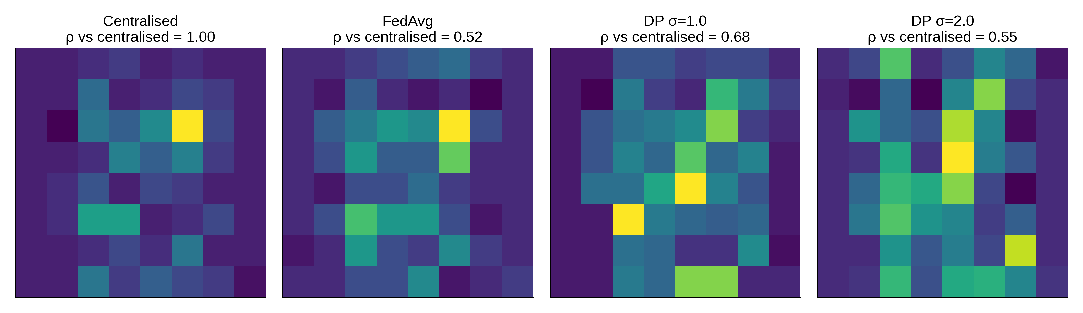
FIGURE 35. Pixel Importance Maps under Privacy. Permutation importance of each pixel on the Digits test set; single run.

TABLE 15. Reproducibility and Environment Details
Item | Value
Language / platform | Python 3.11.4; platform recorded in results metadata as Windows 11 (build 10.0.26200; Python reports it as Windows-10-10.0.26200-SP0).
Libraries | NumPy 2.2.1 (recorded in results metadata); SciPy, scikit-learn, matplotlib and Graphviz are dependencies, but their exact versions are not recorded in the supplied environment files.
Execution | Single process, one CPU core
Entry points | run_experiments.py, run_extra.py, make_figures.py
Outputs | 03_Datasets/results.json; 03_Datasets/derived.json; 03_Datasets/extra_robustness.json; 04_Execution_Logs_and_Videos/execution_log.txt
Seeds | 0, 1, 2 (split, partition, features, sampling)
Datasets | scikit-learn load_digits, load_breast_cancer
Randomness | NumPy RandomState; deterministic given seed

